

The International Committee on Taxonomy of Viruses
Taxonomy Proposal Form, 2025

Part 1a: Details of taxonomy proposals

Title: | Create a new family (Buchnerviridae) with seven genera (Slezavirus, Olaviavirus, Valdenburkvirus, Svidnicavirus, Lubinvirus, Jauervirus, Vieuvirus) for a group of Acinetobacter-specific phages (class Caudoviricetes)
Code assigned: | 2025.006B.Buchnerviridae_1nf_6ng_1mg_1mrs_12ns

Author(s), affiliation and email address(es):
Given name (+middle initial(s)) | Surname | Affiliation | Email address | Corresponding author(s)
Michał J. | Wójcicki | Bacteriophage Laboratory, Department of Phage Therapy, Hirszfeld Institute of Immunology and Experimental Therapy, Polish Academy of Sciences, Wroclaw, Poland | michal.wojcicki@hirszfeld.pl | X
Dann | Turner | School of Applied Sciences, University of the West of England, Bristol, UK | dann2.turner@uwe.ac.uk
Martyna A. | Cieślik | Bacteriophage Laboratory, Department of Phage Therapy, Hirszfeld Institute of Immunology and Experimental Therapy, Polish Academy of Sciences, Wroclaw, Poland | martyna.cieslik@hirszfeld.pl
Andrzej | Górski | Bacteriophage Laboratory, Department of Phage Therapy, Hirszfeld Institute of Immunology and Experimental Therapy, Polish Academy of Sciences, Wroclaw, Poland | andrzej.gorski@hirszfeld.pl
Ewa M. | Jończyk-Matysiak | Bacteriophage Laboratory, Department of Phage Therapy, Hirszfeld Institute of Immunology and Experimental Therapy, Polish Academy of Sciences, Wroclaw, Poland | ewa.jonczyk-matysiak@hirszfeld.pl | X

Part 1b: Taxonomy Proposal Submission
ICTV Subcommittee:
Animal DNA Viruses and Retroviruses |  | Bacterial viruses | X
Animal minus-strand and dsRNA viruses |  | Fungal and protist viruses
Animal positive-strand RNA viruses |  | Plant viruses
Archaeal viruses |  | General

List the ICTV Study Group(s) that have seen or have been involved in creating this proposal:
Caudoviricetes Study Group
Optional – complete only if formally voted on by an ICTV Study Group:
Study Group | Number of members
Study Group | Votes in support | Votes against | No vote

Submission date: | 24/03/2025

Part 1c: Feedback from ICTV Executive Committee (EC) meeting
Executive Committee Meeting Decision code: | X
A – Accept
Ac – Accept subject to revision by relevant subcommittee chair. No further vote required
U – Accept without revision but with re-evaluation and email vote by the EC
Uc – Accept subject to revision and re-evaluation and email vote by the EC | x
Ud – Deferred to the next EC meeting, with an invitation to revise based on EC comments
J - Reject
W - Withdrawn

Comments from the Executive Committee:
The proposal does not meet the demarcation criteria and needs to be revised in that respect. Please check italics.

Part 1d: Revised Taxonomy Proposal Submission
Response of proposer:
All issues have been corrected in accordance with the suggestions.
This proposal also includes proposal number 2025.087B.N.v2.

Revision date: | 22/10/2025

Part 3: TAXONOMIC PROPOSAL

Taxonomic changes proposed:
Establish new taxon | X | Split taxon
Abolish taxon |  | Merge taxon
Move taxon | X | Promote taxon
Rename taxon |  | Demote taxon
Move and rename | X

Etymology (origin) of proposed taxonomic names:
Taxon name | Etymology of the term
Buchnerviridae | family name created in honor of Eduard Buchner (b.1860, d.1917), professor of chemistry at the universities of Cologne, Tübingen, Berlin, Wroclaw and Würzburg, winner of the Nobel Prize in Chemistry in 1907 for his research in biochemistry
Slezavirus | genus name derived from Mount Ślęża, the highest peak of the Ślęża Massif, located near Wroclaw (Poland).
Slezavirus Ab1052phi | species name derived from the phage name in the GenBank database – Acinetobacter phage Ab105-2phi
Olaviavirus | genus name derived from Oława (Latin: Olavia), a town in Poland, in the Lower Silesian Voivodeship
Olaviavirus phi5013M1 | species name derived from the phage name in the GenBank database – Acinetobacter phage phi5013-M1
Olaviavirus phi4197 | species name derived from the phage name in the GenBank database – Acinetobacter phage phi4197
Olaviavirus phi5013M2 | species name derived from the phage name in the GenBank database – Acinetobacter phage phi5013-M2
Olaviavirus Ab11510phi | species name derived from the phage name in the GenBank database – Acinetobacter phage Ab11510-phi
Olaviavirus phi503811536 | species name derived from the phage name in the GenBank database – Acinetobacter phage phi5038-11536
Olaviavirus phi503811551 | species name derived from the phage name in the GenBank database – Acinetobacter phage phi5038-11551
Valdenburkvirus | genus name derived from Wałbrzych (Czech: Valdenburk), a town in Poland, in the Lower Silesian Voivodeship
Valdenburkvirus Acba23 | species name derived from the phage name in the GenBank database – Acinetobacter phage Acba_23
Svidnicavirus | genus name derived from Świdnica (Latin: Svidnica), a town in Poland, in the Lower Silesian Voivodeship
Svidnicavirus Ftm | species name derived from the phage name in the GenBank database – Acinetobacter phage vB_AbaS_Ftm
Svidnicavirus Eva | species name derived from the phage name in the GenBank database – Acinetobacter phage vB_AbaS_Eva
Lubinvirus | genus name derived from Lubin, a town in Poland, in the Lower Silesian Voivodeship
Lubinvirus Ab16562 | species name derived from the phage name in the GenBank database – Acinetobacter phage Ab1656-2
Jauervirus | genus name derived from Jawor (German: Jauer), a town in Poland, in the Lower Silesian Voivodeship
Jauervirus R3177 | species name derived from the phage name in the GenBank database – Acinetobacter phage YMC11/11/R3177 (move from Vieuvirus genus and rename to new genus with one species)
Vieuvirus A24903 | species name derived from the phage name in the GenBank database – Acinetobacter phage A2490.3

Permission for use of names derived from a living person
Taxon name | Full name of person from whom the name is derived | Attached

Abstract of Taxonomy Proposal:
Taxonomic rank(s) affected:
Family, genus, species

Description of current taxonomy:
According to the current taxonomy, the genus Vieuvirus has been classified within the class Caudoviricetes without assignment to a family rank. Currently, the Vieuvirus genus includes two species: Vieuvirus R3177 and Vieuvirus B1251.

Proposed taxonomic change(s):
Create new family (Buchnerviridae) with seven genera (Slezavirus, Olaviavirus, Valdenburkvirus, Svidnicavirus, Lubinvirus, Jauervirus, Vieuvirus) for a group of Acinetobacter-specific phages (realm Duplodnaviria, kingdom Heunggongvirae, phylum Uroviricota, class Caudoviricetes).

We performed a genomic analysis of several Acinetobacter-specific phages deposited in the NCBI database, all of which have been classified within the genus Vieuvirus. Based on our analysis, we propose the creation of a family for these phages along with seven distinct genera.

- To create a new family, Buchnerviridae, with seven genera.
- To create a new single species genus, Slezavirus.
- To create a new genus Olaviavirus, with six species.
- To create a new single species genus, Valdenburkvirus.
- To create a new genus Svidnicavirus, with two species.
- To create a new single species genus, Lubinvirus.
- To move the genus Vieuvirus to new family, Buchnerviridae.
- To move Vieuvirus R3177 from Vieuvirus genus and rename to new Jauervirus genus with one species (Jauervirus R3177).
- To create one new species in genus Vieuvirus.

Justification:
After examination of 20 bacteriophages based on nucleotide sequence similarity, tblastx distances and core gene phylogeny, we propose the creation of a new family, Buchnerviridae, to accommodate seven genera (Slezavirus, Olaviavirus, Valdenburkvirus, Svidnicavirus, Lubinvirus, Jauervirus, Vieuvirus). The proposed taxa conform to the demarcation criteria employed by the ICTV Bacterial Viruses Subcommittee.

Text of Taxonomy proposal:
Taxonomic rank(s) affected:
Family, genus, species

Description of current taxonomy:
According to the current taxonomy, the genus Vieuvirus has been classified within the class Caudoviricetes without assignment to a family rank. Currently, the Vieuvirus genus includes two species: Vieuvirus R3177 and Vieuvirus B1251.

Proposed taxonomic change(s):
We performed a genomic analysis of several Acinetobacter-specific phages deposited in the NCBI database, all of which have been classified within the genus Vieuvirus. Based on our analysis, we propose the creation of a family for these phages along with seven distinct genera.

- To create a new family, Buchnerviridae, with seven genera.
- To create a new single species genus, Slezavirus.
- To create a new genus Olaviavirus, with six species.
- To create a new single species genus, Valdenburkvirus.
- To create a new genus Svidnicavirus, with two species.
- To create a new single species genus, Lubinvirus.
- To move the genus Vieuvirus to new family, Buchnerviridae.
- To move Vieuvirus R3177 from Vieuvirus genus and rename to new Jauervirus genus with one species (Jauervirus R3177).
- To create one new species in genus Vieuvirus.

Demarcation criteria:
Species demarcation criteria: Two phages are assigned to the same species if their genomes are more than 95% identical over their genome length for isolates.
These values can be calculated by several tools, such as BLASTn [1] – usually calculated using the intergenomic distance calculator VIRIDIC [2].

Genus demarcation criteria: In search for criteria that create cohesive and distinct genera that are reproducible and monophyletic, the Bacterial Viruses Subcommittee has established 70% nucleotide identity of the genome length as the cut-off for genera. Genus-level groupings should always be monophyletic in the signature genes, as tested with a phylogenetic tree [3].

Family demarcation criteria: The family is represented by a cohesive and monophyletic group in the main predicted proteome-based clustering tools (ViPTree, GRAViTy dendrogram, vConTACT2 network). Family members share a significant number of orthologous genes (the number will depend on the genome sizes and number of coding sequences of family members) [3].

Justification:
A total of 20 bacteriophages were identified on the basis of nucleotide sequence similarity to classified species within the Vieuvirus. These genomes were first assessed by nucleotide intergenomic sequence similarity (Figure 1) and a hierarchically clustered tblastx distance tree using ViPTree (Figure 2). To assess the presence of conserved proteins, all genomes were first reannotated using Pharokka to provide a standardized dataset. MMSeqs2 was used to perform protein clustering at thresholds of 50% minimum sequence identity and 50% coverage. Protein clusters were extracted as multi-fasta files and converted to matrices of counts and presence/absence by genome. A total of two conserved proteins were identified in all species within the family, with a further 12 proteins conserved in 18 genomes (Figures 3 and 4). These bacterial viruses are temperate and show evidence of gene insertions, deletions and structural reararrangements which might suggest high rates of gene exchange within this family (Figure 5). We propose the creation of a new family, Buchnerviridae, to accommodate seven genera; Slezavirus, Olaviavirus, Valdenburkvirus, Svidnicavirus, Lubinvirus, Jauervirus and Vieuvirus.

References:
- Sayers EW, Beck J, Bolton EE, Bourexis D, Brister JR, Canese K, Comeau DC, Funk K, Kim S, Klimke W, Marchler-Bauer A, Landrum M, Lathrop S, Lu Z, Madden TL, O'Leary N, Phan L, Rangwala SH, Schneider VA, Skripchenko Y, Wang J, Ye J, Trawick BW, Pruitt KD, Sherry ST. Database resources of the National Center for Biotechnology Information. Nucleic Acids Res. 2021, 49(D1):D10-D17.
- Moraru C, Varsani A, Kropinski AM. VIRIDIC - a novel tool to calculate the intergenomic similarities of prokaryote-infecting viruses. Viruses 2020, 12(11):1268.
- Turner D, Kropinski AM, Adriaenssens EM. A roadmap for genome-based phage taxonomy. Viruses 2021, 13(3):506.
- Nishimura Y, Yoshida T, Kuronishi M, Uehara H, Ogata H, Goto S. ViPTree: the viral proteomic tree server. Bioinformatics 2017, 33(15):2379-2380.
- Rohwer F, Edwards R. The Phage Proteomic Tree: a genome-based taxonomy for phage. J. Bacteriol. 2002, 184(16):4529-35.
- Turner D, Reynolds D, Seto D, Mahadevan P. CoreGenes3.5: a webserver for the determination of core genes from sets of viral and small bacterial genomes. BMC Res. Notes. 2013, 6:140.

Accompanying files:
Filename | Description of contents
Caudoviricetes_1nf_6ng_1mg_1mrs_13ns.xlsx | To present the proposed taxonomic changes as a comparison of new taxonomic structures.
Tables, Figures:

Proposals data:

- To create a new family, Buchnerviridae, with seven genera.
- To create a new single species genus, Slezavirus.
- To create a new genus Olaviavirus, with six species.
- To create a new single species genus, Valdenburkvirus.
- To create a new genus Svidnicavirus, with two species.
- To create a new single species genus, Lubinvirus.
- To move the genus Vieuvirus to new family, Buchnerviridae.
- To move Vieuvirus R3177 from Vieuvirus genus and rename to new Jauervirus genus with one species (Jauervirus R3177).
- To create one new species in genus Vieuvirus.

Figure 1. VIRIDIC heat map: VIRIDIC (Virus Intergenomic Distance Calculator [2]; http://rhea.icbm.uni-oldenburg.de/VIRIDIC/) computes pairwise intergenomic distances/similarities amongst phage genomes. Phages belonging to the same species (nucleotide similarity above 95%) are marked with a red frame. The currently distinguished two species belonging to the genus Vieuvirus are marked in blue.

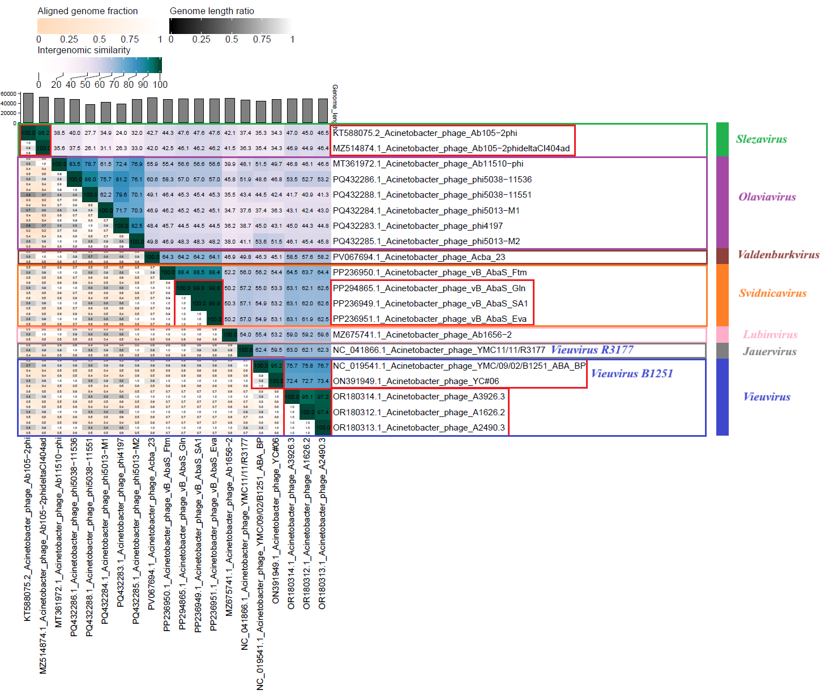
All 20 phages pre-classified in the NCBI database were divided into seven groups, based on which we propose the creation of separate genera. Proposed genera names: green – new genus: Slezavirus, purple – new genus: Olaviavirus, brown – new genus: Valdenburkvirus, orange – new genus: Svidnicavirus, pink – new genus: Lubinvirus, grey – new genus: Jauervirus, and blue – genus: Vieuvirus.

Figure 2. ViPTree analysis*: ViPTree analysis (https://www.genome.jp/viptree/; [4]) is based upon Rohwer and Edwards (2002) Phage Proteomic Tree [5]. The phage of interest is indicated with a red star and a green, purple, brown, pink, orange, grey and blue bars.

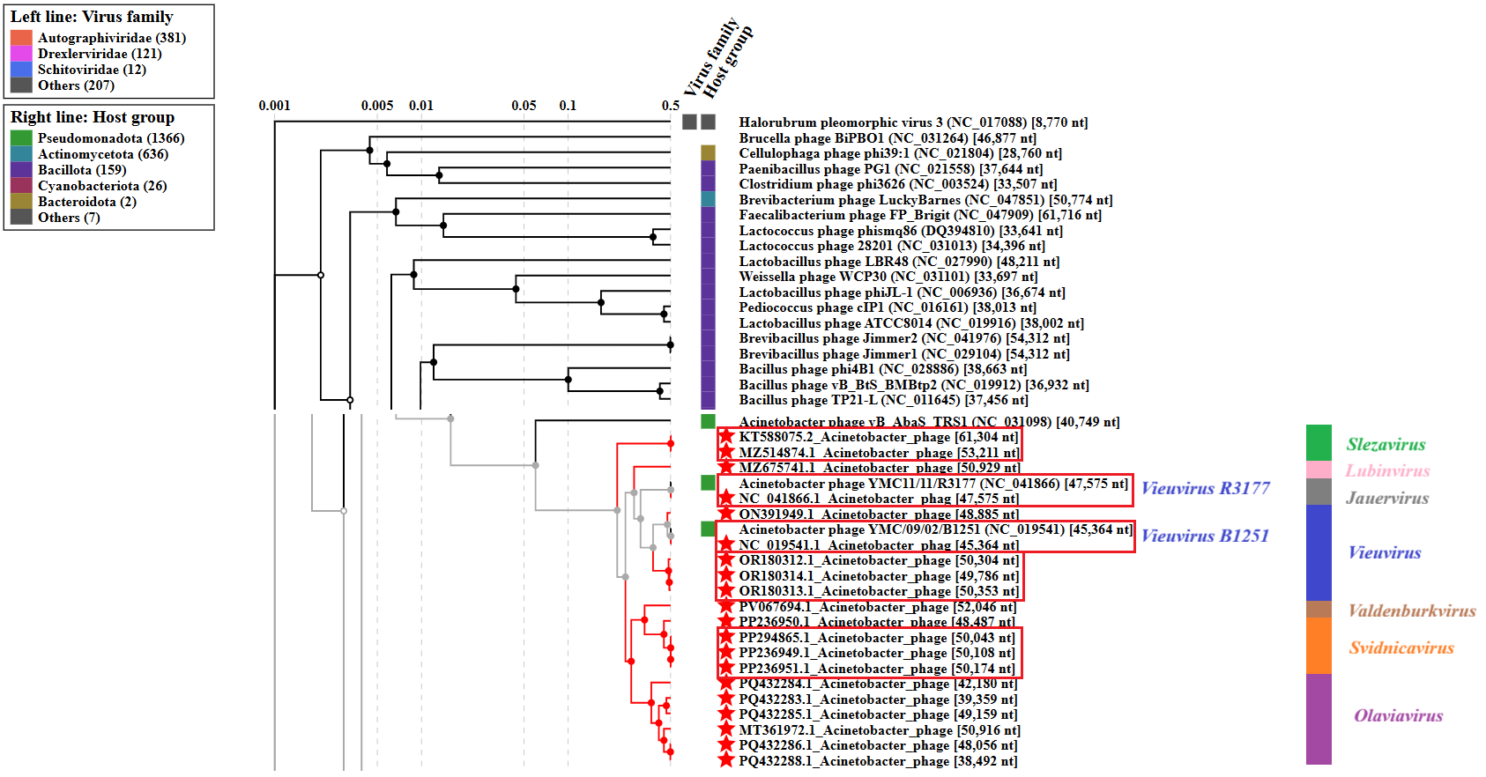

* The Autographiviridae family shown in Figure 2 (automatically labeled by the software) is outdated. In 2025, the Autographiviridae family was elevated to the rank of order and renamed Autographivirales.

All 20 phages pre-classified in the NCBI database were divided into seven groups, based on which we propose the creation of separate genera. Proposed genera names: green – new genus: Slezavirus, purple – new genus: Olaviavirus, brown – new genus: Valdenburkvirus, orange – new genus: Svidnicavirus, pink – new genus: Lubinvirus, grey – new genus: Jauervirus, and blue – genus: Vieuvirus.

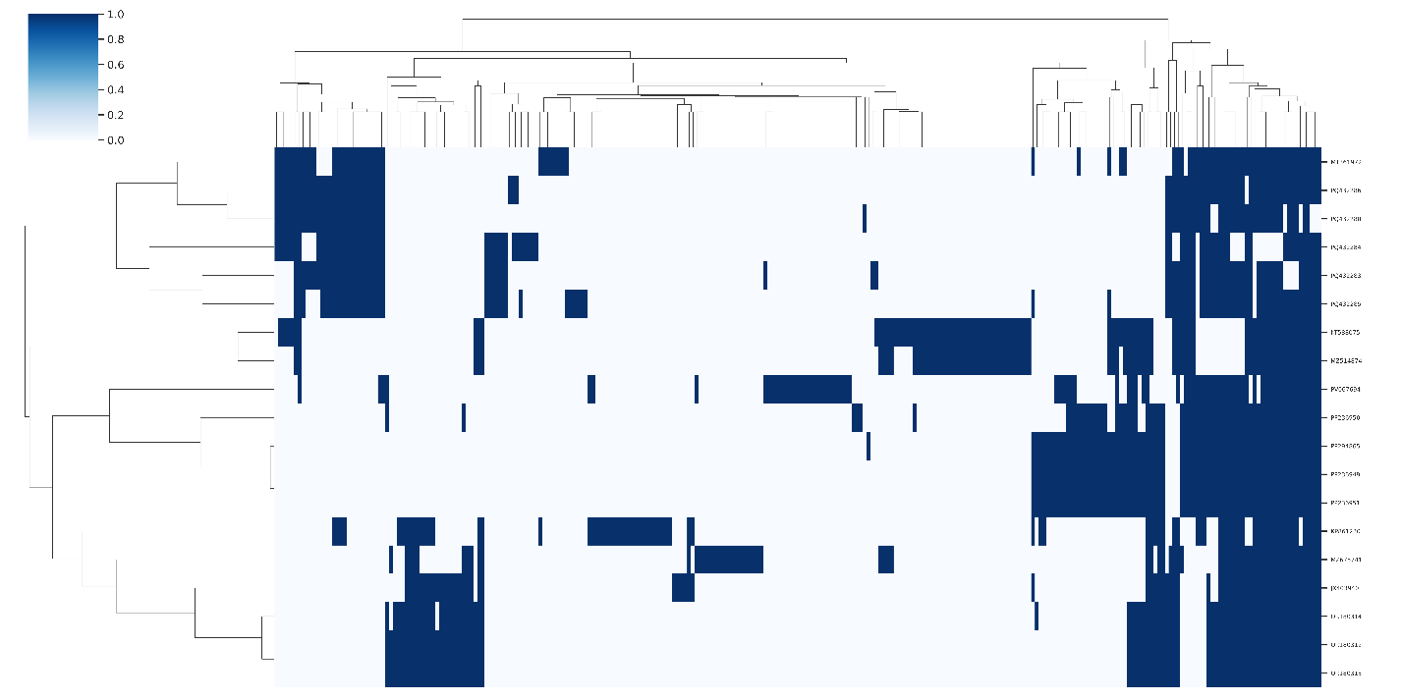
Figure 3. Presence-absence matrix of protein clusters by genome. Rows and columns were heirarchically clustered using the complete method. Rows represent individual genomes with columns representing protein clusters. Vertical blue bars denote the presence of protein clusters in each genome.

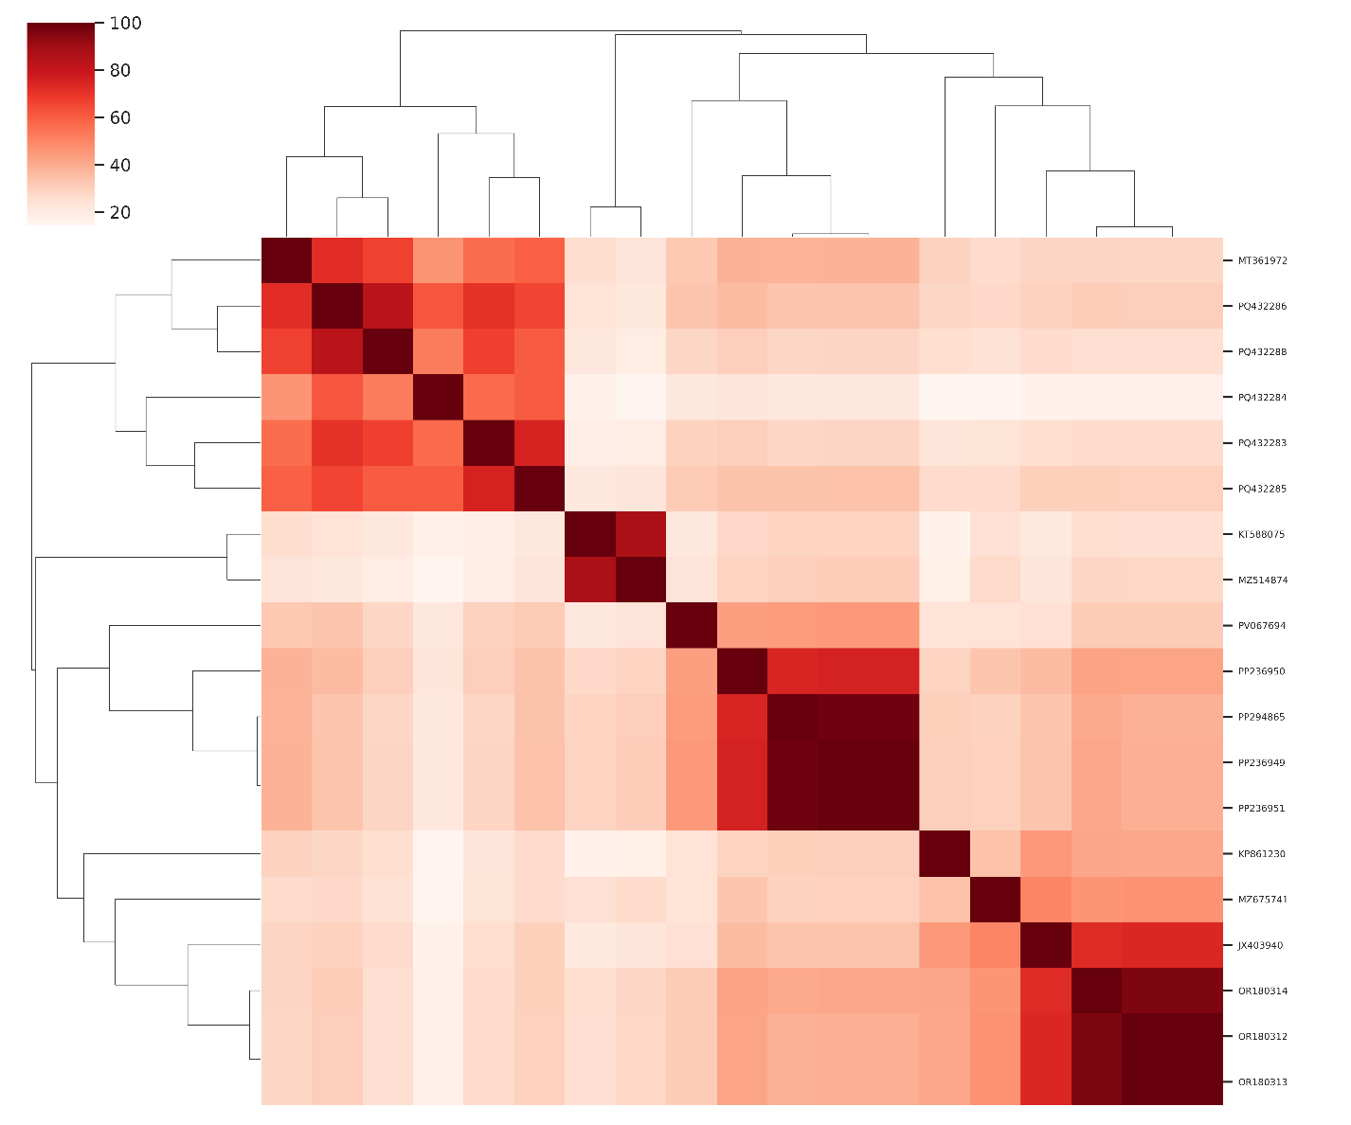
Figure 4. Heatmap of Jaccard similarity calculated from the percentage of shared protein clusters between genomes.
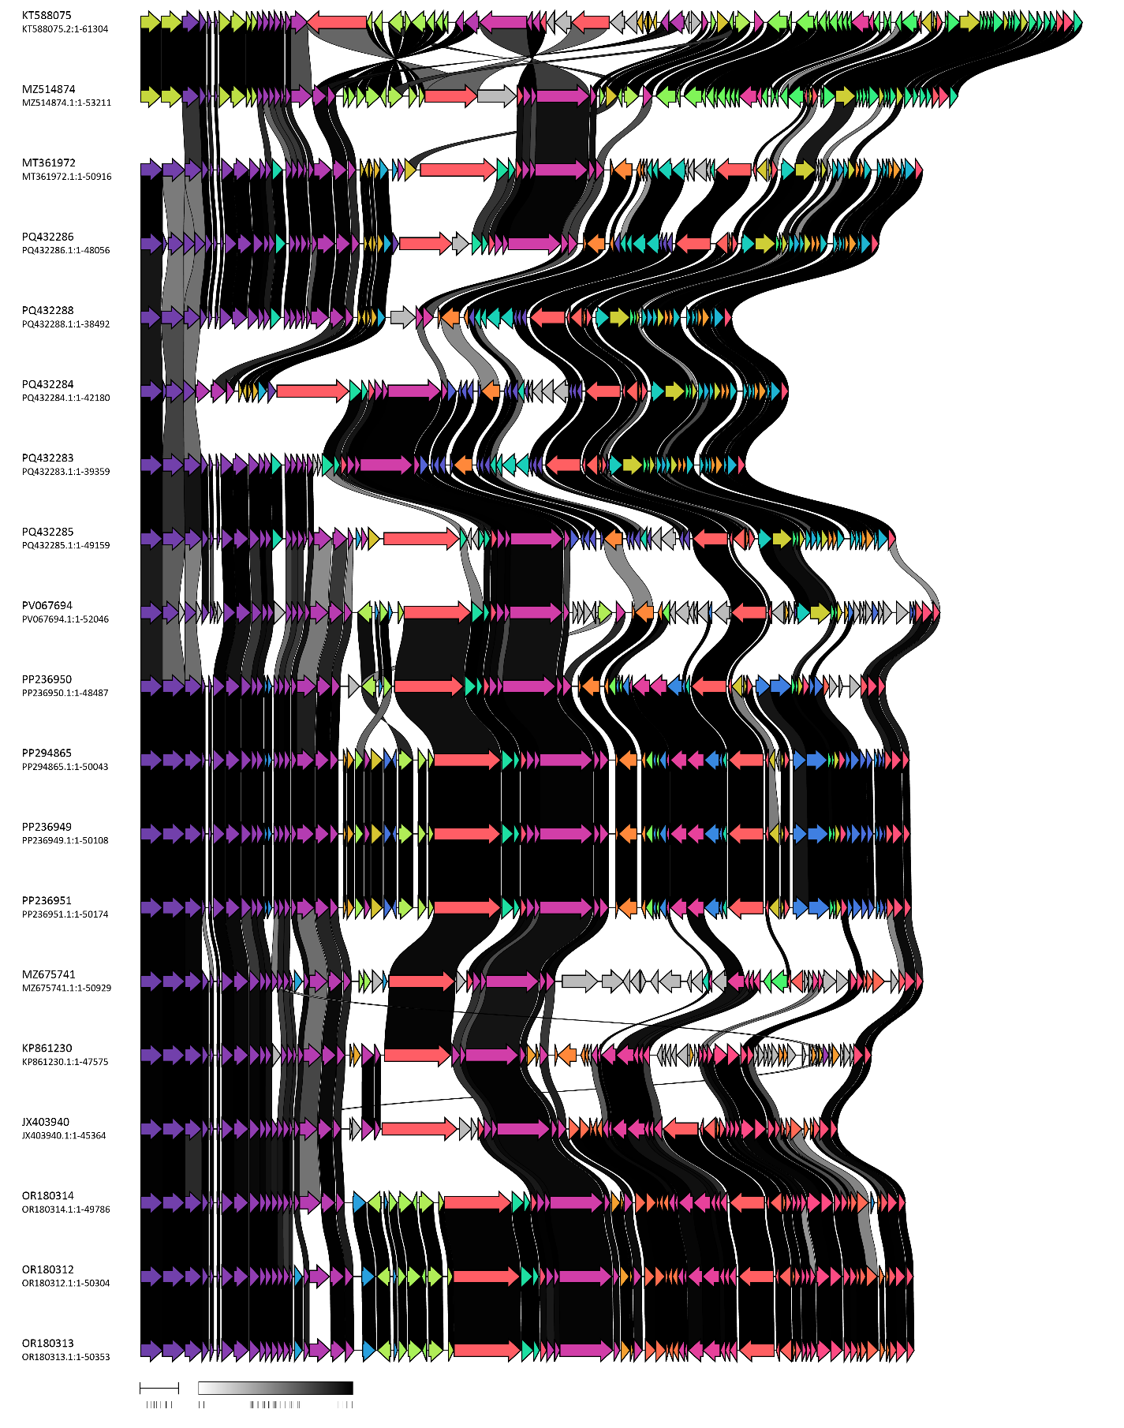
Figure 5. Comparative genome maps of bacterial viruses included in the family Buchnerviridae produced using clinker. Coding sequences are presented as arrows coloured according to group based on BLAST similarity.

A. To create a new family, Buchnerviridae, with seven genera.

After examination of 20 bacteriophages based on nucleotide sequence similarity, tblastx distances and core gene phylogeny, we propose the creation of a new family, Buchnerviridae, to accommodate seven genera (Slezavirus, Olaviavirus, Valdenburkvirus, Svidnicavirus, Lubinvirus, Jauervirus, Vieuvirus).

B. To create a new single species genus, Slezavirus.

Genome summary:

Phage name | RefSeq No. | INSDC | Size (bp) | GC% | Protein | Overall % DNA sequence identity (*) | Overall % homologous proteins (**)
Acinetobacter phage Ab105-2phi |  | KT588075 | 61,304 | 39.4 | 93 | 100.0 | 100.0
(*) determined using VIRIDIC [2]
(**) determined using CoreGenes 3.5 [6]

C. To create a new genus Olaviavirus, with six species.

Genome summary:

Phage name | RefSeq No. | INSDC | Size (bp) | GC% | Protein | Overall % DNA sequence identity (*) | Overall % homologous proteins (**)
Acinetobacter phage phi5013-M1 (selected as the reference genome) | PQ432284.1 | PQ432284 | 42,180 | 39.3 | 63 | 100.0 | 100.00
Acinetobacter phage phi4197 |  | PQ432283 | 39,359 | 38.9 | 67 | 71.7 | 76.19
Acinetobacter phage phi5013-M2 |  | PQ432285 | 49,159 | 38.9 | 73 | 70.3 | 79.37
Acinetobacter phage Ab11510-phi |  | MT361972 | 50,916 | 38.9 | 76 | 61.5 | 68.25
Acinetobacter phage phi5038-11536 |  | PQ432286 | 48,056 | 39.0 | 72 | 75.7 | 80.95
Acinetobacter phage phi5038-11551 |  | PQ432288 | 38,492 | 38.9 | 64 | 62.2 | 69.84
(*) determined using VIRIDIC [2]
(**) determined using CoreGenes 3.5 [6]

D. To create a new single species genus, Valdenburkvirus.

Genome summary:

Phage name | RefSeq No. | INSDC | Size (bp) | GC% | Protein | Overall % DNA sequence identity (*) | Overall % homologous proteins (**)
Acinetobacter phage Acba_23 |  | PV067694 | 52,046 | 39.2 | 78 | 100.0 | 100.0
(*) determined using VIRIDIC [2]
(**) determined using CoreGenes 3.5 [6]

E. To create a new genus Svidnicavirus, with two species.

Genome summary:

Phage name | RefSeq No. | INSDC | Size (bp) | GC% | Protein | Overall % DNA sequence identity (*) | Overall % homologous proteins (**)
Acinetobacter phage vB_AbaS_Ftm (selected as the reference genome) | PP236950.1 | PP236950 | 48,487 | 39.2 | 68 | 100.0 | 100.00
Acinetobacter phage vB_AbaS_Eva |  | PP236951 | 50,174 | 39.2 | 74 | 88.4 | 89.71
(*) determined using VIRIDIC [2]
(**) determined using CoreGenes 3.5 [6]

F. To create a new single species genus, Lubinvirus.

Genome summary:

Phage name | RefSeq No. | INSDC | Size (bp) | GC% | Protein | Overall % DNA sequence identity (*) | Overall % homologous proteins (**)
Acinetobacter phage Ab1656-2 |  | MZ675741 | 50,929 | 38.6 | 67 | 100.0 | 100.0
(*) determined using VIRIDIC [2]
(**) determined using CoreGenes 3.5 [6]

G. To move a genus Vieuvirus to new family, Buchnerviridae.

After examining bacteriophages based on nucleotide sequence similarity, tblastx distance, and core gene phylogeny, we proposed to include the genus Vieuvirus in a newly proposed family, Buchnerviridae.

H. To move Vieuvirus R3177 from Vieuvirus genus and rename to new Jauervirus genus with one species (Jauervirus R3177).

Genome summary:

Phage name | RefSeq No. | INSDC | Size (bp) | GC% | Protein | Overall % DNA sequence identity (*) | Overall % homologous proteins (**)
Acinetobacter phage YMC11/11/R3177 |  | NC_041866 | 47,575 | 39.8 | 80 | 100.0 | 100.0
(*) determined using VIRIDIC [2]
(**) determined using CoreGenes 3.5 [6]

I. To create one new species in genus Vieuvirus.

Genome summary:

Phage name | RefSeq No. | INSDC | Size (bp) | GC% | Protein | Overall % DNA sequence identity (*) | Overall % homologous proteins (**)
Acinetobacter phage YMC/09/02/B1251_ABA_BP (Vieuvirus B1251; reference genome) | NC_019541.1 | NC_019541 | 45,364 | 39.1 | 62 | 100.0 | 100.0
Acinetobacter phage A2490.3 |  | OR180313 | 50,353 | 38.8 | 73 | 76.7 | 93.55
(*) determined using VIRIDIC [2]
(**) determined using CoreGenes 3.5 [6]

