

The International Committee on Taxonomy of Viruses
Taxonomy Proposal Form, 2025

Part 1a: Details of taxonomy proposals

Title: | Reclassifying the order Crassvirales to establish two sister orders and one sister family, with the creation of six new families, 38 new genera, and 99 new species
Code assigned: | 2025.013B.Crassvirales_reorganisation

Author(s), affiliation and email address(es):
Given name (+middle initial(s)) | Surname | Affiliation | Email address | Corr. author(s)
Fabian TS | Bastiaanssen | University College Cork, Ireland | fbastiaanssen@ucc.ie
Rémi | Denise | University College Cork, Ireland | rdenise@ucc.ie
George S | Bouras | The University of Adelaide, Australia | george.bouras@adelaide.edu.au
Steven R | Stockdale | Novogene, Ireland | stephen.stockdale@novogene-europe.com
Robert A | Edwards | Flinders University, Australia | raedwards@gmail.com
Colin | Hil | University College Cork, Ireland | c.hill@ucc.ie
Andrey N | Shkoporov | University College Cork, Ireland | andrey.shkoporov@ucc.ie | X

Part 1b: Taxonomy Proposal Submission
ICTV Subcommittee:
Animal DNA Viruses and Retroviruses |  | Bacterial viruses | X
Animal minus-strand and dsRNA viruses |  | Fungal and protist viruses
Animal positive-strand RNA viruses |  | Plant viruses
Archaeal viruses |  | General -

List the ICTV Study Group(s) that have seen or have been involved in creating this proposal: https://ictv.global/sc
Crassvirales Study Group
Optional – complete only if formally voted on by an ICTV Study Group:
Study Group | Number of members
Study Group | Votes in support | Votes against | No vote

Submission date: | 22/06/2025

Part 1c: Feedback from ICTV Executive Committee (EC) meeting
Executive Committee Meeting Decision code: | X
A – Accept
Ac – Accept subject to revision by relevant subcommittee chair. No further vote required
U – Accept without revision but with re-evaluation and email vote by the EC
Uc – Accept subject to revision and re-evaluation and email vote by the EC | x
Ud – Deferred to the next EC meeting, with an invitation to revise based on EC comments
J - Reject
W - Withdrawn

Comments from the Executive Committee:
Regarding the abolishment of the subfamilies: can the authors provide the evidence in figures for removing the subfamilies? They were previously created with demarcation criteria. Could they stay until better criteria can be found so that they can be replaced in one go? E.g., you mention “We believe the current criteria are too broad, as 27-79% of proteins shared within each subfamily in all possible pairwise comparisons does not appear to identify any meaningful groupings.” If this has been assessed could you provide the trees to evidence this?
Sequence Records need to be available. As an alternative: you could propose a reorganisation of the group without any of the new species that don’t have available accession numbers. If accessions are not available, they can include the information in the word module to discuss proposed taxonomic changes

Part 1d: Revised Taxonomy Proposal Submission
Response of proposer:
We have expanded our explanation on the subfamily demarcation criteria, but agree with the committee that, since no better criteria are being presented, we can continue to use the current methods until newer ones are proposed. The issues would only arise with the expansion of the subfamilies, but the currently assigned subfamilies have no contradictions yet.
Since sequence records were unable to be made public in time with the deadline set, we have attached the sequence records used in zipped form and created additional figures in which only the available sequences are highlighted. We have updated the Excel sheet to reflect these changes.

Revision date: | 29/10/2025

Part 3: TAXONOMIC PROPOSAL
https://ictv.global/taxonomy/templates
Taxonomic changes proposed:
Establish new taxon | X | Split taxon | X
Abolish taxon |  | Merge taxon
Move taxon |  | Promote taxon
Rename taxon |  | Demote taxon
Move and rename | X

Etymology (origin) of proposed taxonomic names:
Taxon name | Etymology of the term
Paracrassvirales | Meaning "near" or "beside" Crassvirales, this clade is highly similar to Crassvirales.
Metacrassvirales | Meaning “beyond” or “other” Crassvirales, this clade is highly similar to Crassvirales.
Tinaiviridae | From the Central Dusun “tinai”, meaning intestines
Darmviridae | From the Dutch “darm”, meaning intestines
Jelitioviridae | From the Polish “jelito”, meaning intestines
Tripviridae | From the French “tripes” meaning intestines
Meiviridae | From the Hebrew “מְעִי”, (me’i) meaning intestines

Permission for use of names derived from a living person:
Taxon name | Full name of person from whom the name is derived | Attached

Abstract of Taxonomy Proposal:
Taxonomic rank(s) affected:
Realm: Duplodnaviria; Kingdom: Heunggongvirae; Phylum: Uroviricota; Class: Caudoviricetes; Order: Crassvirales

Description of current taxonomy:
Crassvirales was established under taxonomic proposal 2021.022B

Proposed taxonomic change(s):
We propose:
- The establishment of demarcation criteria for the order Crassvirales
- The establishment of the order “Paracrassvirales” containing one novel family
- The establishment of the order “Metacrassvirales” containing one novel family
- The adjustment of demarcation criteria for families within Crassvirales
- The creation of one new family within Crassvirales
- The moving and renaming of one genus within Crassvirales
- The adjustment of demarcation criteria for subfamilies within Crassvirales
- The adjustment of demarcation criteria for genera within Crassvirales to reflect ICTV guidelines
- The creation of 38 new genera
- The adjustment of demarcation criteria for species within Crassvirales to reflect ICTV guidelines
- The creation of 99 new species

Justification:
Previously suspected members of Crassvirales, Epsiloncrassviridae and Zetacrassviridae are currently unable to be either placed within or outside of the Crassvirales order, due to a lack of demarcation criteria within Crassvirales. Phylogenetic trees utilizing structural and maximum likelihood approaches based on marker genes reveal the formation of unique clades that align with the proposed orders and support the further proposed changes to family, genus and species demarcation criteria.

Text of Taxonomy proposal:

Taxonomic rank(s) affected:
Realm: Duplodnaviria; Kingdom: Heunggongvirae; Phylum: Uroviricota; Class: Caudoviricetes; Order: Crassvirales

Description of current taxonomy:
Crassvirales was established under taxonomic proposal 2021.022B

Proposed taxonomic change(s):
We propose:
- The establishment of demarcation criteria for the order Crassvirales
- The establishment of the order “Paracrassvirales” containing one novel family
- The establishment of the order “Metacrassvirales” containing one novel family
- The adjustment of demarcation criteria for families within Crassvirales
- The creation of one new family within Crassvirales
- The adjustment of demarcation criteria for genera within Crassvirales to reflect ICTV guidelines
- The creation of 38 new genera
- The adjustment of demarcation criteria for species within Crassvirales to reflect ICTV guidelines
- The creation of 99 new species

Demarcation criteria:
Genus and species:
The demarcation of genus and species was performed by calculating total average nucleotide identity with Vclust¹, adhering to the ICTV² suggested thresholds, species are categorized as genomes showing ≤95% similarity, while genera are characterised by ≥70% similarity.

Subfamilies:
The current demarcation criteria are problematic, resulting in uncertain placements for new members, the formation of non-monophyletic clades, and subfamilies that contain either all genera or only a single genus within the family. No meaningful replacement demarcation criteria for subfamilies were identified; therefore, we recommend maintaining the current criteria and all current classifications, but did not create new subfamilies to accommodate novel genera.

Families:
The demarcation of Families is based on deep-branching monophyletic clades in the gene and consensus species trees generated using both structural phylogenetic and maximum-likelihood phylogenetic trees, all derived from four well-conserved core genes.

Orders:
The demarcation of Orders is based on deep-branching monophyletic clades in the gene and consensus species trees generated using both structural phylogenetic and maximum-likelihood phylogenetic trees, all derived from four well-conserved core genes. As well as the presence or absence of two key core marker genes.

Justification:
Currently, Crassvirales lacks demarcation criteria. The existing criteria within Crassvirales are ambiguous, unintuitive and based on outdated methods and results. Phylogenetic trees utilising structural and maximum likelihood approaches based on marker genes reveal the formation of unique clades that align with the proposed orders and support the proposed demarcation criteria. The criteria proposed for family demarcation establish monophyletic clades through proteome and genome analysis, enhancing clarity and reproducibility. The proposed demarcation criteria for genera and species align with current ICTV guidelines and are supported by phylogenetic analysis.

Orders:
We propose the creation of two new orders, Paracrassvirales and Metacrassvirales. Structural phylogenetic analysis of both single protein and core proteomes using FoldTree³ reveals the creation of three separate clades (Figure 1-6), further supported by maximum likelihood phylogenies of the same proteins (Figure 7). Furthermore, we propose the use of two marker genes discovered through PhaMMseqs v1.0.4 ⁴ to delineate the sister orders. One of these genes (NC_049977 Gp42) is found in over 99% of all Crassvirales genomes, while the other (NC_049977 Gp80) is present in more than 99% of genomes from both Crassvirales and Metacrassvirales.
Metacrassvirales and Paracrassvirales were chosen as the names for these sister-clades to represent their similarity to Crassvirales.
Families:
We propose the creation of seven new families, “Tinaiviridae” belonging to Paracrassvirales, Meiviridae, Tripiviridae and Jelitoviridae belonging to Metacrassvirales and Darmviridae belonging to Crassvirales. The proposed families form monophyletic clades in structural phylogenetic analysis (Figure 1-6, 13) of both single-protein and core proteomes, as well as maximum likelihood phylogenies (Figure 7,12). And create separate clusters based on shared gene clusters (Figure 9-11) and according to tANI (Figure 8,10). While Darmviridae could be placed as a subfamily within Suoliviridae, we have chosen to establish it as a distinct family. This decision aligns with our broader move to eliminate all previously defined subfamilies, whose demarcation criteria were overly broad and inconsistently applied. Recognising Darmviridae at the family level helps preserve meaningful hierarchical resolution and avoids compressing the distinction between family and subfamily to the point of diminishing its taxonomic value.
Subfamilies:
We argue that the current criteria, which require “27-79% of proteins shared within each subfamily in all possible pairwise comparisons,” are too broad, allowing for multiple conflicting subfamilies to exist simultaneously (Figures 14-15) and are not conducive to intuitive taxonomy. Due to the range of possible thresholds, subfamilies can exist as subsets of other subfamilies; with the set of 603 species used for this proposal, 415 unique and valid subfamilies can be created. The 27-79% criterion was proposed to capture distinct monophyletic clades within families for which no explicit cutoff would suffice across all families. However, no cutoffs were ever provided for the individual subfamilies, creating confusion about how these clades should be expanded in the future and when new subfamilies should be created.

This confusion can be seen in the proposal of Rudgehvirus jaberico (2023.018B), as unlike the other novel species in the proposal Kehishuvirus tikkala and Kolpuevirus frurule, its subfamily couldn’t be inferred from the genus, and despite knowing the percentage of proteins it shared with all members in the family, no subfamily was assigned to it. With the 10-fold increase in members that our proposal introduces and a complete overhaul of all taxonomic levels, the groups previously observed across 73 species have become less clear, and through the extrapolation of Loutivirinae and Uncouvirinae, have ceased to represent monophyletic clades (Figures 15-17). Because Loutivirinae exists as a potential subset within Uncouvirinae, there is no clear answer regarding the classification of these members or how these criteria could be adjusted to better reflect the signal these subfamilies were attempting to capture. As more members are classified within these families, it becomes almost inevitable that similar discrepancies will emerge for any family that allows subfamilies to compete for members.

There is no universal threshold that can be selected to expand the existing subfamilies while still respecting the phylogeny (Figures 14-15). The expansion of conflicting subfamilies would either break down existing subfamilies or merge them into a single encompassing subfamily. Both options cause the subfamilies to cease serving as intermediates between the family and the genus level. Splitting the subfamilies down would cause most of them to contain only one genus, as is currently already the case for Coarsevirinae and Churivirinae. Merging these subfamilies would place Intestiviridae in the same situation as Darmviridae and Steigviridae, which contain only one subfamily and therefore convey the same information as the family.

While we believe the current system is not workable and should be replaced, we were unable to find any criteria that would produce biologically relevant and phylogenetically consistent clades. Problematic criteria lead to problematic classifications, and forcing arbitrary criteria to maintain previous classifications puts the cart before the horse, defeating the purpose and usefulness of taxonomy.
Since we don’t have a better alternative and do not wish to discard existing knowledge, we think it best to maintain the current classifications and re-evaluate this situation once more members of each family are identified and more relevant patterns, such as ecological, morphological or host-associated characteristics, can be identified.
Genus and species:
We propose the creation of 38 new genera and 99 new species. A table with the total, global and average nucleotide identity, including coverage between all genomes, is available in the supplementary data.
Genera were named using the previously established method for algorithmically creating names (2021.022B).
Each letter of the term to be mutated was assigned a random number, 1-3. Characters were then passed through a three step script to create the following changes:
- 'a1'→'ah', 'b1'→'p', 'c1'→'k', 'd1'→'t', 'e1'→'eh', 'g1'→'j', 'i1'→'ih', 'k1'→'c', 'o1'→'oh', 't1'→'d', 'u1'→'uh'
- 'a2'→'e', 'e2'→'i', 'i2'→'o', 'o2'→'u', 'u2'→'a'
- 'a3'→'i', 'e3'→'o', 'i3'→'u', 'o3'→'a', 'u3'→'e', 'j3'→'g', 'k3'→'c', 'p3'→'b', 't3'→'d'
In order to maximize the likelihood that the mutated term was pronounceable, only the first occurrence of a repeating letter was kept. All long terms were cut after the 7th character and shortened further if needed to the last occurring vowel. This was to prevent a hard consonant before the genus level suffix '-virus'. Each mutated word needed to be a minimum of 5 characters in length, have two consonants and two vowels.

References:
1. Zielezinski, A. et al. Ultrafast and accurate sequence alignment and clustering of viral genomes. 2024.06.27.601020 Preprint at https://doi.org/10.1101/2024.06.27.601020 (2024).
2. Turner, D., Kropinski, A. M. & Adriaenssens, E. M. A Roadmap for Genome-Based Phage Taxonomy. Viruses 13, 506 (2021).
3. Moi, D. et al. Structural phylogenetics unravels the evolutionary diversification of communication systems in gram-positive bacteria and their viruses. 2023.09.19.558401 Preprint at https://doi.org/10.1101/2023.09.19.558401 (2023).
4. Gauthier, C. H., Cresawn, S. G. & Hatfull, G. F. PhaMMseqs: a new pipeline for constructing phage gene phamilies using MMseqs2. G3 GenesGenomesGenetics 12, jkac233 (2022).
5. Zhang, C. & Mirarab, S. ASTRAL-Pro 2: ultrafast species tree reconstruction from multi-copy gene family trees. Bioinformatics 38, 4949–4950 (2022).
6. Tabatabaee, Y., Zhang, C., Warnow, T. & Mirarab, S. Phylogenomic branch length estimation using quartets. Bioinformatics 39, i185–i193 (2023).
7. Bryant, D. & Charleston, M. MAD roots for large trees. Preprint at https://doi.org/10.48550/arXiv.1811.03174 (2018).
8. Katoh, K. & Standley, D. M. MAFFT Multiple Sequence Alignment Software Version 7: Improvements in Performance and Usability. Mol. Biol. Evol. 30, 772–780 (2013).
9. Steenwyk, J. L., Buida, T. J., Li, Y., Shen, X.-X. & Rokas, A. ClipKIT: A multiple sequence alignment trimming software for accurate phylogenomic inference. PLOS Biol. 18, e3001007 (2020).
10. Minh, B. Q. et al. IQ-TREE 2: New Models and Efficient Methods for Phylogenetic Inference in the Genomic Era. Mol. Biol. Evol. 37, 1530–1534 (2020).
11. Hoang, D. T., Chernomor, O., von Haeseler, A., Minh, B. Q. & Vinh, L. S. UFBoot2: Improving the Ultrafast Bootstrap Approximation. Mol. Biol. Evol. 35, 518–522 (2018).
12. Anisimova, M., Gil, M., Dufayard, J.-F., Dessimoz, C. & Gascuel, O. Survey of Branch Support Methods Demonstrates Accuracy, Power, and Robustness of Fast Likelihood-based Approximation Schemes. Syst. Biol. 60, 685–699 (2011).
13. Kalyaanamoorthy, S., Minh, B. Q., Wong, T. K. F., von Haeseler, A. & Jermiin, L. S. ModelFinder: fast model selection for accurate phylogenetic estimates. Nat. Methods 14, 587–589 (2017).

Accompanying files:
Filename | Description of contents
Taxa_names.xlsx | Contains all genomes, their accession and their taxonomic rank
Distances.tsv | Contains all genomes and their distances to each other genome, using tANI, gANI, ANI and metadata.
Sequences.gzip | Contains all genomes, available on ncbi or not in a gzipped format
All_gbk.gz | Contains all genomes, available on ncbi or not in a gzipped genbank format

Tables, Figures:
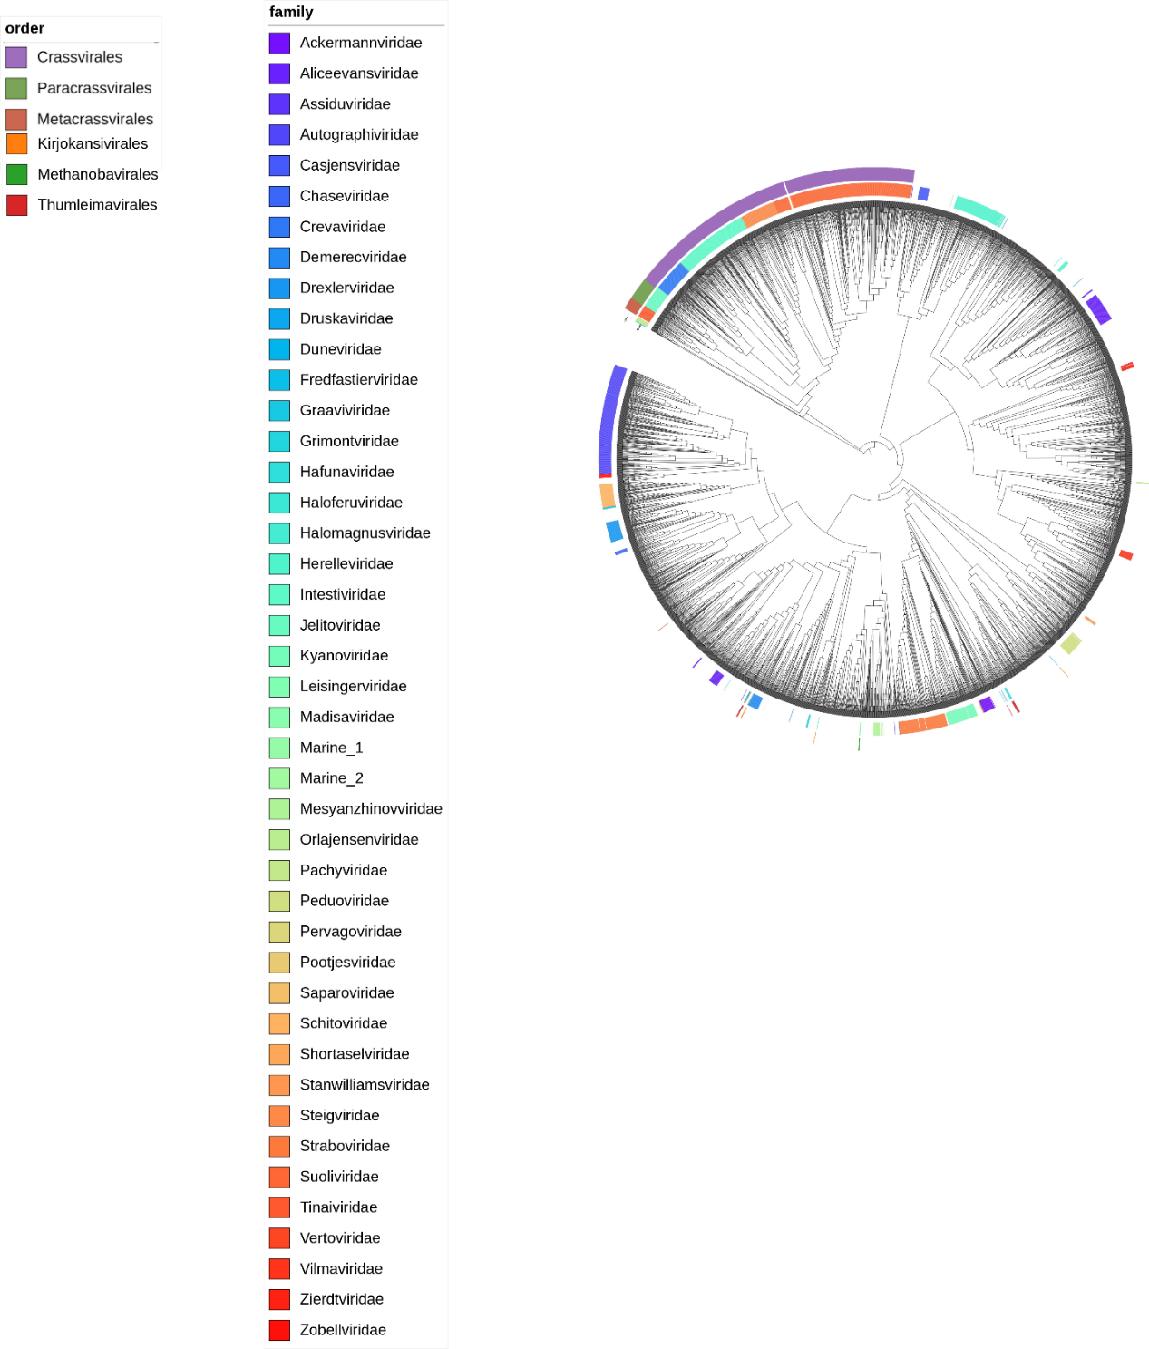

Figure 1: Foldtree structural phylogenetic tree based on the large terminase structure of 3896 members of Caudoviricetes. The classified and proposed families are shown in the inner coloured ring, and the proposed and classified orders in the outer coloured ring. Gaps in the annotation are due to a lack of classification for that level. The tree is midpoint rooted. Marine and Pachyviridae sequences closely related to the orders were selected and used as outgroups for all other figures.

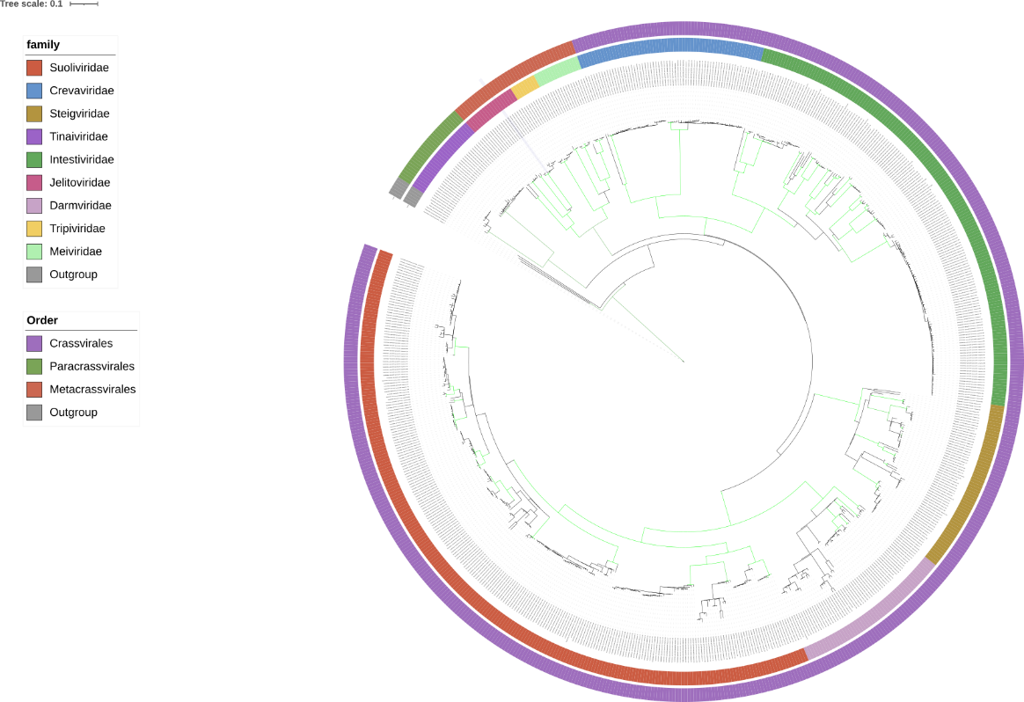

Figure 2: Core-gene structural phylogenetic species tree of the three orders based on gene trees created using ASTRAL-Pro3 v1.2.2⁵. Branch lengths are computed using integrated CASTLES-Pro v1.2.2⁶. 16 rounds of searching and subsampling were performed to ensure that maximum exploration of tree configurations was attempted. The tree was rooted on the outgroups. All branches with at least 95% bootstrapping are colored green, the classified and proposed families are shown in the inner coloured ring, and the proposed and classified orders in the outer coloured ring.

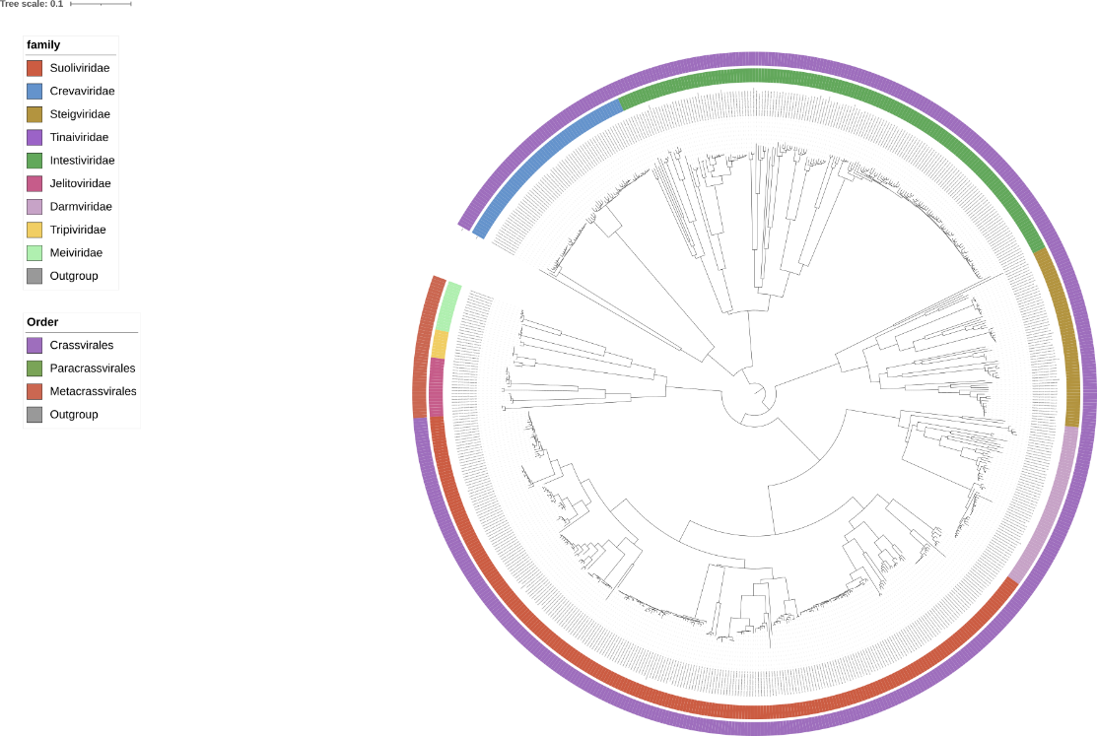

Figure 3: Single gene structural phylogeny of the DNA primase protein using foldtree. The tree was rooted using Madroot⁷ to ensure Minimal Ancestor Deviation(MAD). The classified and proposed families are shown in the inner coloured ring, and the proposed and classified orders in the outer coloured ring.

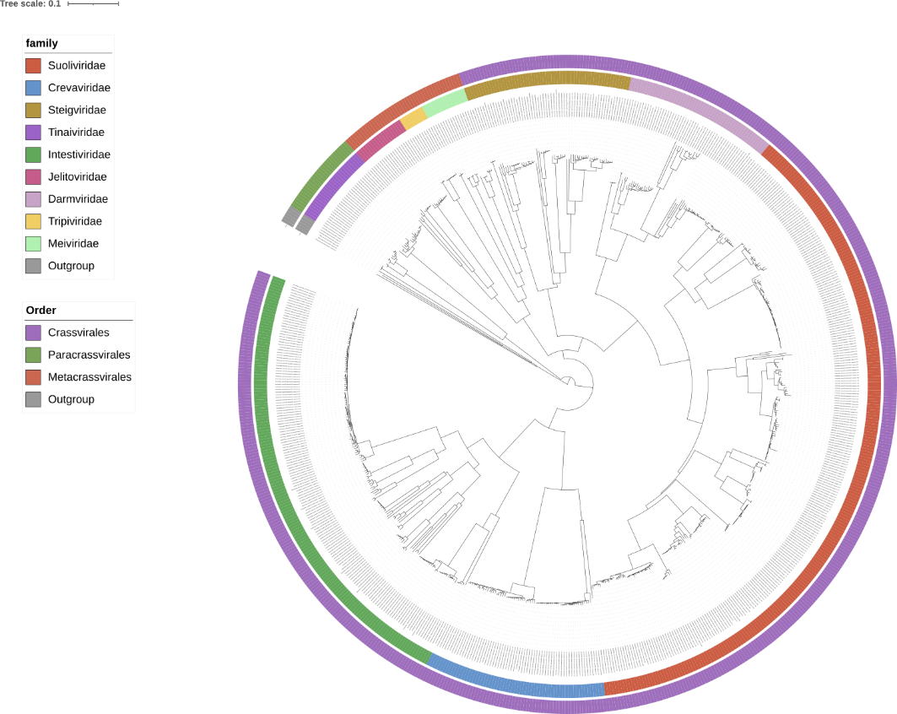

Figure 4: Single gene structural phylogeny of the large terminase subunit using foldtree. The tree was rooted using Madroot7 to ensure Minimal Ancestor Deviation(MAD). The classified and proposed families are shown in the inner coloured ring, and the proposed and classified orders in the outer coloured ring

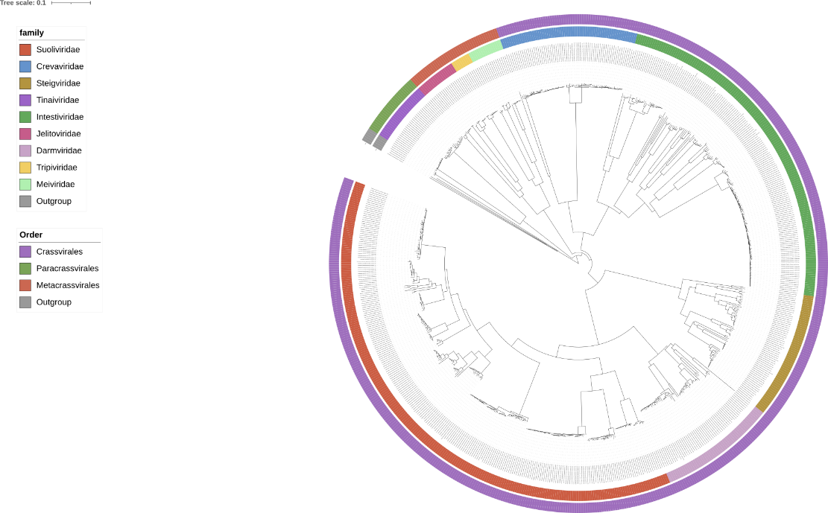

Figure 5: Single gene structural phylogeny of the portal protein using foldtree. The tree was rooted using Madroot⁷ to ensure Minimal Ancestor Deviation(MAD). The classified and proposed families are shown in the inner coloured ring, and the proposed and classified orders in the outer coloured ring
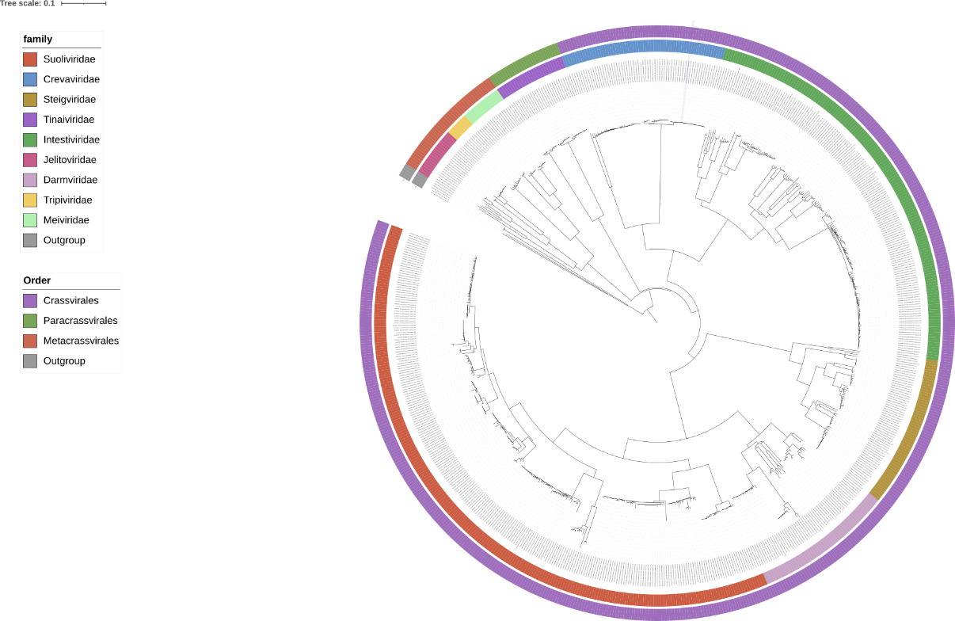

Figure 6: Single gene structural phylogeny of the major capsid protein using foldtree. The tree was rooted using Madroot7 to ensure Minimal Ancestor Deviation(MAD). The classified and proposed families are shown in the inner coloured ring, and the proposed and classified orders in the outer coloured ring

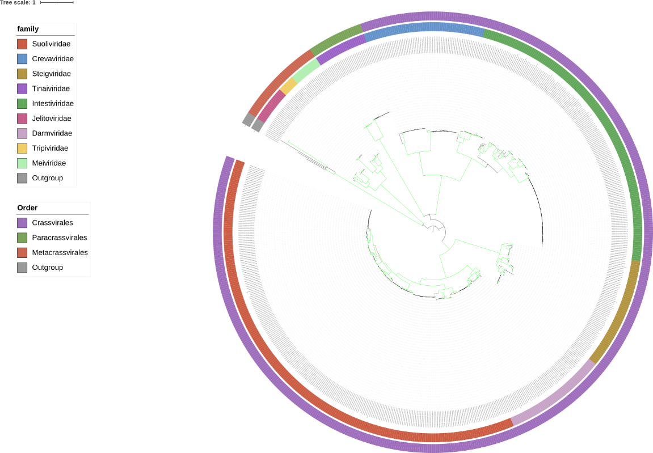

Figure 7: Core-gene phylogenetic tree of the three orders based on concatenated protein created with MAFFT v7.273⁸ using the L-INS-i algorithm. Multiple alignments were curated using the ClipKit⁹ Kpic method to select informative sites. The concatenation of these alignments was used to infer maximum likelihood trees with IQTree version 2.3.4¹⁰ (options -allnni -nm 4000). We evaluated the node supports using the option -bb 1,000 for ultrafast bootstraps with UFBoot2¹¹ and -alrt 1,000 for SH-aLRT¹². The best evolutionary model was selected with ModelFinder¹³. The tree was rooted on the outgroups. All branches with at least 95% bootstrapping are colored green, the classified and proposed families are shown in the inner coloured ring, and the proposed and classified orders in the outer coloured ring.
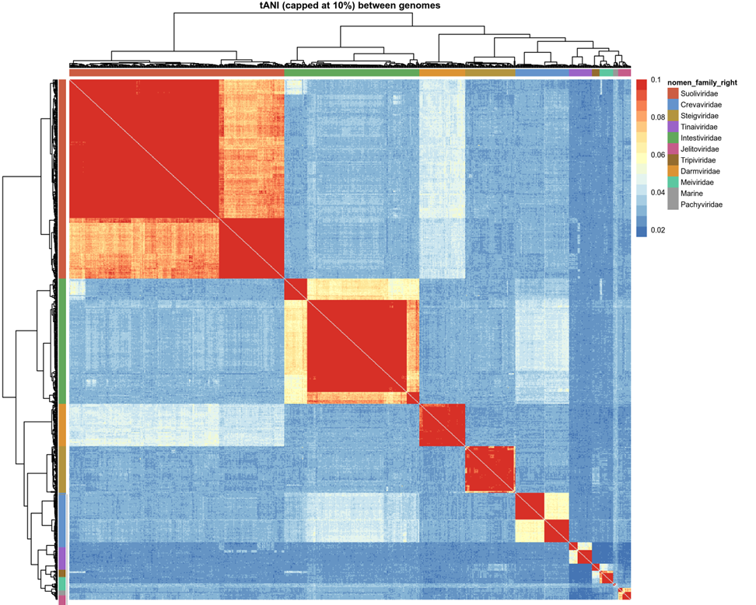

Figure 8: Heatmap of the total average nucleotide identity between families of the Crassvirales, Paracrassvirales and Metacrassvirales. Values above 10% are set to 10%, as including higher values reduces visual granularity and obscures key patterns. The heatmap was visualized using Tidyheatmaps and hierarchically clustered using the complete linkage method of R. Coloured bars indicate the family of each genome.
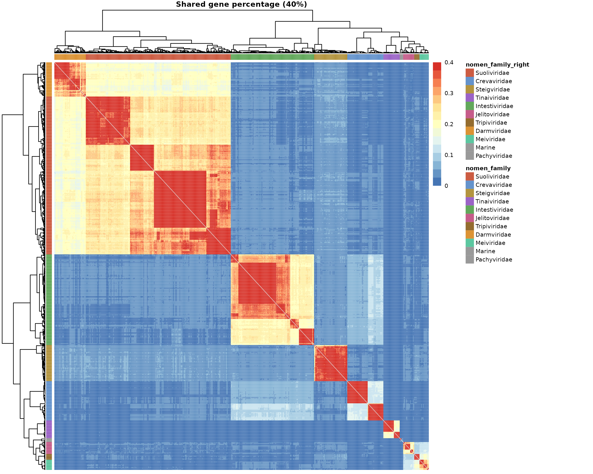

Figure 9: Heatmap of the shared protein cluster percentage between families of the Crassvirales, Paracrassvirales and Metacrassvirales. Values above 40% are set to 40%, as including higher values reduces visual granularity and obscures key patterns.
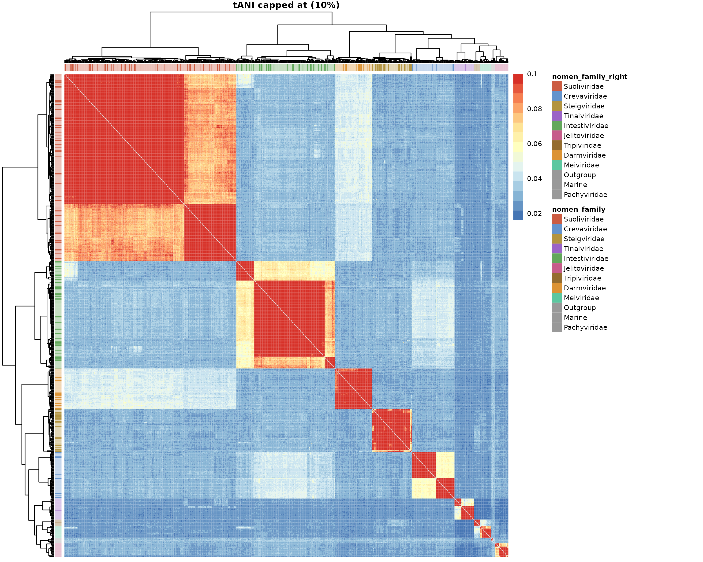

Figure 10: Heatmap of the total average nucleotide identity between families of the Crassvirales, Paracrassvirales and Metacrassvirales. Values above 10% are set to 10%, as including higher values reduces visual granularity and obscures key patterns. Sequences for which a public and annotated INSDC entry is available are highlighted.
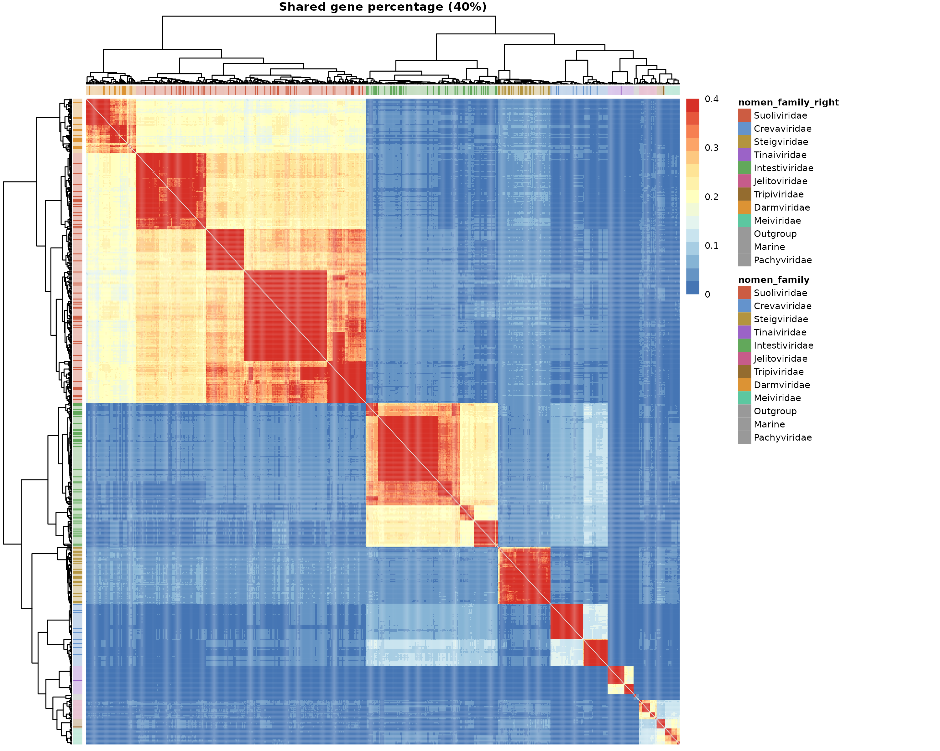

Figure 11: Heatmap of the shared protein cluster percentage between families of the Crassvirales, Paracrassvirales and Metacrassvirales. Values above 40% are set to 40%, as including higher values reduces visual granularity and obscures key patterns. Sequences for which a public and annotated INSDC entry is available are highlighted.
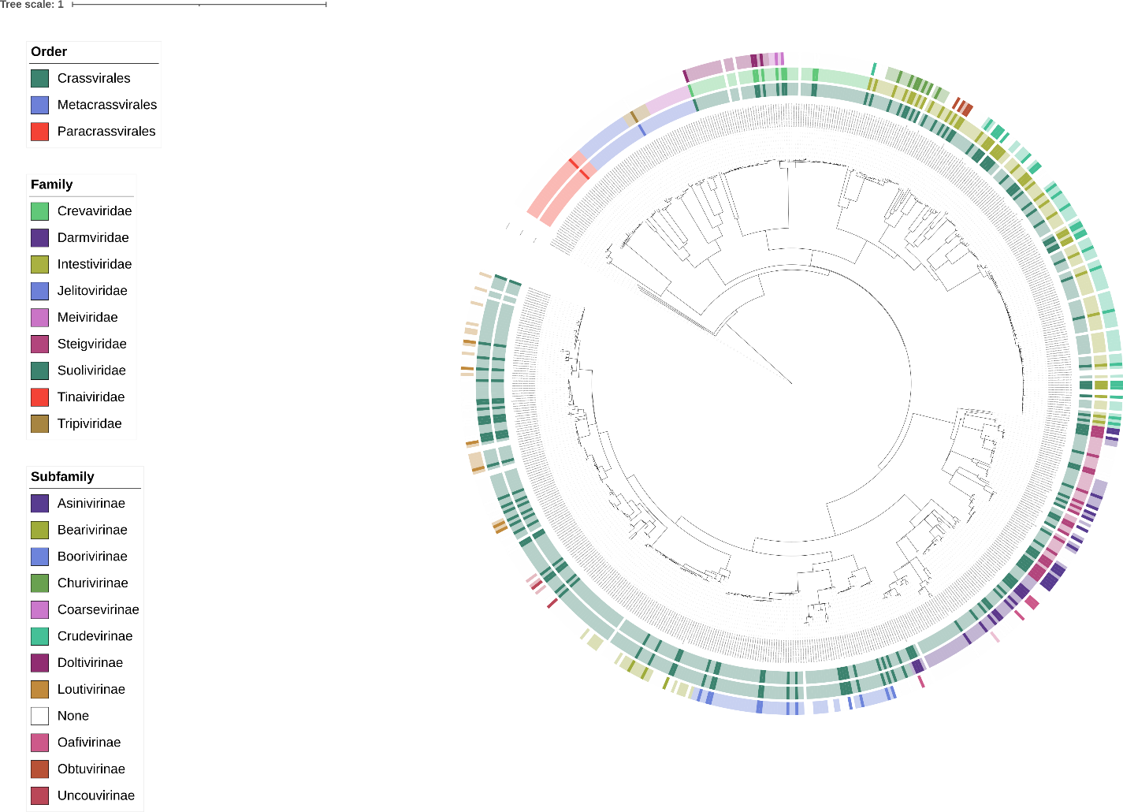

Figure 12: Core-gene phylogenetic tree of the three orders based on concatenated proteins.The inner circle represents order, the middle circle represents family and the outer circle represents subfamily. Sequences for which a public and annotated INSDC entry is available are highlighted.
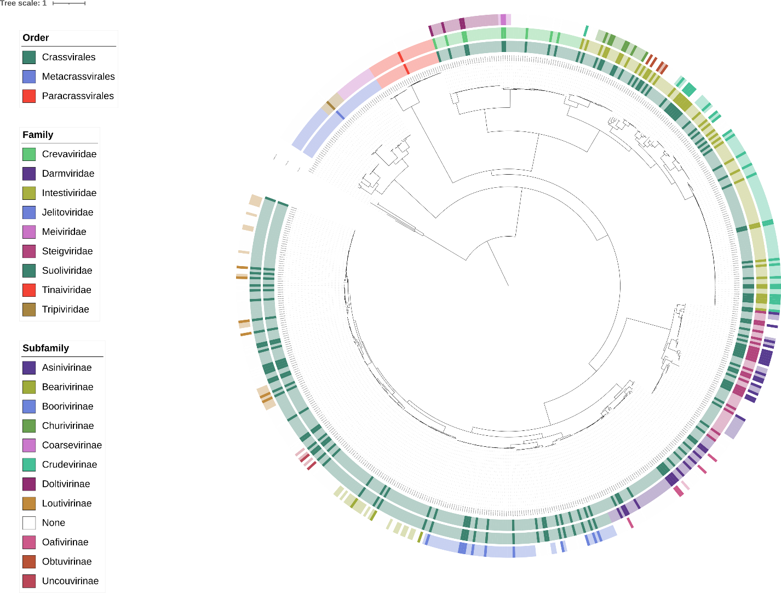

Figure 13: Core-gene structural phylogenetic species tree of the three orders based on gene trees. The inner circle represents order, the middle circle represents family and the outer circle represents subfamily. Sequences for which a public and annotated INSDC entry is available are highlighted.
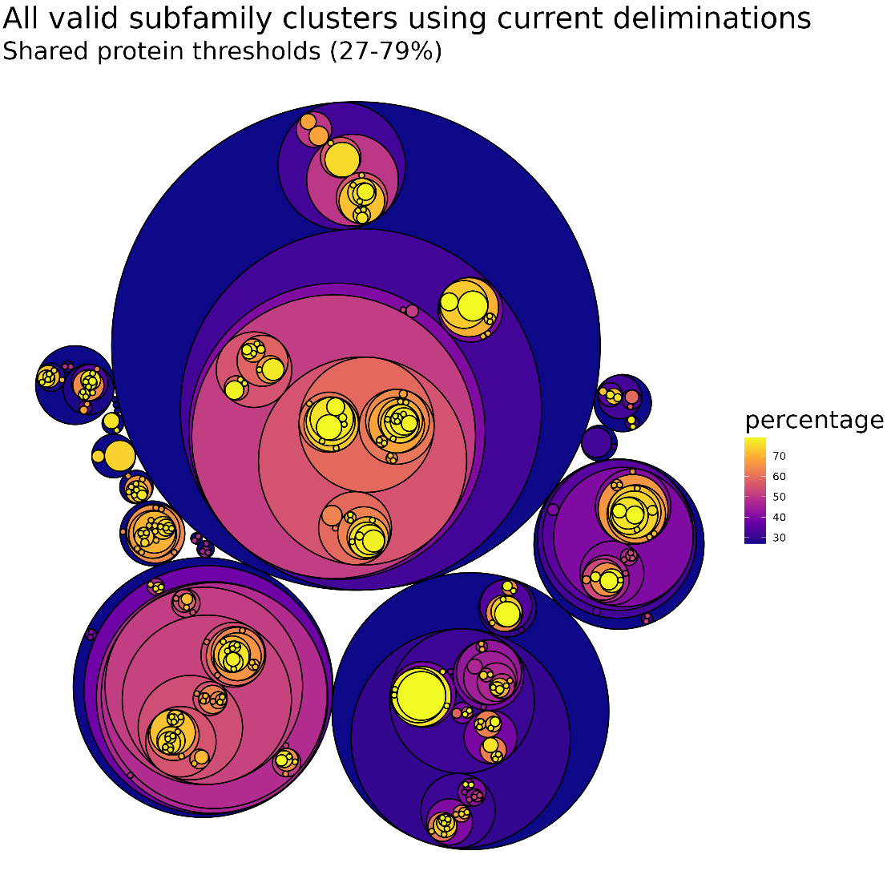
Figure 14: A circularly packed hierarchy tree of all currently possible subfamily classifications. Each circle represents a possible classification, and all circles contained within it are subsets of that classification that can classify as their own subfamily. The fill of each circle shows the minimum percentage of shared genes within the cluster. The clusters were created using Vclust and visualized using ggraph.
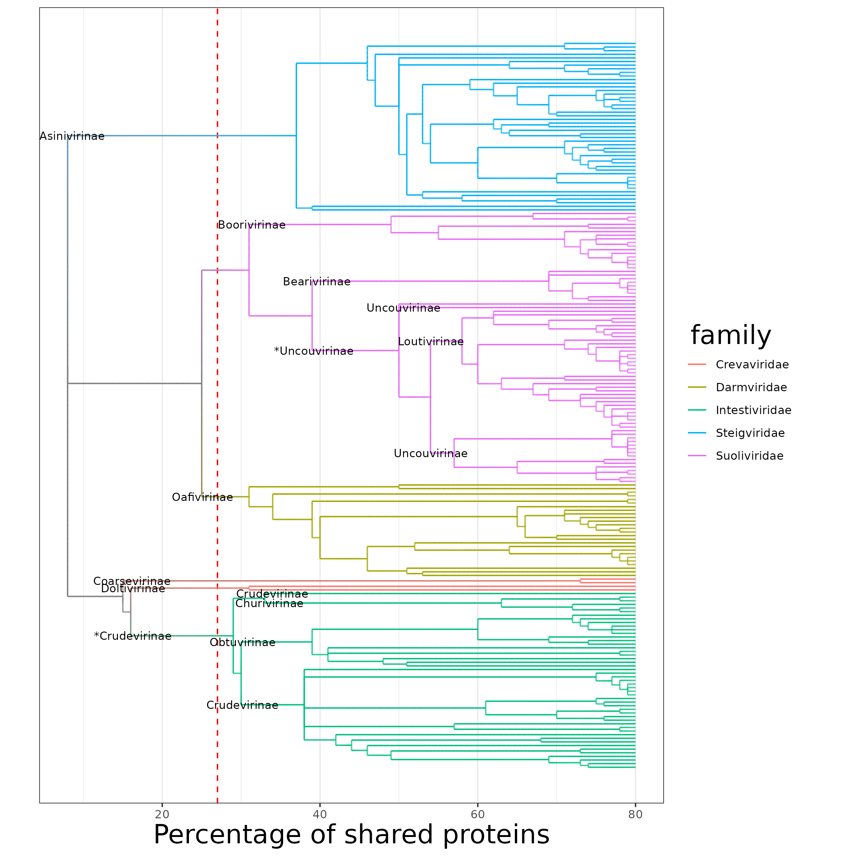
Figure 15: A hierarchical tree showing the distribution of clusters within each family of Crassvirales. Each branch represents a cluster at that percentage of shared proteins, with all branches after the red striped line (27%) representing a subfamily that could be proposed to the ICTV following the current demarcations. Branches are coloured if only members of that family are within it. Names are placed on nodes if only members of that subfamily are within that node and all its branches, and names with an asterisk (*) represent at which node a subfamily should be placed to contain all its currently known members.
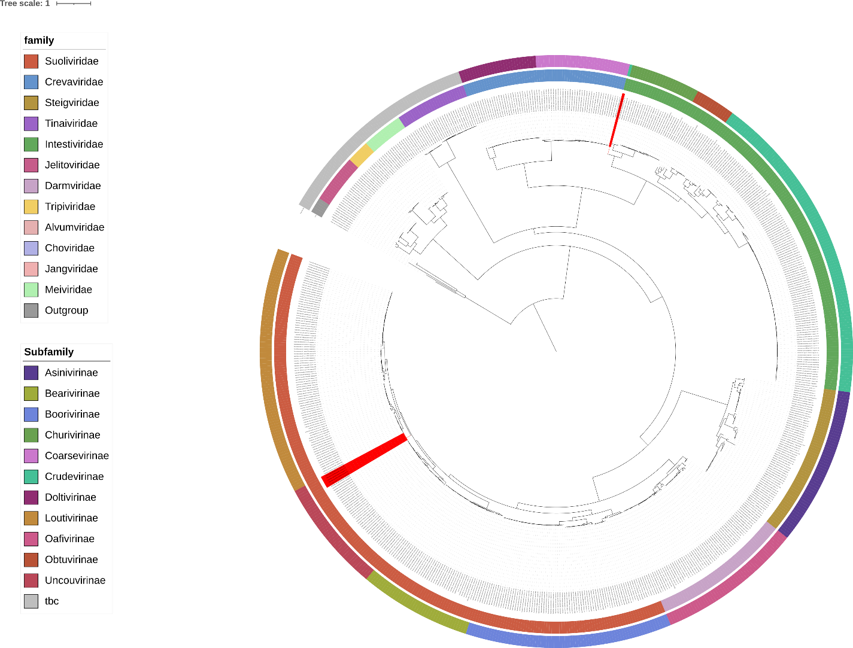

Figure 16: Core-gene phylogenetic species tree based on concatenated protein tree of the three orders, the inner coloured ring showing family and the outer coloured ring showing subfamily. Clades coloured in red do not correspond to phylogeny.
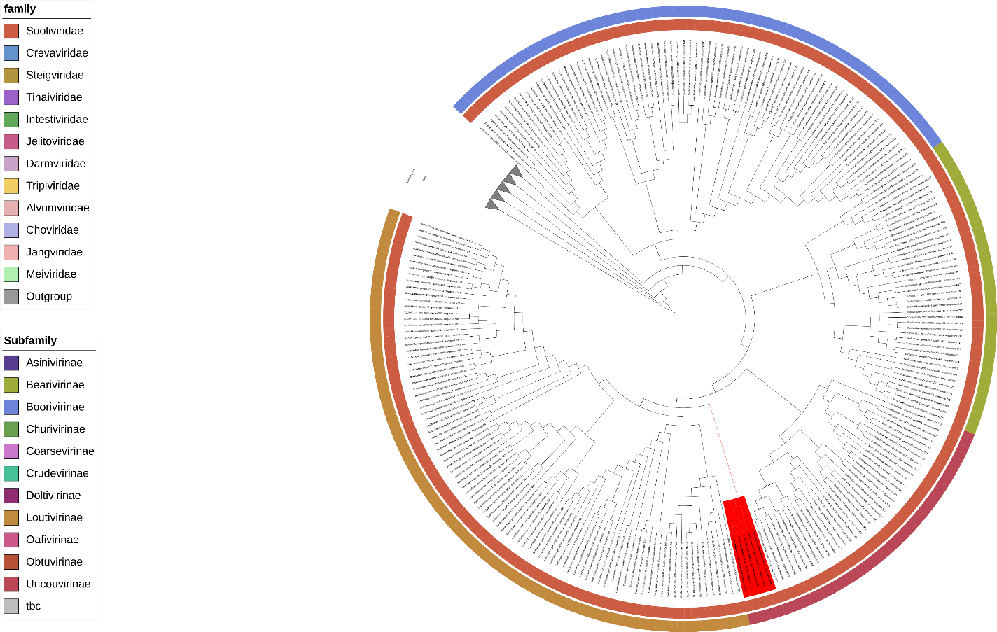

Figure 17: Core-gene structural phylogenetic species tree of the Suoliviridae, the inner coloured ring showing family and the outer coloured ring showing subfamily. Clades coloured in red are not coherent with phylogeny. Branch lengths have been removed for readability.

