

The International Committee on Taxonomy of Viruses
Taxonomy Proposal Form, 2025

Part 1a: Details of taxonomy proposals

Title: | Create a new family, Hirszfeldviridae, with 22 genera, Nosocomialisvirus, Beijingvirus, Guangzhouvirus, Chinavirus, Pittiivirus, Obolenskvirus, Ganjingzivirus, Guizhouvirus, Brutusvirus, Walailakvirus, Scipiovirus, Wenzhouvirus, Burnvirus, Ankaravirus, Polandvirus, Kenyavirus, Cairovirus, Helsinkivirus, Sichuanvirus, Pakistanvirus, Catovirus, and Theraphagusvirus, for a group of Acinetobacter-specific phages (class Caudoviricetes)
Code assigned: | 2025.054B.Hirszfeldviridae_1nf_21ng_1mg_5mrs_46ns

Author(s), affiliation and email address(es):
Given name (+middle initial(s)) | Surname | Affiliation | Email address | Corresponding author(s)
Michał J. | Wójcicki | Bacteriophage Laboratory, Department of Phage Therapy, Hirszfeld Institute of Immunology and Experimental Therapy, Polish Academy of Sciences, Wroclaw, Poland | michal.wojcicki@hirszfeld.pl | X
Dann | Turner | School of Applied Sciences, University of the West of England, Bristol, UK | dann2.turner@uwe.ac.uk
Martyna A. | Cieślik | Bacteriophage Laboratory, Department of Phage Therapy, Hirszfeld Institute of Immunology and Experimental Therapy, Polish Academy of Sciences, Wroclaw, Poland | martyna.cieslik@hirszfeld.pl
Edyta | Pawlak | Laboratory of Immunopathology, Department of Experimental Therapy, Hirszfeld Institute of Immunology and Experimental Therapy, Polish Academy of Sciences, Wroclaw, Poland | edyta.pawlak@hirszfeld.pl
Andrzej | Górski | Bacteriophage Laboratory, Department of Phage Therapy, Hirszfeld Institute of Immunology and Experimental Therapy, Polish Academy of Sciences, Wroclaw, Poland | andrzej.gorski@hirszfeld.pl
Ewa M. | Jończyk-Matysiak | Bacteriophage Laboratory, Department of Phage Therapy, Hirszfeld Institute of Immunology and Experimental Therapy, Polish Academy of Sciences, Wroclaw, Poland | ewa.jonczyk-matysiak@hirszfeld.pl
Part 1b: Taxonomy Proposal Submission
ICTV Subcommittee:
Animal DNA Viruses and Retroviruses |  | Bacterial viruses | X
Animal minus-strand and dsRNA viruses |  | Fungal and protist viruses
Animal positive-strand RNA viruses |  | Plant viruses
Archaeal viruses |  | General

List the ICTV Study Group(s) that have seen or have been involved in creating this proposal:
Caudoviricetes Study Group
Optional – complete only if formally voted on by an ICTV Study Group:
Study Group | Number of members
Study Group | Votes in support | Votes against | No vote

Submission date: | 20/06/2025

Part 1c: Feedback from ICTV Executive Committee (EC) meeting
Executive Committee Meeting Decision code: | X
A – Accept
Ac – Accept subject to revision by relevant subcommittee chair. No further vote required | x
U – Accept without revision but with re-evaluation and email vote by the EC
Uc – Accept subject to revision and re-evaluation and email vote by the EC
Ud – Deferred to the next EC meeting, with an invitation to revise based on EC comments
J - Reject
W - Withdrawn

Comments from the Executive Committee:
Some of the proposed species fall below 70% genus demarcation criteria.

Part 1d: Revised Taxonomy Proposal Submission
Response of proposer:
All issues have been corrected in accordance with the suggestions.

Revision date: | 23/10/2025

Part 3: TAXONOMIC PROPOSAL

Taxonomic changes proposed:
Establish new taxon | X | Split taxon
Abolish taxon |  | Merge taxon
Move taxon | X | Promote taxon
Rename taxon |  | Demote taxon
Move and rename | X

Etymology (origin) of proposed taxonomic names:
Taxon name | Etymology of the term
Hirszfeldviridae | Family name created in honor of Prof. Ludwik Hirszfeld (b. 1884, d. 1954) – Polish physician, bacteriologist, and immunologist, the founder of the Polish School of Immunology and a new scientific discipline – seroanthropology. In 1952, he established the Institute of Immunology and Experimental Therapy of the Polish Academy of Sciences in Wrocław, where the Department of Phage Therapy and the Phage Therapy Unit are located.
Nosocomialisvirus | Genus name derived from Acinetobacter nosocomialis – the host for Acinetobacter phage XC1 – one of the representatives of this genus.
Nosocomialisvirus XC1 | Species name derived from the phage name in the GenBank database – Acinetobacter phage XC1.
Nosocomialisvirus QH4 | Species name derived from the phage name in the GenBank database – Acinetobacter phage vB_Aba_QH4.
Beijingvirus | Genus name derived from Beijing – the capital city of China, where the Acinetobacter phage vB_AbaM_IME284, the only representative of this genus, was isolated.
Beijingvirus IME284 | Species name derived from the phage name in the GenBank database – Acinetobacter phage vB_AbaM_IME284.
Guangzhouvirus | Genus name derived from Guangzhou – the capital and largest city of the Guangdong province in southern China, where the Acinetobacter phage vB_AbaM_AB3P2, the only representative of this genus, was isolated.
Guangzhouvirus AB3P2 | Species name derived from the phage name in the GenBank database – Acinetobacter phage vB_AbaM_AB3P2.
Chinavirus | Genus name derived from China, where the Acinetobacter phage BUCT628, the only representative of this genus, was isolated.
Chinavirus BUCT628 | Species name derived from the phage name in the GenBank database – Acinetobacter phage BUCT628.
Pittiivirus | Genus name derived from Acinetobacter pittii – the host for Acinetobacter phage vB_ApiM_IME-Ap7 – one of the representatives of this genus.
Pittiivirus IMEAp7 | Species name derived from the phage name in the GenBank database – Acinetobacter phage vB_ApiM_IME-Ap7.
Obolenskvirus A8321 | Species name derived from the phage name in the GenBank database – Acinetobacter phage A832.1.
Obolenskvirus R2919 | Species name derived from the phage name in the GenBank database – Acinetobacter phage Bphi-R2919.
Obolenskvirus R1888 | Species name derived from the phage name in the GenBank database – Acinetobacter phage Bphi-R1888.
Obolenskvirus IME285 | Species name derived from the phage name in the GenBank database – Acinetobacter phage vB_AbaM_IME285.
Ganjingzivirus | Genus name derived from Ganjingzi – one of the seven districts of Dalian, Liaoning province (China), where the Acinetobacter phage vB_AbaM_BP10, the only representative of this genus, was isolated.
Ganjingzivirus BP10 | Species name derived from the phage name in the GenBank database – Acinetobacter phage vB_AbaM_BP10.
Guizhouvirus | Genus name derived from Guizhou – an inland province in Southwestern China, where the Acinetobacter phage Abp95, the only representative of this genus, was isolated.
Guizhouvirus Abp95 | Species name derived from the phage name in the GenBank database – Acinetobacter phage Abp95.
Brutusvirus | Genus name derived from Acinetobacter phage Brutus, the only representative of this genus.
Brutusvirus Brutus | Species name derived from the phage name in the GenBank database – Acinetobacter phage Brutus.
Walailakvirus | Genus name derived from Walailak University (Thailand), where the Acinetobacter phage vB_AbM_WUPSU, the only representative of this genus, was isolated.
Walailakvirus WUPSU | Species name derived from the phage name in the GenBank database – Acinetobacter phage vB_AbM_WUPSU.
Scipiovirus | Genus name derived from Acinetobacter phage Scipio, the only representative of this genus.
Scipiovirus Scipio | Species name derived from the phage name in the GenBank database – Acinetobacter phage Scipio.
Wenzhouvirus | Genus name derived from the Institute of Biomedical Informatics/Zhejiang Provincial Key Laboratory of Medical Genetics, Wenzhou Medical College, where the Acinetobacter phage AB1, the one of representatives of this genus, was isolated.
Wenzhouvirus AB1 | Species name derived from the phage name in the GenBank database – Acinetobacter phage AB1 (move from Obolenskvirus genus and rename to new genus).
Wenzhouvirus Acb75 | Species name derived from the phage name in the GenBank database – Acinetobacter phage VB_AB_Acb75.
Burnvirus | Genus name derived from the Southwest Hospital, Third Military Medical University, Institute of Burn Research, where the Acinetobacter phage AbP2, the one of representatives of this genus, was isolated.
Burnvirus AbP2 | Species name derived from the phage name in the GenBank database – Acinetobacter phage AbP2 (move from Obolenskvirus genus and rename to new genus).
Burnvirus P1068 | Species name derived from the phage name in the GenBank database – Acinetobacter phage P1068.
Burnvirus Arbor | Species name derived from the phage name in the GenBank database – Acinetobacter phage Arbor.
Burnvirus MRABphi22 | Species name derived from the phage name in the GenBank database – Acinetobacter phage MRABphi22.
Burnvirus Aba01 | Species name derived from the phage name in the GenBank database – Acinetobacter phage HN_Aba_01.
Burnvirus A72 | Species name derived from the phage name in the GenBank database – Acinetobacter phage vB_AbaM_A72.
Burnvirus HZY2308 | Species name derived from the phage name in the GenBank database – Acinetobacter phage HZY2308.
Burnvirus phi1092006 | Species name derived from the phage name in the GenBank database – Acinetobacter phage phi1_092006.
Burnvirus BUCT629 | Species name derived from the phage name in the GenBank database – Acinetobacter phage BUCT629.
Burnvirus NJ02 | Species name derived from the phage name in the GenBank database – Acinetobacter phage NJ02.
Burnvirus IME512 | Species name derived from the phage name in the GenBank database – Acinetobacter phage vB_AbaM_IME512.
Ankaravirus | Genus name derived from Ankara - the capital city of Turkey, where the Acinetobacter phage Ab69, the only representative of this genus, was isolated.
Ankaravirus Ab69 | Species name derived from the phage name in the GenBank database – Acinetobacter phage Ab69.
Polandvirus | Genus name derived from Poland, where the Acinetobacter phage Acba_21, the one of representatives of this genus, was isolated.
Polandvirus Acba21 | Species name derived from the phage name in the GenBank database – Acinetobacter phage Acba_21.
Polandvirus YNAF | Species name derived from the phage name in the GenBank database – Acinetobacter phage vB_AbaM_YNAF.
Kenyavirus | Genus name derived from Kenya, where the Acinetobacter phage vB_Ab_01_KEN_01, the only representative of this genus, was isolated.
Kenyavirus 01KEN01 | Species name derived from the phage name in the GenBank database – Acinetobacter phage vB_Ab_01_KEN_01.
Cairovirus | Genus name derived from Cairo - the capital city of Egypt, where the Acinetobacter phage RM_A1 and Acinetobacter phage RM_A2, the representative of this genus, were isolated.
Cairovirus RMA1 | Species name derived from the phage name in the GenBank database – Acinetobacter phage RM_A1.
Cairovirus RMA2 | Species name derived from the phage name in the GenBank database – Acinetobacter phage RM_A2.
Helsinkivirus | Genus name derived from Helsinki - the capital city of Finland, where the Acinetobacter phage vB_AbaM_fThrA, the one of representatives of this genus, was isolated.
Helsinkivirus fThrA | Species name derived from the phage name in the GenBank database – Acinetobacter phage vB_AbaM_fThrA.
Helsinkivirus AQ1 | Species name derived from the phage name in the GenBank database – Acinetobacter phage vB_AQ1.
Sichuanvirus | Genus name derived from the Center of Infectious Diseases, West China Hospital, Sichuan University, where the Acinetobacter phage WCHABP1, the one of representatives of this genus, was isolated.
Sichuanvirus WCHABP1 | Species name derived from the phage name in the GenBank database – Acinetobacter phage WCHABP1 (move from Obolenskvirus genus and rename to new genus).
Sichuanvirus WCHABP12 | Species name derived from the phage name in the GenBank database – Acinetobacter phage WCHABP12 (move from Obolenskvirus genus and rename to new genus).
Sichuanvirus ZC3 | Species name derived from the phage name in the GenBank database – Acinetobacter phage vB_Aba_ZC3.
Sichuanvirus 02KEN02 | Species name derived from the phage name in the GenBank database – Acinetobacter phage vB_Ab_02_KEN_02.
Sichuanvirus SPA | Species name derived from the phage name in the GenBank database – Acinetobacter phage vB_AbaM-SPA.
Sichuanvirus Abp9 | Species name derived from the phage name in the GenBank database – Acinetobacter phage Abp9.
Pakistanvirus | Genus name derived from Pakistan, where the Acinetobacter phage SR, the only representative of this genus, was isolated.
Pakistanvirus SR | Species name derived from the phage name in the GenBank database – Acinetobacter phage SR.
Catovirus | Genus name derived from Acinetobacter phage Cato, the only representative of this genus.
Catovirus Cato | Species name derived from the phage name in the GenBank database – Acinetobacter phage Cato.
Theraphagusvirus | Genus name derived from the Greek: therapeia, meaning therapy, and phagus, meaning the one who eats (eater).
Theraphagusvirus AP22 | Species name derived from the phage name in the GenBank database – Acinetobacter phage AP22 (move from Obolenskvirus genus and rename to new genus).
Theraphagusvirus SPB | Species name derived from the phage name in the GenBank database – Acinetobacter phage vB_AbaM-SPB.

Permission for use of names derived from a living person
Taxon name | Full name of person from whom the name is derived | Attached

Abstract of Taxonomy Proposal:
Taxonomic rank(s) affected:
Family, genus, species

Description of current taxonomy:
According to the current taxonomy, the Obolenskvirus genus has been classified within the class Caudoviricetes without assignment to a family rank. Currently, the Obolenskvirus genus includes eight species: Obolenskvirus AB1, Obolenskvirus AB2, Obolenskvirus AbC62, Obolenskvirus AbP2, Obolenskvirus AP22, Obolenskvirus LZ35, Obolenskvirus WCHABP1, and Obolenskvirus WCHABP12.

Proposed taxonomic change(s):
Create a new family, Hirszfeldviridae, with 22 genera, Nosocomialisvirus, Beijingvirus, Guangzhouvirus, Chinavirus, Pittiivirus, Obolenskvirus, Ganjingzivirus, Guizhouvirus, Brutusvirus, Walailakvirus, Scipiovirus, Wenzhouvirus, Burnvirus, Ankaravirus, Polandvirus, Kenyavirus, Cairovirus, Helsinkivirus, Sichuanvirus, Pakistanvirus, Catovirus, and Theraphagusvirus, for a group of Acinetobacter-specific phages.

We performed a genomic analysis of several Acinetobacter-specific phages deposited in the NCBI database, all of which have been classified within the genus Obolenskvirus. Based on our analysis, we propose the creation of a new family for these phages along with 22 distinct genera.

- To create a new family, Hirszfeldviridae, with 22 genera.
- To create a new genus, Nosocomialisvirus, with two species.
- To create a new single species genus, Beijingvirus.
- To create a new single species genus, Guangzhouvirus.
- To create a new single species genus, Chinavirus.
- To create a new single species genus, Pittiivirus.
- To move the genus Obolenskvirus to new family, Hirszfeldviridae.
- To create four new species in genus Obolenskvirus.
- To create a new single species genus, Ganjingzivirus.
- To create a new single species genus, Guizhouvirus.
- To create a new single species genus, Brutusvirus.
- To create a new single species genus, Walailakvirus.
- To create a new single species genus, Scipiovirus.
- To move Obolenskvirus AB1 from Obolenskvirus genus and rename to new Wenzhouvirus genus with two species.
- To move Obolenskvirus AbP2 from Obolenskvirus genus and rename to new Burnvirus genus with 11 species.
- To create a new single species genus, Ankaravirus.
- To create a new genus, Polandvirus, with two species.
- To create a new single species genus, Kenyavirus.
- To create a new genus, Cairovirus, with two species.
- To create a new genus, Helsinkivirus, with two species.
- To move Obolenskvirus WCHABP1 and Obolenskvirus WCHABP12 from Obolenskvirus genus and rename to new Sichuanvirus genus with six species.
- To create a new single species genus, Pakistanvirus.
- To create a new single species genus, Catovirus.
- To move Obolenskvirus AP22 from Obolenskvirus genus and rename to new Theraphagusvirus genus with two species.

Justification:
After examination of 55 bacteriophages based on nucleotide sequence similarity, tblastx distances and core gene phylogeny, we propose the creation of a new family, Hirszfeldviridae, to accommodate 22 genera (Nosocomialisvirus, Beijingvirus, Guangzhouvirus, Chinavirus, Pittiivirus, Obolenskvirus, Ganjingzivirus, Guizhouvirus, Brutusvirus, Walailakvirus, Scipiovirus, Wenzhouvirus, Burnvirus, Ankaravirus, Polandvirus, Kenyavirus, Cairovirus, Helsinkivirus, Sichuanvirus, Pakistanvirus, Catovirus, and Theraphagusvirus).

Text of Taxonomy proposal:
Taxonomic rank(s) affected:
Family, genus, species

Description of current taxonomy:
According to the current taxonomy, the Obolenskvirus genus has been classified within the class Caudoviricetes without assignment to a family rank. Currently, the Obolenskvirus genus includes eight species: Obolenskvirus AB1, Obolenskvirus AB2, Obolenskvirus AbC62, Obolenskvirus AbP2, Obolenskvirus AP22, Obolenskvirus LZ35, Obolenskvirus WCHABP1, and Obolenskvirus WCHABP12.

Proposed taxonomic change(s):
Create a new family, Hirszfeldviridae, with 22 genera, Nosocomialisvirus, Beijingvirus, Guangzhouvirus, Chinavirus, Pittiivirus, Obolenskvirus, Ganjingzivirus, Guizhouvirus, Brutusvirus, Walailakvirus, Scipiovirus, Wenzhouvirus, Burnvirus, Ankaravirus, Polandvirus, Kenyavirus, Cairovirus, Helsinkivirus, Sichuanvirus, Pakistanvirus, Catovirus, and Theraphagusvirus, for a group of Acinetobacter-specific phages.

We performed a genomic analysis of several Acinetobacter-specific phages deposited in the NCBI database, all of which have been classified within the genus Obolenskvirus. Based on our analysis, we propose the creation of a new family for these phages along with 22 distinct genera.

- To create a new family, Hirszfeldviridae, with 22 genera.
- To create a new genus, Nosocomialisvirus, with two species.
- To create a new single species genus, Beijingvirus.
- To create a new single species genus, Guangzhouvirus.
- To create a new single species genus, Chinavirus.
- To create a new single species genus, Pittiivirus.
- To move the genus Obolenskvirus to new family, Hirszfeldviridae.
- To create four new species in genus Obolenskvirus.
- To create a new single species genus, Ganjingzivirus.
- To create a new single species genus, Guizhouvirus.
- To create a new single species genus, Brutusvirus.
- To create a new single species genus, Walailakvirus.
- To create a new single species genus, Scipiovirus.
- To move Obolenskvirus AB1 from Obolenskvirus genus and rename to new Wenzhouvirus genus with two species.
- To move Obolenskvirus AbP2 from Obolenskvirus genus and rename to new Burnvirus genus with 11 species.
- To create a new single species genus, Ankaravirus.
- To create a new genus, Polandvirus, with two species.
- To create a new single species genus, Kenyavirus.
- To create a new genus, Cairovirus, with two species.
- To create a new genus, Helsinkivirus, with two species.
- To move Obolenskvirus WCHABP1 and Obolenskvirus WCHABP12 from Obolenskvirus genus and rename to new Sichuanvirus genus with six species.
- To create a new single species genus, Pakistanvirus.
- To create a new single species genus, Catovirus.
- To move Obolenskvirus AP22 from Obolenskvirus genus and rename to new Theraphagusvirus genus with two species.

Demarcation criteria:
Species demarcation criteria: Two phages are assigned to the same species if their genomes are more than 95% identical over their genome length for isolates.
These values can be calculated using several tools, such as BLASTn [1], and are typically determined with the intergenomic distance calculator VIRIDIC [2].

Genus demarcation criteria: In search for criteria that create cohesive and distinct genera that are reproducible and monophyletic, the Bacterial Viruses Subcommittee has established 70% nucleotide identity of the genome length as the cut-off for genera. Genus-level groupings should always be monophyletic in the signature genes, as tested with a phylogenetic tree [3].

Family demarcation criteria: The family is represented by a cohesive and monophyletic group in the main predicted proteome-based clustering tools (ViPTree, GRAViTy dendrogram, vConTACT2 network). Family members share a significant number of orthologous genes (the number will depend on the genome sizes and number of coding sequences of family members) [3].

Justification:
After examination of 55 bacteriophages we identified 22 genera and 46 species based on intergenomic nucleotide sequence similarity (Figure 1). The heirarchially clustered tblastx distance tree produced using ViPTree indicated that these genomes for a deep-branching clade (Figure 2). Comparison of 50 genomes with MMSeqs2 after reannotated with Pharokka resulted in the identification of 8 proteins conserved across all members of the proposed family (Figures 3 and 4).

We propose the creation of a new family, Hirszfeldviridae, to accommodate 22 genera (Nosocomialisvirus, Beijingvirus, Guangzhouvirus, Chinavirus, Pittiivirus, Obolenskvirus, Ganjingzivirus, Guizhouvirus, Brutusvirus, Walailakvirus, Scipiovirus, Wenzhouvirus, Burnvirus, Ankaravirus, Polandvirus, Kenyavirus, Cairovirus, Helsinkivirus, Sichuanvirus, Pakistanvirus, Catovirus, and Theraphagusvirus).

References:
- Sayers EW, Beck J, Bolton EE, Bourexis D, Brister JR, Canese K, Comeau DC, Funk K, Kim S, Klimke W, Marchler-Bauer A, Landrum M, Lathrop S, Lu Z, Madden TL, O'Leary N, Phan L, Rangwala SH, Schneider VA, Skripchenko Y, Wang J, Ye J, Trawick BW, Pruitt KD, Sherry ST. Database resources of the National Center for Biotechnology Information. Nucleic Acids Res. 2021, 49(D1):D10-D17.
- Moraru C, Varsani A, Kropinski AM. VIRIDIC - a novel tool to calculate the intergenomic similarities of prokaryote-infecting viruses. Viruses 2020, 12(11):1268.
- Turner D, Kropinski AM, Adriaenssens EM. A roadmap for genome-based phage taxonomy. Viruses 2021, 13(3):506.
- Nishimura Y, Yoshida T, Kuronishi M, Uehara H, Ogata H, Goto S. ViPTree: the viral proteomic tree server. Bioinformatics 2017, 33(15):2379-2380.
- Rohwer F, Edwards R. The Phage Proteomic Tree: a genome-based taxonomy for phage. J. Bacteriol. 2002, 184(16):4529-35.
- Turner D, Reynolds D, Seto D, Mahadevan P. CoreGenes3.5: a webserver for the determination of core genes from sets of viral and small bacterial genomes. BMC Res. Notes. 2013, 6:140.

Accompanying files:
Filename | Description of contents
2025.054B.Hirszfeldviridae_1nf_21ng_1mg_5mrs_46ns.xlsx | To present the proposed taxonomic changes as a comparison of new taxonomic structures.

Tables, Figures:

Proposals data:

- To create a new family, Hirszfeldviridae, with 22 genera.
- To create a new genus, Nosocomialisvirus, with two species.
- To create a new single species genus, Beijingvirus.
- To create a new single species genus, Guangzhouvirus.
- To create a new single species genus, Chinavirus.
- To create a new single species genus, Pittiivirus.
- To move the genus Obolenskvirus to new family, Hirszfeldviridae.
- To create four new species in genus Obolenskvirus.
- To create a new single species genus, Ganjingzivirus.
- To create a new single species genus, Guizhouvirus.
- To create a new single species genus, Brutusvirus.
- To create a new single species genus, Walailakvirus.
- To create a new single species genus, Scipiovirus.
- To move Obolenskvirus AB1 from Obolenskvirus genus and rename to new Wenzhouvirus genus with two species.
- To move Obolenskvirus AbP2 from Obolenskvirus genus and rename to new Burnvirus genus with 11 species.
- To create a new single species genus, Ankaravirus.
- To create a new genus, Polandvirus, with two species.
- To create a new single species genus, Kenyavirus.
- To create a new genus, Cairovirus, with two species.
- To create a new genus, Helsinkivirus, with two species.
- To move Obolenskvirus WCHABP1 and Obolenskvirus WCHABP12 from Obolenskvirus genus and rename to new Sichuanvirus genus with six species.
- To create a new single species genus, Pakistanvirus.
- To create a new single species genus, Catovirus.
- To move Obolenskvirus AP22 from Obolenskvirus genus and rename to new Theraphagusvirus genus with two species.

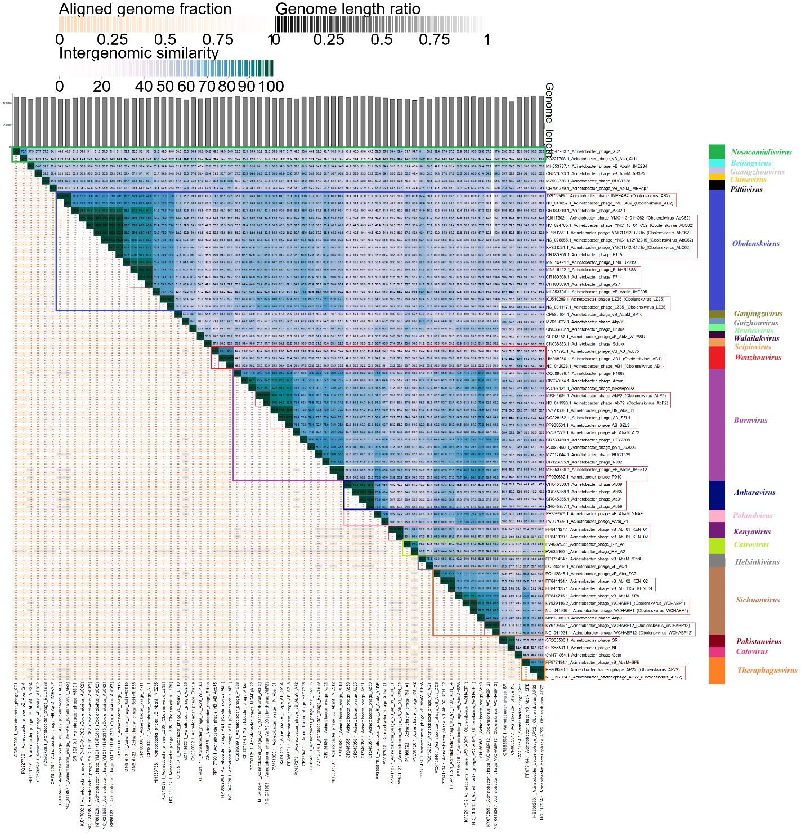

Figure 1. VIRIDIC heat map: VIRIDIC (Virus Intergenomic Distance Calculator [2]; http://rhea.icbm.uni-oldenburg.de/VIRIDIC/) computes pairwise intergenomic distances/similarities amongst phage genomes. Phages belonging to the same species (nucleotide similarity above 95%) are marked with a red thin frame.

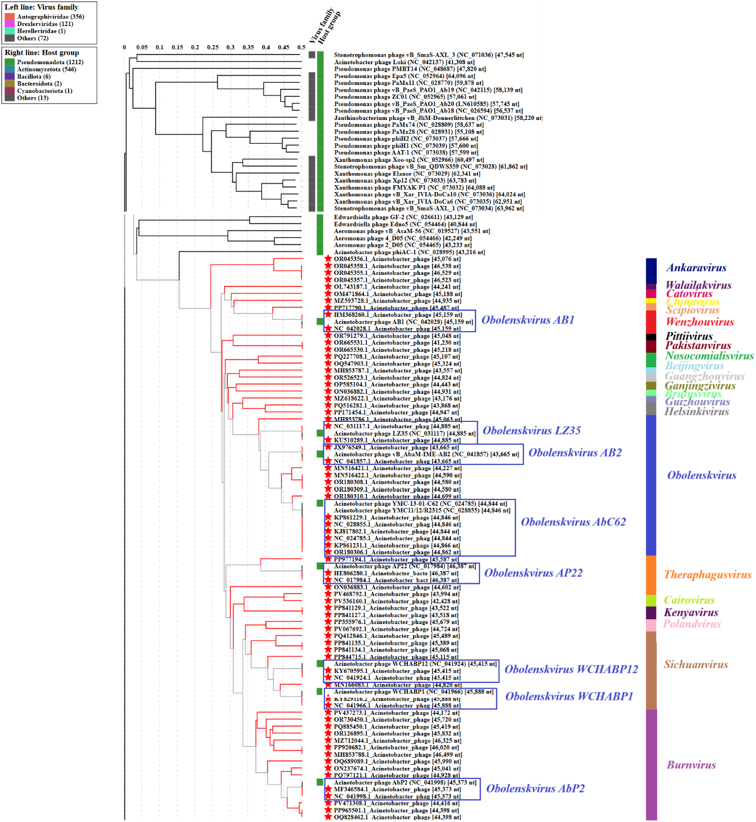

Figure 2. ViPTree analysis*: ViPTree analysis (https://www.genome.jp/viptree/; [4]) is based upon Rohwer and Edwards (2002) Phage Proteomic Tree [5]. The phages of interest are indicated with a red stars. Current species in the Obolenskvirus genus are marked in blue font.

* The Autographiviridae family shown in Figure 2 (automatically labeled by the software) is outdated. In 2025, the Autographiviridae family was elevated to the rank of order and renamed Autographivirales.

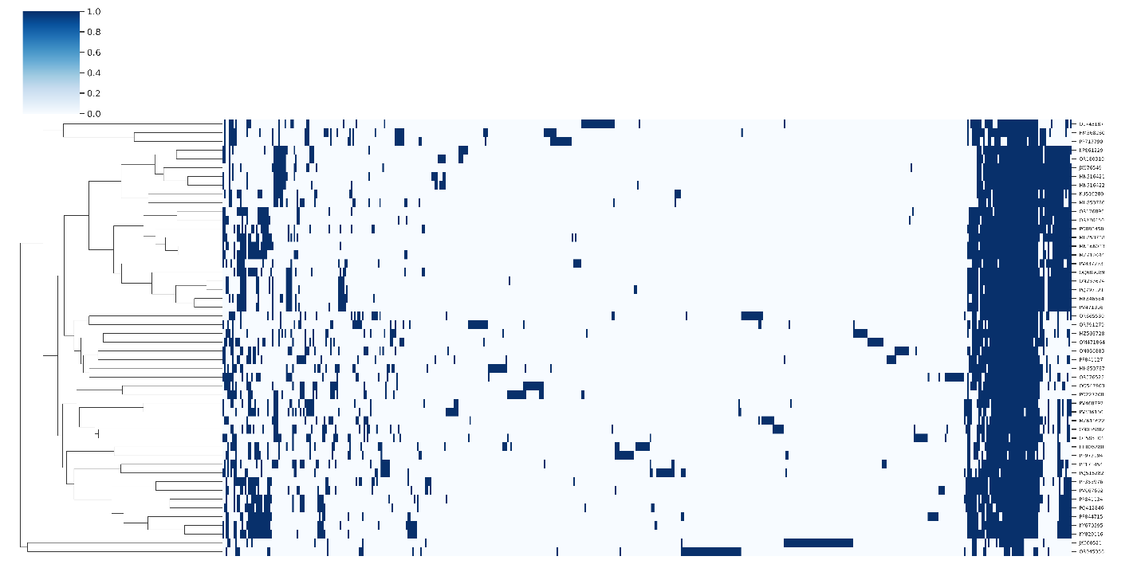
Figure 3. Presence-absence matrix of protein clusters by genome. Rows and columns were heirarchically clustered using the complete method. Rows represent individual genomes with columns representing protein clusters. Vertical blue bars denote the presence of protein clusters in each genome.

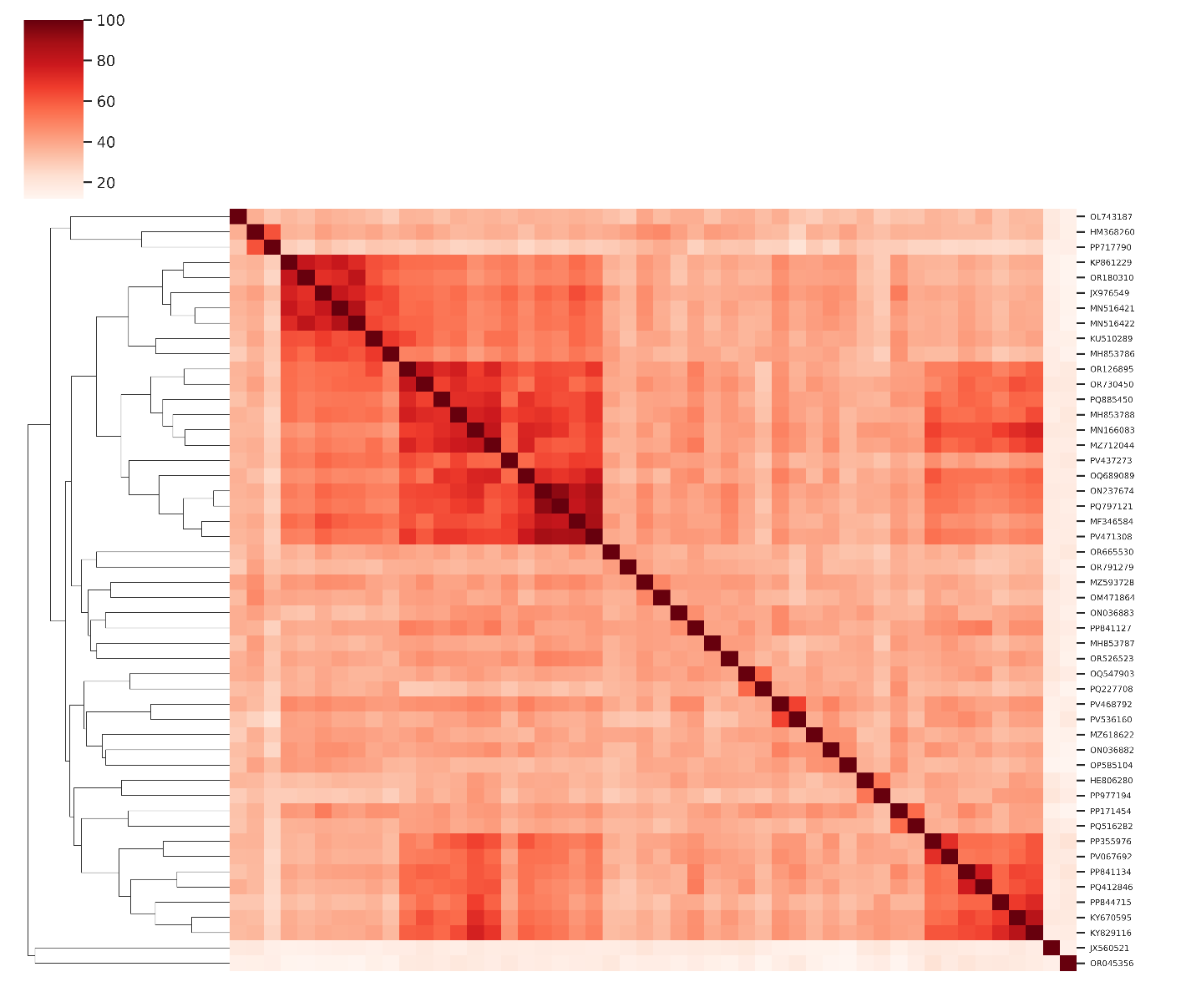
Figure 4. Heatmap of Jaccard similarity calculated from the percentage of shared protein clusters between genomes. PV067699 is included as an outlier.

Table 1. Conserved proteins in the family Hirszfeldviridae.
Protein cluster | Putative function
1 | Baseplate hub protein
2 | Baseplate wedge subunit
3 | Structural protein
4 | Baseplate spike protein
5 | Hypothetical protein
6 | Virion structural protein
7 | Baseplate wedge subunit
8 | Hypothetical protein

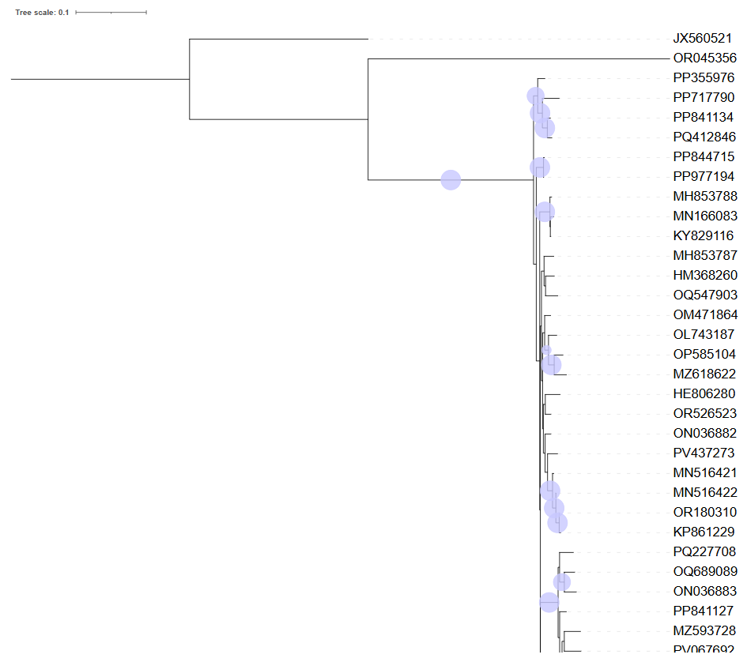Figure 5. Partition maximum likelihood phylogeny of the eight conserved proteins, inferred with IQTree2. The circles represent UFBoot support of ≥95%.

- To create a new family, Hirszfeldviridae, with 22 genera.

After examination of 55 bacteriophages based on nucleotide sequence similarity, tblastx distances and core gene phylogeny, we propose the creation of a new family, Hirszfeldviridae, to accommodate 22 genera; Nosocomialisvirus, Beijingvirus, Guangzhouvirus, Chinavirus, Pittiivirus, Obolenskvirus, Ganjingzivirus, Guizhouvirus, Brutusvirus, Walailakvirus, Scipiovirus, Wenzhouvirus, Burnvirus, Ankaravirus, Polandvirus, Kenyavirus, Cairovirus, Helsinkivirus, Sichuanvirus, Pakistanvirus, Catovirus, and Theraphagusvirus.

- To create a new genus, Nosocomialisvirus, with two species.

Genome summary:

Phage name | RefSeq No. | INSDC | Size (bp) | GC% | Protein | Overall % DNA sequence identity (*) | Overall % homologous proteins (**)
Acinetobacter phage XC1 (selected as the reference genome) | OQ547903.1 | OQ547903 | 45,324 | 37.4 | 84 | 100.0 | 100.00
Acinetobacter phage vB_Aba_QH4 |  | PQ227708 | 45,107 | 37.3 | 84 | 73.7 | 80.95
(*) determined using VIRIDIC [2]
(**) determined using CoreGenes 3.5 [6]

- To create a new single species genus, Beijingvirus.

Genome summary:

Phage name | RefSeq No. | INSDC | Size (bp) | GC% | Protein | Overall % DNA sequence identity (*) | Overall % homologous proteins (**)
Acinetobacter phage vB_AbaM_IME284 |  | MH853787 | 43,557 | 38.3 | 84 | 100.0 | 100.0
(*) determined using VIRIDIC [2]
(**) determined using CoreGenes 3.5 [6]

- To create a new single species genus, Guangzhouvirus.

Genome summary:

Phage name | RefSeq No. | INSDC | Size (bp) | GC% | Protein | Overall % DNA sequence identity (*) | Overall % homologous proteins (**)
Acinetobacter phage vB_AbaM_AB3P2 |  | OR526523 | 44,824 | 37.8 | 94 | 100.0 | 100.0
(*) determined using VIRIDIC [2]
(**) determined using CoreGenes 3.5 [6]

- To create a new single species genus, Chinavirus.

Genome summary:

Phage name | RefSeq No. | INSDC | Size (bp) | GC% | Protein | Overall % DNA sequence identity (*) | Overall % homologous proteins (**)
Acinetobacter phage BUCT628 |  | MZ593728 | 44,935 | 37.5 | 86 | 100.0 | 100.0
(*) determined using VIRIDIC [2]
(**) determined using CoreGenes 3.5 [6]

- To create a new single species genus, Pittiivirus.

Genome summary:

Phage name | RefSeq No. | INSDC | Size (bp) | GC% | Protein | Overall % DNA sequence identity (*) | Overall % homologous proteins (**)
Acinetobacter phage vB_ApiM_IME-Ap7 |  | OR791279 | 45,048 | 37.9 | 92 | 100.0 | 100.0
(*) determined using VIRIDIC [2]
(**) determined using CoreGenes 3.5 [6]

- To move the genus Obolenskvirus to new family, Hirszfeldviridae.

After examining bacteriophages based on nucleotide sequence similarity, tblastx distance, and core gene phylogeny, we proposed to include the genus Obolenskvirus in a newly proposed family, Hirszfeldviridae.

- To create four new species in genus Obolenskvirus.

Genome summary:

Phage name | RefSeq No. | INSDC | Size (bp) | GC% | Protein | Overall % DNA sequence identity (*) | Overall % homologous proteins (**)
Acinetobacter phage IME-AB2  (Obolenskvirus AB2; reference genome) | JX976549.1 = NC_041857.1 | JX976549 | 43,665 | 37.5 | 82 | 100.0 | 100.00
Acinetobacter phage YMC11/12/R2315 (Obolenskvirus AbC62) | KP861229.1 = NC_028855.1 | KP861229 | 44,846 | 37.6 | 85 | 79.5 | 90.24
Acinetobacter phage LZ35 (Obolenskvirus LZ35) | KU510289.1 = NC_031117.1 | KU510289 | 44,885 | 37.9 | 83 | 77.5 | 86.59
Acinetobacter phage A832.1 |  | OR180310 | 44,699 | 37.8 | 86 | 78.6 | 90.24
Acinetobacter phage Bphi-R2919 |  | MN516421 | 44,227 | 37.8 | 80 | 81.8 | 90.24
Acinetobacter phage Bphi-R1888 |  | MN516422 | 44,590 | 37.9 | 78 | 80.6 | 85.37
Acinetobacter phage vB_AbaM_IME285 |  | MH853786 | 45,063 | 37.9 | 85 | 74.7 | 87.80
(*) determined using VIRIDIC [2]
(**) determined using CoreGenes 3.5 [6]

- To create a new single species genus, Ganjingzivirus.

Genome summary:

Phage name | RefSeq No. | INSDC | Size (bp) | GC% | Protein | Overall % DNA sequence identity (*) | Overall % homologous proteins (**)
Acinetobacter phage vB_AbaM_BP10 |  | OP585104 | 44,443 | 37.3 | 88 | 100.0 | 100.0
(*) determined using VIRIDIC [2]
(**) determined using CoreGenes 3.5 [6]

- To create a new single species genus, Guizhouvirus.

Genome summary:

Phage name | RefSeq No. | INSDC | Size (bp) | GC% | Protein | Overall % DNA sequence identity (*) | Overall % homologous proteins (**)
Acinetobacter phage Abp95 |  | MZ618622 | 43,176 | 37.8 | 57 | 100.0 | 100.0
(*) determined using VIRIDIC [2]
(**) determined using CoreGenes 3.5 [6]

- To create a new single species genus, Brutusvirus.

Genome summary:

Phage name | RefSeq No. | INSDC | Size (bp) | GC% | Protein | Overall % DNA sequence identity (*) | Overall % homologous proteins (**)
Acinetobacter phage Brutus |  | ON036882 | 44,931 | 37.4 | 86 | 100.0 | 100.0
(*) determined using VIRIDIC [2]
(**) determined using CoreGenes 3.5 [6]

- To create a new single species genus, Walailakvirus.

Genome summary:

Phage name | RefSeq No. | INSDC | Size (bp) | GC% | Protein | Overall % DNA sequence identity (*) | Overall % homologous proteins (**)
Acinetobacter phage vB_AbM_WUPSU |  | OL743187 | 44,241 | 37.2 | 83 | 100.0 | 100.0
(*) determined using VIRIDIC [2]
(**) determined using CoreGenes 3.5 [6]

- To create a new single species genus, Scipiovirus.

Genome summary:

Phage name | RefSeq No. | INSDC | Size (bp) | GC% | Protein | Overall % DNA sequence identity (*) | Overall % homologous proteins (**)
Acinetobacter phage Scipio |  | ON036883 | 44,602 | 37.6 | 81 | 100.0 | 100.0
(*) determined using VIRIDIC [2]
(**) determined using CoreGenes 3.5 [6]

- To move Obolenskvirus AB1 from Obolenskvirus genus and rename to new Wenzhouvirus genus with two species.

Genome summary:

Phage name | RefSeq No. | INSDC | Size (bp) | GC% | Protein | Overall % DNA sequence identity (*) | Overall % homologous proteins (**)
Acinetobacter phage AB1 (selected as the reference genome) | HM368260.1 = NC_042028.1 | HM368260 | 45,159 | 37.7 | 85 | 100.0 | 100.00
Acinetobacter phage VB_AB_Acb75 |  | PP717790 | 45,487 | 38.0 | 42 | 84.1 | 47.06
(*) determined using VIRIDIC [2]
(**) determined using CoreGenes 3.5 [6]

- To move Obolenskvirus AbP2 from Obolenskvirus genus and rename to new Burnvirus genus with 11 species.

Genome summary:

Phage name | RefSeq No. | INSDC | Size (bp) | GC% | Protein | Overall % DNA sequence identity (*) | Overall % homologous proteins (**)
Acinetobacter phage AbP2 (selected as the reference genome) | MF346584.1 = NC_041998.1 | MF346584 | 45,373 | 37.8 | 88 | 100.0 | 100.0
Acinetobacter phage P1068 |  | OQ689089 | 45,990 | 37.4 | 102 | 79.0 | 88.64
Acinetobacter phage Arbor |  | ON237674 | 45,041 | 37.4 | 83 | 83.8 | 88.64
Acinetobacter phage MRABphi22 |  | PQ797121 | 44,928 | 37.9 | 83 | 88.7 | 88.64
Acinetobacter phage HN_Aba_01 |  | PV471308 | 44,416 | 37.9 | 85 | 90.9 | 94.32
Acinetobacter phage vB_AbaM_A72 |  | PV437273 | 44,172 | 37.7 | 90 | 78.4 | 81.82
Acinetobacter phage HZY2308 |  | OR730450 | 45,720 | 37.9 | 87 | 68.4 | 80.68
Acinetobacter phage phi1_092006 |  | PQ885450 | 45,419 | 37.6 | 101 | 76.5 | 85.23
Acinetobacter phage BUCT629 |  | MZ712044 | 46,325 | 37.6 | 89 | 70.8 | 81.82
Acinetobacter phage NJ02 |  | OR126895 | 45,832 | 37.9 | 86 | 74.6 | 82.95
Acinetobacter phage vB_AbaM_IME512 |  | MH853788 | 46,499 | 37.6 | 91 | 71.6 | 86.36
(*) determined using VIRIDIC [2]
(**) determined using CoreGenes 3.5 [6]

- To create a new single species genus, Ankaravirus.

Genome summary:

Phage name | RefSeq No. | INSDC | Size (bp) | GC% | Protein | Overall % DNA sequence identity (*) | Overall % homologous proteins (**)
Acinetobacter phage Ab69 |  | OR045356 | 45,076 | 38.0 | 159 | 100.0 | 100.0
(*) determined using VIRIDIC [2]
(**) determined using CoreGenes 3.5 [6]

- To create a new genus, Polandvirus, with two species.

Genome summary:

Phage name | RefSeq No. | INSDC | Size (bp) | GC% | Protein | Overall % DNA sequence identity (*) | Overall % homologous proteins (**)
Acinetobacter phage Acba_21 (selected as the reference genome) | PV067692.1 | PV067692 | 44,724 | 37.8 | 85 | 100.0 | 100.00
Acinetobacter phage vB_AbaM_YNAF |  | PP355976 | 45,379 | 37.6 | 85 | 78.9 | 85.88
(*) determined using VIRIDIC [2]
(**) determined using CoreGenes 3.5 [6]

- To create a new single species genus, Kenyavirus.

Genome summary:

Phage name | RefSeq No. | INSDC | Size (bp) | GC% | Protein | Overall % DNA sequence identity (*) | Overall % homologous proteins (**)
Acinetobacter phage vB_Ab_01_KEN_01 |  | PP841127 | 43,518 | 37.8 | 91 | 100.0 | 100.0
(*) determined using VIRIDIC [2]
(**) determined using CoreGenes 3.5 [6]

- To create a new genus, Cairovirus, with two species.

Genome summary:

Phage name | RefSeq No. | INSDC | Size (bp) | GC% | Protein | Overall % DNA sequence identity (*) | Overall % homologous proteins (**)
Acinetobacter phage RM_A1 (selected as the reference genome) | PV468792.1 | PV468792 | 43,994 | 38.0 | 84 | 100.0 | 100.00
Acinetobacter phage RM_A2 |  | PV536160 | 42,428 | 37.8 | 84 | 86.0 | 89.29
(*) determined using VIRIDIC [2]
(**) determined using CoreGenes 3.5 [6]

- To create a new genus, Helsinkivirus, with two species.

Genome summary:

Phage name | RefSeq No. | INSDC | Size (bp) | GC% | Protein | Overall % DNA sequence identity (*) | Overall % homologous proteins (**)
Acinetobacter phage vB_AbaM_fThrA (selected as the reference genome) | PP171454.1 | PP171454 | 44,947 | 37.6 | 98 | 100.0 | 100.00
Acinetobacter phage vB_AQ1 |  | PQ516282 | 43,868 | 37.4 | 103 | 75.6 | 78.57
(*) determined using VIRIDIC [2]
(**) determined using CoreGenes 3.5 [6]

- To move Obolenskvirus WCHABP1 and Obolenskvirus WCHABP12 from Obolenskvirus genus and rename to new Sichuanvirus genus with six species.

Genome summary:

Phage name | RefSeq No. | INSDC | Size (bp) | GC% | Protein | Overall % DNA sequence identity (*) | Overall % homologous proteins (**)
Acinetobacter phage WCHABP1 (selected as the reference genome) | KY829116.2 = NC_041966.1 | KY829116 | 45,888 | 37.6 | 89 | 100.0 | 100.00
Acinetobacter phage WCHABP12 | KY670595.1 = NC_041924.1 | KY670595 | 45,415 | 37.6 | 88 | 85.5 | 94.38
Acinetobacter phage vB_Aba_ZC3 |  | PQ412846 | 45,489 | 37.3 | 88 | 72.1 | 84.27
Acinetobacter phage vB_Ab_02_KEN_02 |  | PP841134 | 45,068 | 37.7 | 90 | 72.0 | 82.02
Acinetobacter phage vB_AbaM-SPA |  | PP844715 | 45,115 | 37.4 | 70 | 89.0 | 75.28
Acinetobacter phage Abp9 |  | MN166083 | 44,820 | 37.7 | 81 | 87.0 | 83.15
(*) determined using VIRIDIC [2]
(**) determined using CoreGenes 3.5 [6]

- To create a new single species genus, Pakistanvirus.

Genome summary:

Phage name | RefSeq No. | INSDC | Size (bp) | GC% | Protein | Overall % DNA sequence identity (*) | Overall % homologous proteins (**)
Acinetobacter phage SR |  | OR665530 | 45,218 | 38.0 | 87 | 100.0 | 100.0
(*) determined using VIRIDIC [2]
(**) determined using CoreGenes 3.5 [6]

- To create a new single species genus, Catovirus.

Genome summary:

Phage name | RefSeq No. | INSDC | Size (bp) | GC% | Protein | Overall % DNA sequence identity (*) | Overall % homologous proteins (**)
Acinetobacter phage Cato |  | OM471864 | 45,188 | 37.4 | 85 | 100.0 | 100.0
(*) determined using VIRIDIC [2]
(**) determined using CoreGenes 3.5 [6]

- To move Obolenskvirus AP22 from Obolenskvirus genus and rename to new Theraphagusvirus genus with two species.

Genome summary:

Phage name | RefSeq No. | INSDC | Size (bp) | GC% | Protein | Overall % DNA sequence identity (*) | Overall % homologous proteins (**)
Acinetobacter bacteriophage AP22 (selected as the reference genome) | HE806280.1 = NC_017984.1 | HE806280 | 46,387 | 37.7 | 89 | 100.0 | 100.00
Acinetobacter phage vB_AbaM-SPB |  | PP977194 | 45,587 | 37.7 | 70 | 78.6 | 66.29
(*) determined using VIRIDIC [2]
(**) determined using CoreGenes 3.5 [6]

Conclusion: On the basis of DNA and protein similarity, Hirszfeldviridae is a cohesive family.

