

The International Committee on Taxonomy of Viruses
Taxonomy Proposal Form, 2025

Part 1a: Details of taxonomy proposals

Title: | Create a new family, Pituviridae, including seven new genera and eight new species (Class Caudoviricetes)
Code assigned: | 2025.061B

Author(s), affiliation and email address(es):
Given name (+middle initial(s)) | Surname | Affiliation | Email address | Corr. author(s)
Michael Angelou L. | Nada | Industrial Technology Development Institute, Department of Science and Technology, DOST Compound, Taguig, 1631, Philippines | mikeangelounada@gmail.com | X
Marel Jan G. | Joloro | Industrial Technology Development Institute, Department of Science and Technology, DOST Compound, Taguig, 1631, Philippines | mgjoloro.dostvip@gmail.com
Ruth Antoinette D. | Chin | Industrial Technology Development Institute, Department of Science and Technology, DOST Compound, Taguig, 1631, Philippines | chinruthantoinette@gmail.com
Mark Christian C. | Reterta | Industrial Technology Development Institute, Department of Science and Technology, DOST Compound, Taguig, 1631, Philippines | mcreterta@gmail.com
Janna Ysabelle O. | Casidsid | Industrial Technology Development Institute, Department of Science and Technology, DOST Compound, Taguig, 1631, Philippines | jannaysabelle28@gmail.com
Anton Roi G. | Collado | Industrial Technology Development Institute, Department of Science and Technology, DOST Compound, Taguig, 1631, Philippines | colladoantonr@gmail.com
Aubrey Joy P. | Tejada | Industrial Technology Development Institute, Department of Science and Technology, DOST Compound, Taguig, 1631, Philippines | ajptejada.dostvip@gmail.com
Sharmen C. | Berlin | Industrial Technology Development Institute, Department of Science and Technology, DOST Compound, Taguig, 1631, Philippines | scberlin@up.edu.ph
Joseph B. | Ancla | Industrial Technology Development Institute, Department of Science and Technology, DOST Compound, Taguig, 1631, Philippines | anclajoseph8492@gmail.com
Arra B. | Asejo | Industrial Technology Development Institute, Department of Science and Technology, DOST Compound, Taguig, 1631, Philippines | abasejo.dost@gmail.com
Rommel J. | Gestuveo | S&T Fellows Program, Department of Science and Technology, DOST Compound, Taguig, 1631, Philippines | rgestuveo@dost.gov.ph

Part 1b: Taxonomy Proposal Submission
ICTV Subcommittee:
Animal DNA Viruses and Retroviruses |  | Bacterial viruses | X
Animal minus-strand and dsRNA viruses |  | Fungal and protist viruses
Animal positive-strand RNA viruses |  | Plant viruses
Archaeal viruses |  | General -

List the ICTV Study Group(s) that have seen or have been involved in creating this proposal: https://ictv.global/sc
Caudoviricetes Study Group

Optional – complete only if formally voted on by an ICTV Study Group:
Study Group | Number of members
Study Group | Votes in support | Votes against | No vote

Submission date: | 30/05/2025

Part 1c: Feedback from ICTV Executive Committee (EC) meeting
Executive Committee Meeting Decision code: | X
A – Accept
Ac – Accept subject to revision by relevant subcommittee chair. No further vote required
U – Accept without revision but with re-evaluation and email vote by the EC
Uc – Accept subject to revision and re-evaluation and email vote by the EC | x
Ud – Deferred to the next EC meeting, with an invitation to revise based on EC comments
J - Reject
W - Withdrawn

Comments from the Executive Committee:
Are the middle names correctly initialed or are some of the middle names part of the first name?
E.g. is: Mark Christian C. , Reterta not Mark C., Reterta? Or Ruth Antoinette D., Chin not Ruth A. D., Chin.
Uc to give option to include more in-filing of species.

Part 1d: Revised Taxonomy Proposal Submission
Response of proposer:
All names listed in Part1a are correctly initialed. The proposed family has been expanded to include additional species and genera.

Revision date: | 01/09/2025

Part 3: TAXONOMIC PROPOSAL
https://ictv.global/taxonomy/templates
Taxonomic changes proposed:
Establish new taxon | X | Split taxon
Abolish taxon |  | Merge taxon
Move taxon |  | Promote taxon
Rename taxon |  | Demote taxon
Move and rename

Etymology (origin) of proposed taxonomic names:
Taxon name | Etymology of the term
Pituviridae | The proposed family name is derived from the acronym of the VIP Project Team 2 (P2), who first isolated and characterized Klebsiella phage vB_VIPKPNMC05
Pituvirus | The genus name is derived from the acronym of the VIP Project Team 2 (P2), who first isolated and characterized Klebsiella phage vB_VIPKPNMC05
Pituvirus akira | The species name is derived from the name of the researchers’ dog, Akira
Oxavirus | genus named is after the gene (OXA-48) that confers antibiotic resistance to its host, K. pneumoniae strain ST13-OXA48
Oxavirus ST13OXA48phi124 | species name derived from the prophage name in the GenBank database – Klebsiella phage ST13-OXA48phi12.4
Corunyavirus | genus name is derived from Coruña, a city in Spain where the phage was isolated or studied
Corunyavirus ST13OXA48phi122 | species name derived from the prophage name in the GenBank database – Klebsiella phage ST13-OXA48phi12.2
Vimivirus | genus named is after the gene (VIM-1) that confers antibiotic resistance to its host, K. pneumoniae strain ST147­VIM1
Vimivirus ST147VIM1phi72 | species name derived from the prophage name in the GenBank database – Klebsiella phage ST147-VIM1phi7.2
Vimivirus Kp48873 | species name derived from the prophage name in the GenBank database – Klebsiella phage Kp4887-3
Xubiasivirus | genus name is derived from Xubias, a small village in Spain where the phage was isolated or studied
Xubiasivirus EcoS733R5 | species name derived from the phage name in the GenBank database – Escherichia phage vB_EcoS-733R
Keypisivirus | genus named is after the gene (KPC-2) that confers antibiotic resistance to its host, K. pneumoniae strain ST101-KPC2phi6.3
Keypisivirus ST101KPC2phi63 | species name derived from the prophage name in the GenBank database – Klebsiella phage ST101-KPC2phi6.3
Samsivirus | genus name is derived from the named of the hospital (SAMS Hospital) where the phage was isolated or studied
Samsivirus Kp48802 | species name derived from the prophage name in the GenBank database – Klebsiella phage Kp4880-2

Permission for use of names derived from a living person:
Taxon name | Full name of person from whom the name is derived | Attached

Abstract of Taxonomy Proposal:
Taxonomic rank(s) affected:
Family, genus, species

Description of current taxonomy:
Klebsiella phages are currently classified in the order Autographivirales and the families Ackermannviridae, Casjensviridae, Demerecviridae, Drexlerviridae, Peduoviridae, Schitoviridae, and Straboviridae. Our taxonomic analysis revealed that Klebsiella phage vB_VIPKPNMC05 does not belong to the existing phage families, thus, remains unclassified.

Proposed taxonomic change(s):

- Create a new family, Pituviridae
- Create a new single species genus, Pituvirus
- Create a new single species genus, Oxavirus
- Create a new single species genus, Corunyavirus
- Create a new genus Vimivirus, with two species
- Create a new single species genus, Xubiasivirus
- Create a new single species genus, Keypisivirus
- Create a new single species genus, Samsivirus

Justification:

As a result of detailed genomic, proteomic, and phylogenetic analyses using VIRIDIC, ViPTree, VirClust, we propose the creation a new phage family, Pituviridae, with seven genera (Pituvirus, Oxavirus, Corunyavirus, Vimivirus, Xubiasivirus, Keypisivirus, and Samsivirus). The proposed taxa conform to the demarcation criteria employed by the ICTV Bacterial Viruses Subcommittee.

Text of Taxonomy proposal:

Taxonomic rank(s) affected:
Family, genus, species

Description of current taxonomy:
Klebsiella phages are currently classified into eight families: Ackermannviridae, Autographiviridae, Casjensviridae, Demerecviridae, Drexlerviridae, Peduoviridae, Schitoviridae, and Straboviridae. Our taxonomic analysis revealed that Klebsiella phage vB_VIPKPNMC05 does not belong to the existing phage families, thus, remains unclassified.

Proposed taxonomic change(s):

- Create a new family, Pituviridae
- Create a new single species genus, Pituvirus
- Create a new single species genus, Oxavirus
- Create a new single species genus, Corunyavirus
- Create a new genus Vimivirus, with two species
- Create a new single species genus, Xubiasivirus
- Create a new single species genus, Keypisivirus
- Create a new single species genus, Samsivirus

Demarcation criteria:

Species demarcation criteria: Two phages are assigned to the same species if their genomes are more than 95% identical over their genome length using VIRIDIC [2].

Genus demarcation criteria: In search for criteria that create cohesive and distinct genera that are reproducible and monophyletic, the Bacterial Viruses Subcommittee has established 70% nucleotide identity of the genome length as the cut-off for genera. Genus-level groupings should always be monophyletic in the signature genes, as tested with a phylogenetic tree [2].

Family demarcation criteria: Subfamilies are to be created when two or more genera are related below the family level. In practical terms, this usually means that they share a low degree of sequence similarity (usually about 40-50%) and that the genera form a clade in a marker tree phylogeny [2].

Family demarcation criteria: The family is represented by a cohesive and monophyletic group in the main predicted proteome-based clustering tools (e.g. VirClust, ViPTree, GRAViTy dendrogram, vConTACT2 network). Members of the family share a significant number of orthologous genes (the number will depend on the genome sizes and number of coding sequences of members of the family) [2].

Justification:
Klebsiella phage vB_VIPKPNMC05 were isolated from Masalasa creek, Tarlac, Philippines. Our taxonomic analysis revealed that VIPKPNMC05 does not belong to any of the existing families that include Klebsiella phages, indicating that VIPKPNMC05 represents a new species. The genome is complete with DTR based on checkV [1] analysis and is publicly available in NCBI Genbank database. Here, we propose to create a new phage family, Pituviridae, under Class Caudoviricetes. We also proposed the creation of 7 new phage genera. As a result of detailed genomic, proteomic and phylogenetic analyses using VIRIDIC, ViPTree, VirClust, we propose to create a new phage family, Pituviridae, with 7 genera ;Pituvirus, Oxavirus, Corunyavirus, Vimivirus, Xubiasivirus, Keypisivirus, and Samsivirus. The proposed phage family, Pituviridae, is named after the VIP project team (P2) that isolated and characterized Klebsiella phage vB_VIPKPNMC05.




References:
- Nayfach, S., Camargo, A. P., Schulz, F., Eloe-Fadrosh, E., Roux, S., & Kyrpides, N. C. (2021). CheckV assesses the quality and completeness of metagenome-assembled viral genomes. Nature biotechnology, 39(5), 578-585.

- Turner, D., Kropinski, A. M., & Adriaenssens, E. M. (2021). A roadmap for genome-based phage taxonomy. Viruses, 13(3), 506.

- Millard, A. D., Denise, R., Lestido, M., Thomas, M., Webster, D., Turner, D., & Sicheritz-Ponten, T. (2024). taxmyPHAGE: Automated taxonomy of dsDNA phage genomes at the genus and species. bioRxiv, 2024-08.

- Nishimura, Y., Yoshida, T., Kuronishi, M., Uehara, H., Ogata, H., & Goto, S. (2017). ViPTree: the viral proteomic tree server. Bioinformatics, 33(15), 2379-2380.

- Moraru, C. (2023). VirClust—A tool for hierarchical clustering, core protein detection and annotation of (prokaryotic) viruses. Viruses, 15(4), 1007.

- Ondov, B. D., Treangen, T. J., Melsted, P., Mallonee, A. B., Bergman, N. H., Koren, S., & Phillippy, A. M. (2016). Mash: fast genome and metagenome distance estimation using MinHash. Genome biology, 17, 1-14.

- Cook, R., Brown, N., Redgwell, T., Rihtman, B., Barnes, M., Clokie, M., ... & Millard, A. (2021). INfrastructure for a PHAge REference database: identification of large-scale biases in the current collection of cultured phage genomes. Phage, 2(4), 214-223.

- Moraru, C., Varsani, A., & Kropinski, A. M. (2020). VIRIDIC—A novel tool to calculate the intergenomic similarities of prokaryote-infecting viruses. Viruses, 12(11), 1268.

- Tamura, K., Stecher, G., & Kumar, S. (2021). MEGA11: molecular evolutionary genetics analysis version 11. Molecular biology and evolution, 38(7), 3022-3027.

- Edgar, R. C. (2004). MUSCLE: multiple sequence alignment with high accuracy and high throughput. Nucleic acids research, 32(5), 1792-1797.

- Letunic, I., & Bork, P. (2021). Interactive Tree Of Life (iTOL) v5: an online tool for phylogenetic tree display and annotation. Nucleic acids research, 49(W1), W293-W296.

Accompanying files:
Filename | Description of contents
2025.061B.N.v2.Pituviridae_1nf_7ng_9ns.xlsx | Name of accompanying Excel module.

Tables, Figures:
<Start here>
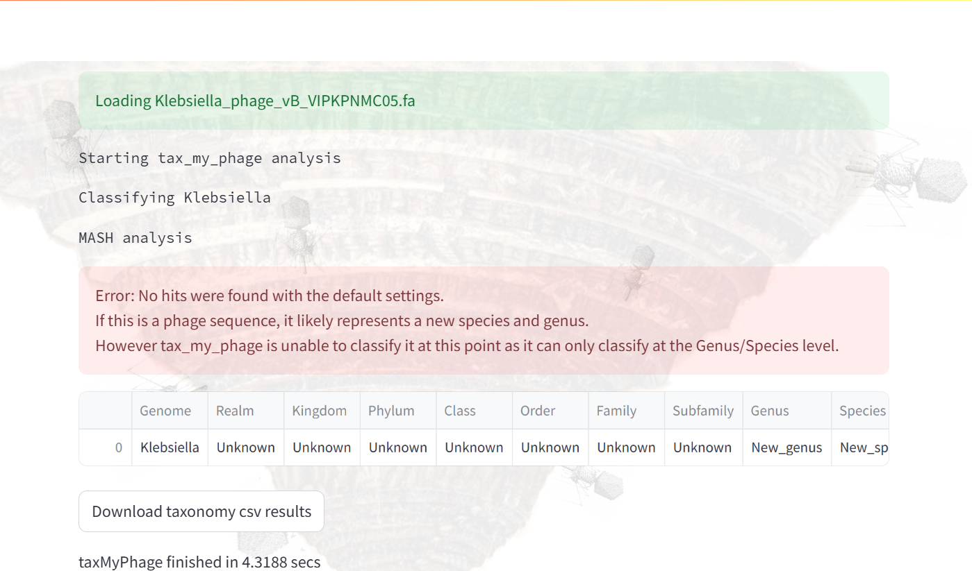

Figure 1. Initial taxonomic identification of VIPKPNMC05 at genus and species level using taxmyphage [3]. Taxmyphage cannot assigned VIPKPNMC05 using the ICTV registered genomes suggesting that this isolate is still unclassified.

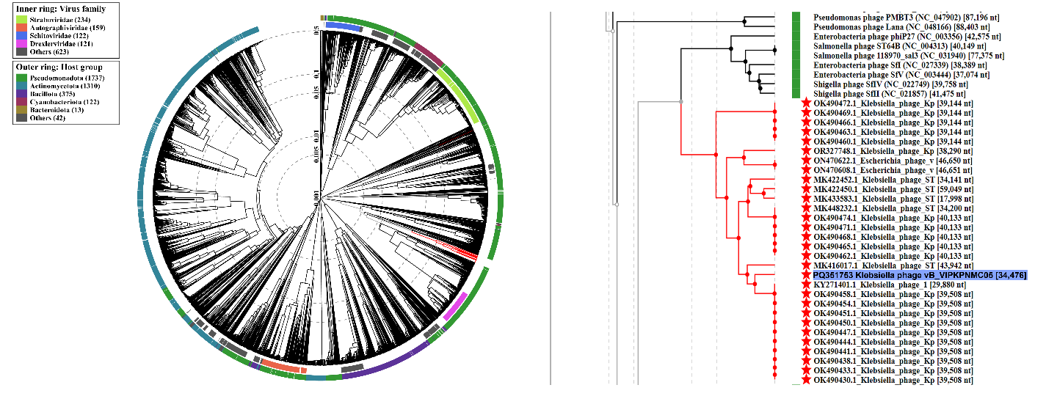
Figure 2. The phage proteomic tree consisting of 3,724 bacterial viruses were built using the ViPTree [4]. First, the closest relative of VIPKPNMC05 were identified using mash [5] and INPHARED database [6] using a 0.20 distance cutoff. Then, closely related genomes marked by the red star symbol (Family Pituviridae) were downloaded from NCBI nucleotide database and submitted to the VIPTree webserver. The tree is based on a dissimilarity matrix generated by pairwise tBLASTx scores between each of the genomes. Isolate VIPKPNMC05 was highlighted in blue.

Figure 3. Clustering of VIPKPNMC05 and closely related genomes. Viral proteins were grouped into protein clusters (PC) based on their reciprocal BLASTP similarities. VIPKPNMC05 (genus Pituvirus) grouped together with Klebsiella phage Kp4880-2 (genus Samsivirus). Protein clustering was determined using VirClust [7]. Isolate VIPKPNMC05 was in blue font.

Figure 4. VIRIDIC heatmap of VIPKPNMC05 and closely related genomes. Our analysis showed that genome similarities between VIPKPNMC05 (genus Pituvirus) and Klebsiella phage Kp4880-2 (genus Samsivirus) were relatively low (53.8%). Genome similarities were calculated using VIRIDIC (Virus Intergenomic Distance Calculator) [8]. Isolate VIPKPNMC05 was in blue font.

Figure 5. Constructed phylogenetic tree based on terminase large subunit (terL), major capsid protein (MCP), and portal protein. Multiple sequence alignment was performed, and a Maximum-Likelihood (ML) tree was constructed with 1,000 UFBoot and SH-Alrt iterations. The tree is rooted at the midpoint.

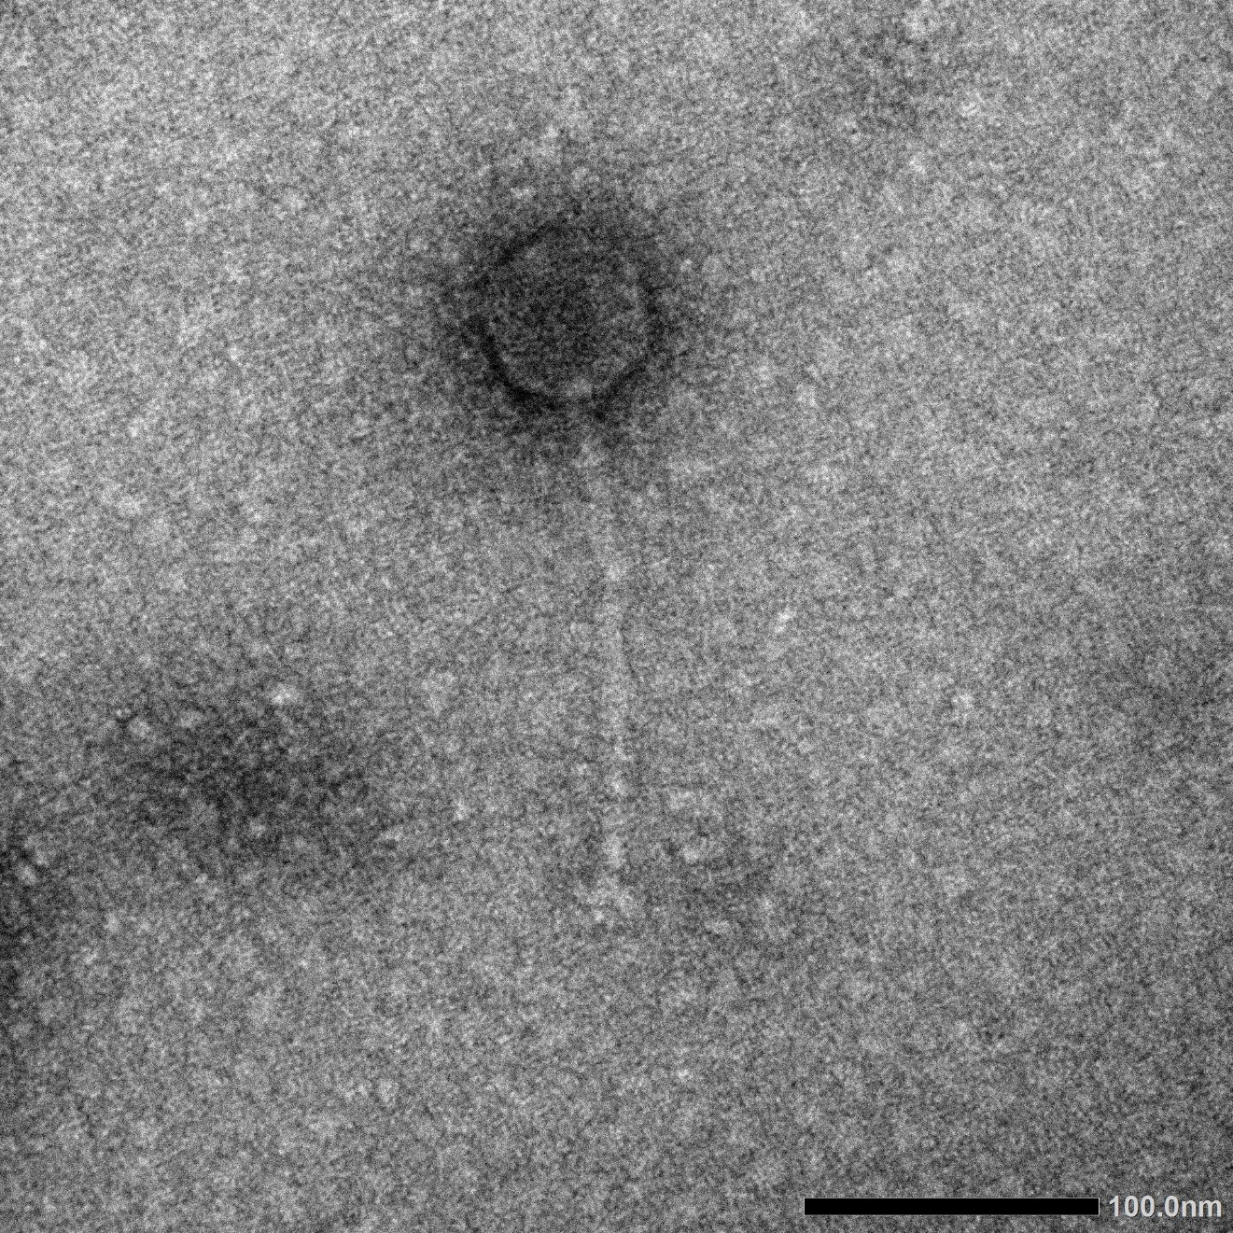
Figure 6. TEM micrograph of Klebsiella phage vB_VIPKPNMC05 showing a siphovirus morphology.

- Create a new family, Pituviridae

As a result of genomic, proteomic and phylogenetic analyses using VIRIDIC, ViPTree, VirClust and maximum likelihood phylogenies we propose the creation of a new phage family, Pituviridae, with seven genera: Pituvirus, Oxavirus, Corunyavirus, Vimivirus, Xubiasivirus, Keypisivirus, and Samsivirus

- Create a new single species genus, Pituvirus

Phage name | NCBI accession no | Genome length (bp) | GC content | CDS | tRNA | % intergenomic similarity to closest relative (VIRIDIC)
Klebsiella phage vB_VIPKPNMC05 | PQ351753 | 34,476 | 51.0% | 58 | 0 | 53.8%  Reference: OK490458.1 Klebsiella phage Kp4880−2

- Create a new single species genus, Oxavirus

Phage name | NCBI accession no | Genome length (bp) | GC content | CDS | tRNA | % intergenomic similarity to closest relative (VIRIDIC)
Klebsiella phage ST13-OXA48phi12.4 | MK422450 | 59,049 | 52.1 | 86 | 0 | 30.4%  Reference: MK448232.1 Klebsiella phage ST147−VIM1phi7.2

- Create a new single species genus, Corunyavirus

Phage name | NCBI accession no | Genome length (bp) | GC content | CDS | tRNA | % intergenomic similarity to closest relative (VIRIDIC)
Klebsiella phage ST13-OXA48phi12.2 | MK422452 | 34,141 | 50.5 | 51 | 0 | 45.3%  Reference:  MK448232.1 Klebsiella phage ST147−VIM1phi7.2

- Create a new genus Vimivirus, with two species

Phage name | NCBI accession no | Genome length (bp) | GC content | CDS | tRNA | % intergenomic similarity to closest relative (VIRIDIC)
Klebsiella phage ST147-VIM1phi7.2 | MK448232 | 34,200 | 40.0 | 45 | 0 | 92.0%  Reference: OK490474.1 Klebsiella phage Kp4887−3
Klebsiella phage Kp4887-3 | OK490474 | 40,133 | 50.9 | 53 | 0 | 100%  Reference:  OK490471.1 Klebsiella phage Kp4886−3

- Create a new single species genus, Xubiasivirus

Phage name | NCBI accession no | Genome length (bp) | GC content | CDS | tRNA | % intergenomic similarity to closest relative (VIRIDIC)
Escherichia phage vB_EcoS-733R5 | ON470608 | 46,651 | 50.2 | 60 | 1 | 100%  Reference:  ON470622.1 Escherichia phage vB_EcoS−716R3

- Create a new single species genus, Keypisivirus

Phage name | NCBI accession no | Genome length (bp) | GC content | CDS | tRNA | % intergenomic similarity to closest relative (VIRIDIC)
Klebsiella phage ST101-KPC2phi6.3 | MK416017 | 43,942 | 52.2 | 62 | 3 | 41.3%  Reference:  OK490458.1 Klebsiella phage Kp4880−2

- Create a new single species genus, Samsivirus

Phage name | NCBI accession no | Genome length (bp) | GC content | CDS | tRNA | % intergenomic similarity to closest relative (VIRIDIC)
Klebsiella phage Kp4880-2 | OK490458 | 39,508 | 50.4 | 48 | 0 | 100%  Reference:  OK490454.1 Klebsiella phage Kp4879−1

