

The International Committee on Taxonomy of Viruses
Taxonomy Proposal Form, 2025

https://ictv.global/taxonomy/templatesPart 1a: Details of taxonomy proposals

Title: | Create a new family Zimmerviridae (Class: Caudoviricetes)
Code assigned: | 2025.083B.Zimmerviridae_1nf_3nsf_4ng_9ns

Author(s), affiliation and email address(es):
Given name (+middle initial(s)) | Surname | Affiliation | Email address | Corr. author(s)
Julien | Lossouarn | Université Paris-Saclay, INRAE, AgroParisTech, Micalis Institute, Jouy en Josas, France | julien.lossouarn@inrae.fr | x
Susan (M) | Lehman | Center for Biologics Evaluation and Research, US Food and Drug Administration, Silver Spring, USA | susan.lehman@fda.hhs.gov
Igor | Tolstoy | National Center for Biotechnology Information, National Library of Medicine, National Institutes of Health, Bethesda, USA. | itolstoy@me.com
Andrew (M) | Kropinski | Department of Pathobiology, Ontario Veterinary College,  University of Guelph, Guelph, Canada | phage.canada@gmail.com
Evelien | Adriaenssens | Quadram Institute Bioscience, Norwich, UK | evelien.adriaenssens@quadram.ac.uk
Marie-Agnès | Petit | Université Paris-Saclay, INRAE, AgroParisTech, Micalis Institute, Jouy en Josas, France | marie-agnes.petit@inrae.fr

Part 1b: Taxonomy Proposal Submission
ICTV Subcommittee:
Animal DNA Viruses and Retroviruses |  | Bacterial viruses | x
Animal minus-strand and dsRNA viruses |  | Fungal and protist viruses
Animal positive-strand RNA viruses |  | Plant viruses
Archaeal viruses |  | General -

List the ICTV Study Group(s) that have seen or have been involved in creating this proposal: https://ictv.global/sc
Optional – complete only if formally voted on by an ICTV Study Group:
Study Group | Number of members
Study Group | Votes in support | Votes against | No vote

Submission date:

Part 1c: Feedback from ICTV Executive Committee (EC) meeting
Executive Committee Meeting Decision code: | X
A – Accept
Ac – Accept subject to revision by relevant subcommittee chair. No further vote required
U – Accept without revision but with re-evaluation and email vote by the EC
Uc – Accept subject to revision and re-evaluation and email vote by the EC | x
Ud – Deferred to the next EC meeting, with an invitation to revise based on EC comments
J - Reject
W - Withdrawn

Comments from the Executive Committee:
Please remove the figure from VICTOR and keep GRAViTy, also add hallmark genes (morphogenesis module)

Part 1d: Revised Taxonomy Proposal Submission
Response of proposer:
We would like to thank the committee members for evaluating this work and contributing to its improvement through their requests.

In accordance with the recommendations, we have removed the analysis with VICTOR from this revised proposal.

We also performed phylogenetic analyses based on terminase large subunit (TerL) and portal proteins but not the MCP, given that some of the lambdoid MCPs are fused with the scaffolding proteins or the capsid maturation proteases.

The phylogenetic analyses based on TerL and portal led us to revise our family proposal, as we observed that among the three initially proposed subfamilies, two were definitely closer to each other. These two are now defining the family, the third is left out.

The core proteome of the revised family consists of 13 proteins: TerL and portal, two connector proteins and seven tail proteins. This “reduced” family appears monophyletic based on TerL and portal single phylogenies, as well as on the concatenated phylogeny on the seven tail proteins.
This delineation of the family is also in line with the clusters obtained using global proteomics tools. Finally, it resists better splitting when using slightly different sets of genomes to run the whole proteomic tools. We therefore believe this new proposal to be more robust.

Finally, in accordance with our email exchanges, we have also replaced the RefSeq accession numbers with GenBank accession numbers wherever possible.

Revision date: | 03/11/2025

Part 3: TAXONOMIC PROPOSAL
https://ictv.global/taxonomy/templates
Taxonomic changes proposed:
Establish new taxon | x | Split taxon
Abolish taxon |  | Merge taxon
Move taxon | x | Promote taxon
Rename taxon |  | Demote taxon
Move and rename

Etymology (origin) of proposed taxonomic names:
Taxon name | Etymology of the term
Zimmerviridae | Proposed for a family including phage lambda, named in honour of the American microbiologist Esther Zimmer Lederberg (1922 – 2006), who was the discoverer of lambda. This family may be subdivided in two subfamilies, which etymology comes from two French scientists that performed pioneering studies on lambda.
Jacobvirinae | To celebrate French microbiologist François Jacob
Wollmanvirinae | To celebrate French microbiologist Elie Wollman

Permission for use of names derived from a living person:
Taxon name | Full name of person from whom the name is derived | Attached

Abstract of Taxonomy Proposal:
Taxonomic rank(s) affected
Family, subfamily, genus, species

Description of current taxonomy:
Since its discovery in the early 1950’s to the mid 1980’s, the temperate bacterial virus (phage) lambda was at the heart of the research which played a crucial role in our current understanding of molecular genetics. Over the years, many phages related to lambda, and susceptible to recombine with it, were isolated and named « lambdoids » (or « lambda-like »). Until recently, lambda and most of the lambdoid phages were taxonomically assigned into the family Siphoviridae, according to a classification scheme based on prokaryotic virion morphotype. In the last years, this morphological taxonomy was abandoned in favor of a molecular taxonomy, based upon overall DNA and protein similarity, for which lambda still remains unclassified at the family level.

Proposed taxonomic change(s):
- Create a new family, Zimmerviridae, with two new subfamilies, six new genera and eight new species
- Move the genera Jouyvirus, Bievrevirus, Glaedevirus, Nesevirus, Alegriavirus, Radostvirus and Lambdavirus into the newly created Jacobvirinae subfamily

Justification:
We have applied whole proteome and phylogenetic approaches to analyse a set of 98 lambdoid genomes and 2 outliers, Escherichia phage T1 (Tunavirus T1) and T7 (Teseptimavirus T7). Based on these results, 22 of the 98 genomes form a cohesive and monophyletic group; we consequently propose a new family, named “Zimmerviridae” to honour microbiologist Esther Zimmer Lederberg. We propose to divide this family into two subfamilies, forming distinct monophyletic clades. We propose to name them “Jacobvirinae” and “Wollmanvirinae” to celebrate respectively microbiologists François Jacob and Elie Wollman. Seven previously defined genera and 14 previously defined species are clustered in the “Jacobvirinae”, while intergenomic nucleotide similarities helped us to define three more genera and five species within the “Wollmanvirinae” subfamily.

- Text of Taxonomy proposal:

Taxonomic rank(s) affected
Family, subfamily, genus, species

Description of current taxonomy:
Discovered by Esther Zimmer Lederberg in 1951, the temperate tailed bacterial virus (phage) lambda present as a prophage in the Escherichia coli strain K-12 was made famous by being at the center of the molecular genetic universe during three decades [1]. Over the years, many phages related to lambda, and susceptible to recombine with it, were isolated and named « lambdoids » (or « lambda-like »). Due to an increase in whole-genome sequencing, the ill-defined term of lambdoid was expanded to mean a phage with the same functional gene order as lambda, and carrying patches of nucleotide sequence similarity with it or another lambdoid phage. Whole genomic comparison indeed revealed lambdoid phage genomes were highly mosaic with each other and thus appeared to regularly share and exchange a wide pool of genes [1]. In terms of taxonomy, lambdoid phages were historically assigned to the morphology-based Siphoviridae (lambdoid in the stricter sense) or Podoviridae (P22-like and 933W-like lambdoid phages with short tails), and to a lesser extent Myoviridae (phages with long contractile tails) families, which were recently abolished. Following the new megataxonomy of viruses, the Bacterial and Archaeal Viruses Subcommittee of the ICTV has largely moved to a molecular taxonomy based upon overall DNA and protein similarity [2, 3]. The process of demarcating new genomically coherent families for all prokaryotic viruses has therefore started but this question remained unresolved for lambdoid phage genomes, including lambda, given their mosaic relationships and flexibility [3].

Proposed taxonomic change(s), demarcation criteria and justification:

In this TaxoProp three proteome-based clustering tools VIPTree [4], GRAViTy-V2 [5] and VirClust [6] were applied, as well as phylogenetic approaches on individual and concatenated signature genes as recommended in [2, 3] to define the boundaries of a family including lambda. We selected 98 representative lambdoid phages genomes, and the exemplars for the species Tunavirus T1 and Teseptimavirus T7 as outgroup genomes. The lambdoid genomes were selected based on (1) their inclusion, for 60 of them, in the lambdoid phages historical report by Grose and Casjens in 2014 [7], (2) the authors of this Taxprop who isolated and sequenced 11 of them from infant fecal viromes in 2021 [8], or (3) through the input of Igor Tolstoy (formerly NCBI) who retrieved 27 other genomes with custom algorithms. They had not yet been assigned to any ICTV-recognized taxonomic groups above the subfamily rank. The “historical” dataset corresponds to 35 defined species that are now gathered in various ICTV clades like the genus Lambdavirus (with lambda, HK629 and HK630), Lederbergvirus (with P22), Pankowvirus, Marienburgvirus and Sawaravirus genera (these three genera are Stx (pro)phages with a siphoviral morphotype), and the Sepvirinae (with Traversvirus tv933W) and Hendrixvirinae (with Byrnievirus HK97) subfamilies. The 11 lambdoid genomes from children’s feces and the 27 additional retrieved genomes respectively represent 11 and 24 other defined species, so that altogether 35 new species were added to the 35 historical ones. This investigation resulted in our proposal to create a new family “Zimmerviridae”, named in honour of the American Esther Zimmer Lederberg (1922 – 2006), who was the discoverer of lambda and one of the pioneers of bacterial genetics [1, 9].

We began by finding that 33 out of the 98 selected lambdoid phages represented a monophyletic group, including lambda, when they were compared using VIPTree [4] and visualized with iTol [10] (Figure 1A). This hierarchical clustering of the viral genomes based on pairwise intergenomic distances calculated by tBLASTx comparisons on whole viral proteomes excluded Lederbergvirus, Sepvirinae and Hendrixvirinae phages from the monophyletic group of 33 phages. This 33-member cluster was organized into three subgroups, including (1) phages closest to lambda, (2) phages closest to mEp460 and (3) Stx (pro)phages belonging to Pankowvirus, Marienburgvirus and Sawaravirus (PMS) genera as well as prophages VT1-Sakai and CP-1639. We tested the cohesiveness of this clustering by repeating the same analysis but slightly changing the lambdoid dataset by (1) removing VT1-Sakai and CP-1639, as they were reported as defective prophages [11, 12], and (2) adding at the same time phages Bcep176 and KS9, both belonging to the Stanholtvirus genus that was reported to include lambda-related phages infecting Burkholderia [13]. The group of 33 genomes was thus split : eight of them, corresponding to PMS subgroup, were separated and closer to the Sepvirinae phages, while the rest of the former group (23 genomes) was expanded by including three phi80-like genomes and remained monophyletic (Figure 1B). With the second tool GRAViTy-V2 [5], 37 out of the 98 initial genomes formed a monophyletic group that included lambda (Figure 2A). Pairwise intergenomic distances are here calculated thanks to both protein profile hidden Markov models (PPHMMs) and genomic organization models (GOMs) and it might be wise to give more weight to the results obtained with GRAViTy-V2 than VIPTree. Interestingly, both tools were not at odds with each other. GRAViTy-V2 also excluded Lederbergvirus, Sepvirinae and Hendrixvirinae phages from the 37-member cluster. This cluster was composed of the three already recognized subgroups (lambda, mEp460 and PMS, with its VT1-Sakai and CP-1639 branch, Figure 1A), to which a branch including phi80 (as in Figure 1B) and Ravinvirus N15 was added. We tested the cohesiveness of this clustering by launching GRAViTy-V2 on the dataset slightly modified as before (Figure 2B). As with VIPTree (Figure 1B), this was sufficient to detach the PMS subgroup and graft it to the Sepvirinae subfamily, while the rest of the group (27 phages) remained monophyletic. These results showed that the PMS branch did not meet our criteria for robustness, which is clear from the GRAViTy-V2 heatmaps. In the presence of VT1-Sakai and CP-1639, the PMS subgroup was closer to the 27-member lambda group but only slightly more distant from the Sepvirinae subfamily (Figure 3). This was reversed when the two defective prophages were replaced by the two Burkholderia lambda-related phages (Figure 4). We suspect the rampant recombination between all these lambdoids to confound the signal for the PMS phages.

We next turned to a core proteome analysis with VirClust [6], using the 37 lambdoid genomes clustered by GRAViTy-V2 (Figure 2A and Figure 3). VirClust calculates intergenomic distances based on the presence/absence of protein “super clusters” (PSCs), as defined by remote homology search, and derives both clustering and core proteomes. The 37 lambdoid phage genomes were assigned to one unique viral genome cluster (VGC) using the default intergenomic distance threshold recommended by VirClust to define a family rank within the class Caudoviricetes [6] (Figure 5A). Nevertheless, the “internal” clustering within this VGC showed again the PMS subgroup was more distant from the rest of the lambdoid genomes (Figure 5B). This is explained by the fact that the PMS subgroup shared only 6 of the 13 PSCs that constituted the core proteome of the 29 lambdoids genomes more similar to lambda (Figure 5C and Table 1). We noted that VirClust retained VT1-Sakai and CP-1639 inside this 29-genome group.

Although fluctuating, all of the above results tend to show that 29 lambdoid phages are grouped in a monophyletic and relatively cohesive manner (Figure 1 to Figure 5). We hypothesized that they could be used to define a lambda family. The core proteome of this putative family was composed of 13 structural proteins (Table 1), divided into three functional categories. Within the head and packaging module, only the terminase large subunit (TerL) and the portal proteins were included. The capsid maturation protease and the major capsid protein (MCP) were excluded, despite being part of the four viral hallmarks for tailed phages [14]. This is due to protease-capsid, scaffold-capsid or even protease-scaffold-capsid fusions found in lambdoid phages, as previously reported [15]. Two proteins of the connector, Lambda_Z and _U, were also shared by the group. The 9 remaining core proteins corresponded to tail proteins: from lambda_V to lambda_J (on lambda). To challenge our core-proteome definition, using the PHROG viral protein superclusters database [16], we searched for phages lying outside the lambdoid family but having a homolog in each of the 13 core protein PHROG families, using a probability threshold of at least 95%. Only phages belonging to the Aguilavirus genus (present in the initial dataset) shared these 13 signature proteins with our 29 lambdoid phages. Other phages shared from 10 to 7 proteins, which essentially corresponded to tail proteins. This includes phages from the initial dataset as well as phages from other genera or species (Table 2).

Phylogeny analysis was then performed from two perspectives. On the one hand, we sought to evaluate the evolutionary relationships within our initial 98 lambdoid dataset composed of sipho, podo and myophages, constructing individual phylogenies based on TerL and portal proteins (Table 1). On the other hand, we also performed a concatenated phylogeny based on seven tail proteins (7TP) shared in our group of 29 phages and other siphophages detected both inside and outside the initial lambdoid set (Table 1 and Table 2). For the individual TerL and portal phylogenies, we selected a subset of lambdoids, taking one or two representatives of each genus in our putative clade (25 phages), to which we added nine Hendrixvirinae (one representative of each genus), eight phages from PMS subgroup and six Sepvirinae (two representatives of each genus), two Lederbergvirus, Aguilavirus and Sendosyvirus as well as other lambdoid phages from our initial dataset, making together a total of 67 genomes, using Tunavirus T1 and Teseptimavirus T7 as outgroups. Phylogeny analyses were performed as for the establishment of the Herelleviridae family [17]. Each orthologous protein of the 69 genomes were aligned using Clustal Omega with default parameters [18]. The resulting alignments were analyzed with IQ-TREE [19] that uses the ModelFinder tool to construct maximum-likelihood trees with ultrafast bootstrap, which were visualized with iTol [10]. This revealed that the 25 phage TerL and portal (and by extension all the group of 29 phages) from the putative family, together with the two Aguilavirus genomes, were monophyletic (Figure 6 and Figure 7). For the 7TP concatenated phylogeny, the selected set differed, as all podoviruses were notably removed: we selected the same subset for our lambda clade, the Hendrixvirinae, the PMS subgroup, the Aguilavirus, and Drexlerviridae (Tunavirus T1) as well as two Stanholtvirus and Dhillonvirus, one Eiauvirus and other phage species (detailed in Table 2), making together a total of 59 genomes and one outlier. The seven orthologous proteins were concatenated for each of the 60 genomes, aligned and analysed as previously described. This revealed that 18 out of the 25 phages (by extension 22 of the 29-member group) from the putative family were indeed monophyletic (Figure 8). At this stage, Enterobacteria phages phi80, HK225, mEp237 and Ravinvirus N15 were removed from the clade, due to the lack of monophyletic signal on the seven core tail proteins. This is also the case for prophages VT1-Sakai, CP-1639 and 1720a-02 (all three of them clustered with the PMS subgroup), as well as phages belonging to the genus Aguilavirus.

In summary, we have applied a combination of approaches to delimit the family Zimmerviridae, as recommended for family taxonomic level dermarcation [2, 3]. Despite the mosaicism and recombination in the group of “lambdoid” viruses, the delineation criteria for inclusion in the family Zimmerviridae mainly overlapped for the two proteome-based tools VipTree and GRAViTy-v2, and the overlapping fraction corresponded to what will finally delimit the proposed family. To reach this conclusion, we explored the core-proteome with VirClust, which offered two possible levels of demarcation, one with six proteins (all from the tail module), the other with 13 proteins (all from structural modules). We opted for the more robust, 13 proteins demarcation, but here again, we could find a challenger genus Aguilavirus, which also shared these 13 proteins. The final phylogenetic analysis of the head and encapsidation proteins (TerL and portal) of the core proteome on the one side, and of seven concatenated tail proteins (7TP) on the other, allowed to recognize the Aguilavirus genus as outsider based on the 7TP phylogeny, and to delimit the Zimmerviridae family as proposed below.

Based on all these results, we propose that a group of 22 lambda-like genomes, corresponding to 22 species and 13 genera, contributes to the creation of a new family, named “Zimmerviridae” (Table 3). Several of these genera are cohesive, sharing with each other ~ 40-50% intergenomic nucleotide identity (Figure 9 to Figure 11, calculated by VIRIDIC [20]), and clearly form two distinct clades in most whole proteome dendrograms (Figure 1 to Figure 5) and in the marker tree phylogeny (Figure 6 to Figure 8). We consequently propose these clades correspond to two subfamilies (Table 3) that could be named after scientists whose pioneering work on lambda also helped the advance of bacterial genetics and molecular biology [1]. The first subfamily with all the genomes closest to lambda could be called “Jacobvirinae”, to pay tribute to the French biologist and physician François Jacob (1920 – 2013). The second subfamily with phages closest to mEp460, “Wollmanvirinae”, in honour to the French microbiologist Elie Wollman (1917 – 2008). While seven genera and 14 defined species were previously defined (2023 Release, MSL #39) within “Jacobvirinae” (Figure 9, Table 3), three new genera and five new species could be proposed within “Wollmanvirinae” (Figure 10, Table 3), using the recommended 70 and 95% nucleotide identity over the full genome length as cut-off for genera and species, respectively [2, 3]. The first genus within “Wollmanvirinae” would include Enterobacteria phage mEp460 and Escherichia virus mEp460_4F5; we propose to name it “Limmatquaivirus”, after a touristic street of Zurich that is the city where mEp460 genome was sequenced. The second genus would be composed of Escherichia phage Ayreon and phage cdtI. Given that Enterobacteria phage cdtI was first studied by researchers from Osaka, we propose the name “Dotonborivirus” for this genus, after the name of a district of the Japanese city. Escherichia phage mEp460_ev081 would be the only representative of the genus “Vilvertvirus”, named after the Vilvert domain that houses the laboratory where this virus was isolated. Given Salmonella phages Gifsy-1, Gifsy-2 and Fels-1 were reported to be active phages [21], we consider they may represent three additional new genera and reference species, unclassified at the subfamily level, in the current state of our research, within the family “Zimmerviridae” (Figure 11, Table 3). As their name implies, Gifsy-1 and Gifsy-2 phages were discovered in Gif-sur-Yvette CNRS campus (Paris area). The two sequences could represent the “Yvettevirus” and “Essonnevirus” genera, named after the river that flows through Gif-sur-Yvette and after the French Department where the city is located, respectively. Fels-1 was first studied in Philadelphia, the phage could consequently be the representative species of the “Schuylkillvirus” genus, named after a river bordering the US city.
References:
[1] Casjens SR, Hendrix RW. Bacteriophage lambda: early pioneer and still relevant. Virology. 2015 May;479-480:310-30. doi: 10.1016/j.virol.2015.02.010. Epub 2015 Mar 3. PMID: 25742714; PMCID: PMC4424060.
[2] Turner D, Kropinski AM, Adriaenssens EM. A roadmap for genome-based phage taxonomy. Viruses. 2021 Mar 18;13(3):506. doi: 10.3390/v13030506. PMID: 33803862; PMCID: PMC8003253.
[3] Turner D, Adriaenssens EM, Lehman SM, Moraru C, Kropinski AM. Bacteriophage taxonomy: a continually evolving discipline. Methods Mol Biol. 2024;2734:27-45. doi: 10.1007/978-1-0716-3523-0_3. PMID: 38066361.
[4] Nishimura Y, Yoshida T, Kuronishi M, Uehara H, Ogata H, Goto S. ViPTree: the viral proteomic tree server. Bioinformatics. 2017 Aug 1;33(15):2379-2380. doi: 10.1093/bioinformatics/btx157. PMID: 28379287.
[5] Mayne R, Aiewsakun P, Turner D, Adriaenssens EM, Simmonds P. GRAViTy-V2: a grounded viral taxonomy application. NAR Genom Bioinform. 2024 Dec 18;6(4):lqae183. doi: 10.1093/nargab/lqae183. PMID: 39703433; PMCID: PMC11655284.
[6] Moraru C. VirClust-a tool for hierarchical clustering, core protein detection and annotation of (prokaryotic) viruses. Viruses. 2023 Apr 19;15(4):1007. doi: 10.3390/v15041007. PMID: 37112988; PMCID: PMC10143988.
[7] Grose JH, Casjens SR. Understanding the enormous diversity of bacteriophages: the tailed phages that infect the bacterial family Enterobacteriaceae. Virology. 2014 Nov;468-470:421-443. doi: 10.1016/j.virol.2014.08.024. PMID: 25240328; PMCID: PMC4301999.
[8] Mathieu A, Dion M, Deng L, Tremblay D, Moncaut E, Shah SA, Stokholm J, Krogfelt KA, Schjørring S, Bisgaard H, Nielsen DS, Moineau S, Petit MA. Virulent coliphages in 1-year-old children fecal samples are fewer, but more infectious than temperate coliphages. Nat Commun. 2020 Jan 17;11(1):378. doi: 10.1038/s41467-019-14042-z. PMID: 31953385; PMCID: PMC6969025.
[9] Schindler TE. A hidden legacy: the life and work of Esther Zimmer Lederberg. Oxford Academic, online edn. 2021 Aug 19. doi.org/10.1093/oso/9780197531679.001.0001.
[10] Letunic I, Bork P. Interactive Tree Of Life (iTOL) v5: an online tool for phylogenetic tree display and annotation. Nucleic Acids Res. 2021 Jul 2;49(W1):W293-W296. doi: 10.1093/nar/gkab301. PMID: 33885785; PMCID: PMC8265157.
[11] Creuzburg K, Köhler B, Hempel H, Schreier P, Jacobs E, Schmidt H. Genetic structure and chromosomal integration site of the cryptic prophage CP-1639 encoding Shiga toxin 1. Microbiology (Reading). 2005 Mar;151(Pt 3):941-950. doi: 10.1099/mic.0.27632-0. PMID: 15758239.
[12] Canchaya C, Proux C, Fournous G, Bruttin A, Brüssow H. Prophage genomics. Microbiol Mol Biol Rev. 2003 Jun;67(2):238-76, table of contents. doi: 10.1128/MMBR.67.2.238-276.2003. Erratum in: Microbiol Mol Biol Rev. 2003 Sep;67(3):473. PMID: 12794192; PMCID: PMC156470.
[13] Summer EJ, Gill JJ, Upton C, Gonzalez CF, Young R. Role of phages in the pathogenesis of Burkholderia, or 'Where are the toxin genes in Burkholderia phages?'. Curr Opin Microbiol. 2007 Aug;10(4):410-7. doi: 10.1016/j.mib.2007.05.016. Epub 2007 Aug 23. PMID: 17719265; PMCID: PMC2064068.
[14] Adriaenssens EM, Cook R, Dolja V, Koonin EV, Krupovic M, Kuhn JH, Lood C, Reyes Muñoz A, Turner D, Varsani A, Vaz PK, Waltzek T, Wolf YI, Yutin N, Zerbini FM. ICTV Virus Taxonomy Profile: Duplodnaviria 2025. J Gen Virol. 2025 Sep;106(9):002139. doi: 10.1099/jgv.0.002139. PMID: 40892591; PMCID: PMC12451611.
[15] Effantin G, Figueroa-Bossi N, Schoehn G, Bossi L, Conway JF. The tripartite capsid gene of Salmonella phage Gifsy-2 yields a capsid assembly pathway engaging features from HK97 and lambda. Virology. 2010 Jul 5;402(2):355-65. doi: 10.1016/j.virol.2010.03.041. Epub 2010 Apr 28. PMID: 20427067.
[16] Terzian P, Olo Ndela E, Galiez C, Lossouarn J, Pérez Bucio RE, Mom R, Toussaint A, Petit MA, Enault F. PHROG: families of prokaryotic virus proteins clustered using remote homology. NAR Genom Bioinform. 2021 Aug 5;3(3):lqab067. doi: 10.1093/nargab/lqab067. PMID: 34377978; PMCID: PMC8341000.
[17] Barylski J, Enault F, Dutilh BE, Schuller MB, Edwards RA, Gillis A, Klumpp J, Knezevic P, Krupovic M, Kuhn JH, Lavigne R, Oksanen HM, Sullivan MB, Jang HB, Simmonds P, Aiewsakun P, Wittmann J, Tolstoy I, Brister JR, Kropinski AM, Adriaenssens EM. Analysis of Spounaviruses as a Case Study for the Overdue Reclassification of Tailed Phages. Syst Biol. 2020 Jan 1;69(1):110-123. doi: 10.1093/sysbio/syz036. PMID: 31127947; PMCID: PMC7409376.
[18] Sievers F, Wilm A, Dineen D, Gibson TJ, Karplus K, Li W, Lopez R, McWilliam H, Remmert M, Söding J, Thompson JD, Higgins DG. Fast, scalable generation of high-quality protein multiple sequence alignments using Clustal Omega. Mol Syst Biol. 2011 Oct 11;7:539. doi: 10.1038/msb.2011.75. PMID: 21988835; PMCID: PMC3261699.
[19] Trifinopoulos J, Nguyen LT, von Haeseler A, Minh BQ. W-IQ-TREE: a fast online phylogenetic tool for maximum likelihood analysis. Nucleic Acids Res. 2016 Jul 8;44(W1):W232-5. doi: 10.1093/nar/gkw256. Epub 2016 Apr 15. PMID: 27084950; PMCID: PMC4987875.
[20] Moraru C, Varsani A, Kropinski AM. VIRIDIC-A Novel Tool to Calculate the Intergenomic Similarities of Prokaryote-Infecting Viruses. Viruses. 2020 Nov 6;12(11):1268. doi: 10.3390/v12111268. PMID: 33172115; PMCID: PMC7694805.
[21] Kropinski AM, Sulakvelidze A, Konczy P, Poppe C. Salmonella phages and prophages--genomics and practical aspects. Methods Mol Biol. 2007;394:133-75. doi: 10.1007/978-1-59745-512-1_9. PMID: 18363236.

Accompanying files:
Filename | Description of contents
Figure_1.pdf | PDF version of the Figure 1 included in this word file
Figure_2.pdf | PDF version of the Figure 2 included in this word file
Figure_3.pdf | PDF version of the Figure 3 included in this word file
Figure_4.pdf | PDF version of the Figure 4 included in this word file
Table_2.xlsx | Excel version of the Table 2, included in this word file

Tables, Figures:

Figure 1: VIPTree [4] comparisons visualized with iTol [10]. The scale bar represents the calculated distance metric. A. The comparison of the complete set of 98 initial lambdoid genomes and 2 putative outliers (Tunavirus T1 and Teseptimavirus T7) reveals that 33 of the 98 lambdoid genomes form a cohesive and monophyletic group (colored in blue) B. The removal of VT1-Sakai and CP-1639 defective prophages [11, 12] from the genome set, combined with the addition of Bcep176 and KS9 lambda-related phages [13], profoundly perturbs the dendrogram: the cohesive group shrinks to 26 genomes (colored in blue), and the lower PMS branch of the former tree (in A) has now joined the Sepvirinae.

Figure 2: GRAViTy-V2 [5] comparisons visualized with iTol [10]. The scale bar represents the calculated distance metric. A. The comparison of the complete set of 98 initial lambdoid genomes and 2 putative outliers (Tunavirus T1 and Teseptimavirus T7) reveals that 37 of the 98 lambdoid genomes form a cohesive and monophyletic group (colored in blue) B. The removal of VT1-Sakai and CP-1639 defective prophages [11, 12] from the genome set, combined with the addition of Bcep176 and KS9 lambda-related phages [13] profoundly perturbs the dendrogram: the cohesive group shrinks to 27 genomes (colored in blue), and the PMS branch of the former tree (in A) has now joined the Sepvirinae.

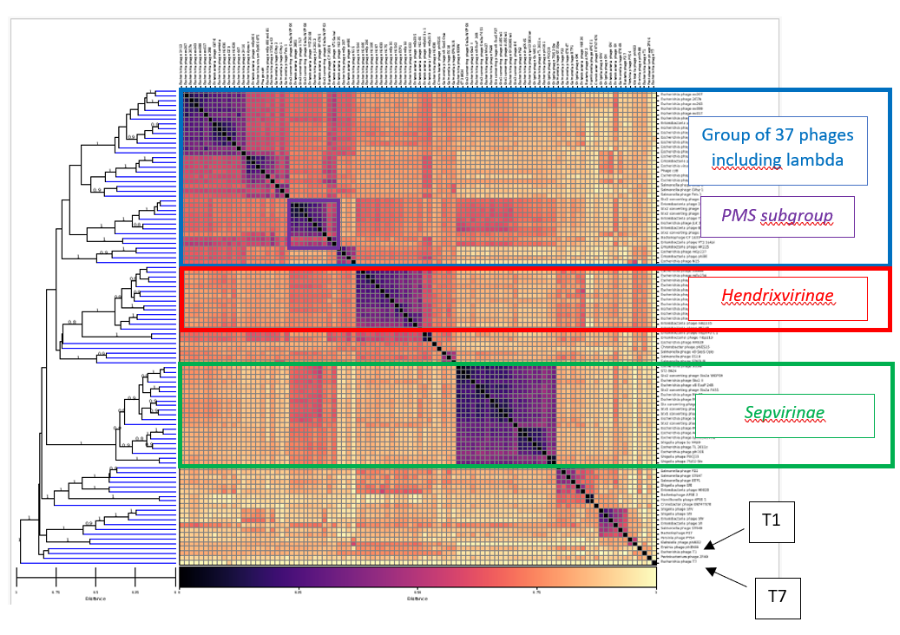
Figure 3: GRAViTy-V2 [5] heatmap (and dendrogram) of the 98 initial selected lambdoid genomes, using Tunavirus T1 and Teseptimavirus T7 as outliers. Squared in blue, the 37 genomes (including lambda) forming a cohesive group that contains the PMS subgroup in purple. Squared in red and green the Hendrixvirinae and Sepvirinae subfamilies, respectively. See the attached pdf, for higher definition.
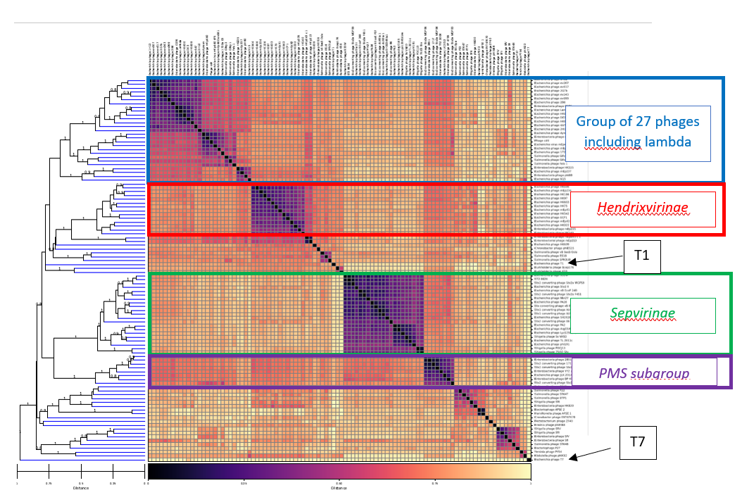

Figure 4: GRAViTy-V2 [5] heatmap (and dendrogram) of the slightly modified lambdoid set after the removal of VT1-Sakai and CP-1639 defective prophages [11, 12] and the addition of Bcep176 and KS9 lambda-related phages [13], using Tunavirus T1 and Teseptimavirus T7 as outliers. Squared in purple, the PMS subgroup is no more included with the “lambda group” in blue (27 genomes), but clustered to the Sepvirinae subfamily in green. See the attached pdf, for higher definition.

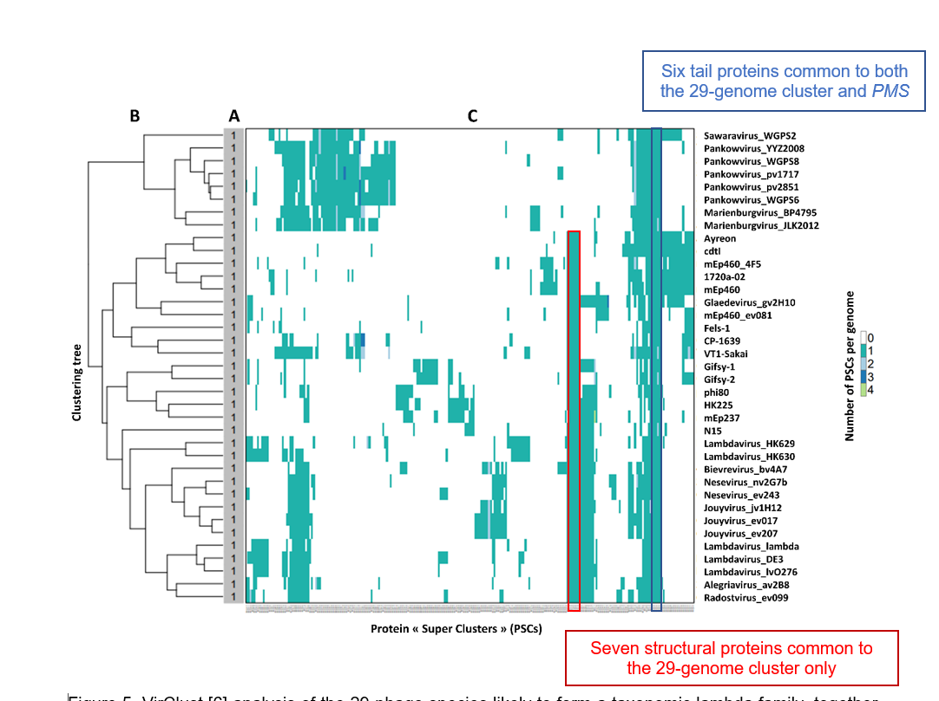

Figure 5: VirClust [6] analysis of the 29-phage species likely to form a taxonomic lambda family, together with the eight species of the PMS genera. A. They form a single viral genome cluster (VGC), when using the default parameters recommended in the definition of a family rank within Caudoviricetes. B. Hierarchical tree calculated using PSC-based intergenomic distances. C. Heatmap representation of the PSC distribution in the viral genomes. The core proteome of the putative lambda family is squared in red and blue.

Table 1: The 13 core proteins for the putative lambda family, based on VirClust PSCs [6]. ªCore proteins shared with the PMS subgroup. ^{b}Core proteins used individually in phylogenetic trees. ^{c}Core proteins used in a concatenated phylogenetic tree.

Protein annotation in phage Lambda (Uniprot) | PSC number
Terminase large subunit A (P03708)^{b} | PSC_10
Portal protein B (P03710)^{b} | PSC_9
Tail completion protein Z (P03731) | PSC_40
Tail tube terminator protein U (P03732) | PSC_39
Tail tube protein V (P03733)^{c} | PSC_38
Tail assembly protein G (P03734) | PSC_8
Tail assembly protein T or GT (P03735) | PSC_37
Tape measure protein H (P03736)^{a, c} | PSC_7
Tail tip protein M (P03737)^{a, c} | PSC_36
Tail tip protein L (P03738)^{a, c} | PSC_35
Tail tip assembly protein K (P03729)^{a, c} | PSC_34
Tail tip assembly protein I (P03730)^{a, c} | PSC_33
Tip attachment protein J (P03749)^{a, c} | PSC_32

Table 2: Phages sharing most orthologs with the core proteome of the putative lambda family. The original file is provided in accompanying file. ªExemplar phage of the Aguilavirus genus. ^{b}Exemplar phage of the Stanholtvirus virus genus. ^{c}Exemplar phage of the Pankowvirus-Marienburgvirus-Sawaravirus (PMS) subgroup. ^{d}Exemplar phage of the Byrnievirus genus and Hendrixvirinae subfamily. ^{e}Exemplar phage of the genus Tunavirus and Drexlerviridae family. ^{f}Exemplar phage of the genus Eiauvirus. ^{g}Exemplar phage of the genus Dhillonvirus.

Figure 6: Maximum-likelihood tree based on the alignment of 69 terminase large subunit (TerL), generated using IQ-tree [19] and visualized with iTol [10]. The scale bar represents the number of substitutions per site, branch support values were calculated from 1000 ultrafast bootstrap (UFBOOT) replicates. The tree was rooted at Teseptimavirus T7 TerL. The 25 lambdoid phage TerL (selected subset from the 29 phages belonging to the putative lambda family) form a monophyletic group with two Aguilavirus phage TerL (in blue).

Figure 7: Maximum-likelihood tree based on the alignment of the portal protein (Port), generated using IQ-tree [19] and visualized with iTol [10]. The scale bar represents the number of substitutions per site, branch support values were calculated from 1000 ultrafast bootstrap (UFBOOT) replicates. The tree was rooted at Teseptimavirus T7 Port. The 25 lambdoid phage portal (selected subset from the 29 phages belonging to the putative lambda family) form a monophyletic group with the two Aguilavirus phage Port (in blue).

Figure 8: Maximum-likelihood tree based on the alignment of the concatenation of seven tail proteins (7TP), generated using IQ-tree [19] and visualized with iTol [10]. The scale bar represents the number of substitutions per site, branch support values were calculated from 1000 ultrafast bootstrap (UFBOOT) replicates. The tree was rooted at Pseudomonas phage PMBT14. Only 18 out of the 25 lamdoid phage 7TP (selected subset from the 29 phages belonging to the putative lambda family) form a monophyletic group (in blue), from which Phi80, mEp237, N15, VT1-Sakai and CP-1639, as well as the two Aguilavirus phage 7TP are excluded.

Figure 9: VIRIDIC [20] heatmap of proposed “Jacobvirinae” phages. This subfamily includes the seven already defined genera (2023 Release, MSL #39) that are labeled in gold.

Figure 10: VIRIDIC [20] heatmap of proposed “Wollmanvirinae” phages. The three new genera established in this proposal are labeled in gold.

Figure 11: VIRIDIC [20] heatmap of proposed additional genera within the “Zimmerviridae”. The three new genera established in this proposal are labeled in gold.

Table 3: 22 lambdoid defined species belonging to the newly proposed Zimmerviridae family.

