

The International Committee on Taxonomy of Viruses
Taxonomy Proposal Form, 2025

Part 1a: Details of taxonomy proposals

Title: | Create a new family, Luriaviridae, with four genera, Queenastridvirus, Wulsvirus, Saclayvirus, and Dalianvirus, for a group of Acinetobacter-specific phages (class Caudoviricetes)
Code assigned: | 2025.086B.Luriaviridae_1nf_3ng_1mg_12ns

Author(s), affiliation and email address(es):
Given name (+middle initial(s)) | Surname | Affiliation | Email address | Corresponding author(s)
Michał J. | Wójcicki | Bacteriophage Laboratory, Department of Phage Therapy, Hirszfeld Institute of Immunology and Experimental Therapy, Polish Academy of Sciences, Wroclaw, Poland | michal.wojcicki@hirszfeld.pl | X
Dann | Turner | School of Applied Sciences, University of the West of England, Bristol, UK | dann2.turner@uwe.ac.uk
Iwona | Gientka | Department of Biotechnology and Food Microbiology, Institute of Food Sciences, Warsaw University of Life Sciences (WULS-SGGW), Warsaw, Poland | iwona_gientka@sggw.edu.pl | X
Martyna A. | Cieślik | Bacteriophage Laboratory, Department of Phage Therapy, Hirszfeld Institute of Immunology and Experimental Therapy, Polish Academy of Sciences, Wroclaw, Poland | martyna.cieslik@hirszfeld.pl
Andrzej | Górski | Bacteriophage Laboratory, Department of Phage Therapy, Hirszfeld Institute of Immunology and Experimental Therapy, Polish Academy of Sciences, Wroclaw, Poland | andrzej.gorski@hirszfeld.pl
Ewa M. | Jończyk-Matysiak | Bacteriophage Laboratory, Department of Phage Therapy, Hirszfeld Institute of Immunology and Experimental Therapy, Polish Academy of Sciences, Wroclaw, Poland | ewa.jonczyk-matysiak@hirszfeld.pl

Part 1b: Taxonomy Proposal Submission
ICTV Subcommittee:
Animal DNA Viruses and Retroviruses |  | Bacterial viruses | X
Animal minus-strand and dsRNA viruses |  | Fungal and protist viruses
Animal positive-strand RNA viruses |  | Plant viruses
Archaeal viruses |  | General

List the ICTV Study Group(s) that have seen or have been involved in creating this proposal:
Caudoviricetes Study Group
Optional – complete only if formally voted on by an ICTV Study Group:
Study Group | Number of members
Study Group | Votes in support | Votes against | No vote

Submission date: | 20/06/2025

Part 1c: Feedback from ICTV Executive Committee (EC) meeting
Executive Committee Meeting Decision code: | X
A – Accept
Ac – Accept subject to revision by relevant subcommittee chair. No further vote required
U – Accept without revision but with re-evaluation and email vote by the EC
Uc – Accept subject to revision and re-evaluation and email vote by the EC | x
Ud – Deferred to the next EC meeting, with an invitation to revise based on EC comments
J - Reject
W - Withdrawn

Comments from the Executive Committee:
Parts of the proposal do not respect the demarcation criteria (95% for species; 70% for genus). Please also check italics.

Part 1d: Revised Taxonomy Proposal Submission
Response of proposer:
All issues have been corrected in accordance with the comments from the Executive Committee.

Revision date: | 17/10/2025

Part 3: TAXONOMIC PROPOSAL

Taxonomic changes proposed:
Establish new taxon | X | Split taxon
Abolish taxon |  | Merge taxon
Move taxon | X | Promote taxon
Rename taxon |  | Demote taxon
Move and rename

Etymology (origin) of proposed taxonomic names:
Taxon name | Etymology of the term
Luriaviridae | family name created in honor of Italian microbiologist - Salvador Edward Luria (b. 1912, d. 1991). Luria researched viruses. Based on images obtained through an electron microscope, he described the structure of bacteriophages and discovered their ability to create mutant replicas. Luria won the Nobel Prize in Physiology or Medicine in 1969, with Max Delbrück and Alfred Hershey, for their discoveries on the replication mechanism and the genetic structure of viruses.
Queenastridvirus | genus name derived from the Queen Astrid Military Hospital, where the Acinetobacter phage vB_AbaM_Acibel004, the only representative of this genus, was isolated
Queenastridvirus Acibel004 | species name derived from the phage name in the GenBank database –Acinetobacter phage vB_AbaM_Acibel004
Wulsvirus | genus name derived from Warsaw University of Life Sciences (WULS-SGGW), where the Institute of Food Sciences conducts research on the isolation and characterization of phages with potential use in food biocontrol.
Wulsvirus Acba22 | species name derived from the phage name in the GenBank database –Acinetobacter phage Acba_22
Wulsvirus KissB | species name derived from the phage name in the GenBank database –Acinetobacter phage vB_AbaM_KissB
Wulsvirus Rocket | species name derived from the phage name in the GenBank database –Acinetobacter phage vB_AbaM_Rocket
Dalianvirus | genus name derived from the Dalian University of Technology, where the Acinetobacter phage vB_AbaM_D22, the one of representatives of this genus, was isolated
Dalianvirus D22 | species name derived from the phage name in the GenBank database –Acinetobacter phage vB_AbaM_D22
Dalianvirus P1 | species name derived from the phage name in the GenBank database –Acinetobacter phage vB_AbaM_P1
Saclayvirus Ab121 | species name derived from the phage name in the GenBank database –Acinetobacter phage Ab_121
Saclayvirus CP14 | species name derived from the phage name in the GenBank database –Acinetobacter phage vB_AbaM_CP14
Saclayvirus Liucustia | species name derived from the phage name in the GenBank database –Acinetobacter phage Liucustia
Saclayvirus phi1092033 | species name derived from the phage name in the GenBank database –Acinetobacter phage phi1_092033
Saclayvirus TAC1 | species name derived from the phage name in the GenBank database –Acinetobacter phage TAC1
Saclayvirus 14CRR8 | species name derived from the phage name in the GenBank database –Acinetobacter phage vB_AbaM_14/CRR8

Permission for use of names derived from a living person
Taxon name | Full name of person from whom the name is derived | Attached

Abstract of Taxonomy Proposal:
Taxonomic rank(s) affected:
Family, genus, species

Description of current taxonomy:
Currently, the Saclayvirus genus includes three species: Saclayvirus Aci011, Saclayvirus Aci022, and Saclayvirus Aci05.

Proposed taxonomic change(s):
We performed a genomic analysis of phages deposited in the NCBI database. We propose to create a new family (Luriaviridae) with four genera (Queenastridvirus, Wulsvirus, Saclayvirus, and Dalianvirus) for a group of Acinetobacter-specific phages (realm Duplodnaviria, kingdom Heunggongvirae, phylum Uroviricota, class Caudoviricetes).

We performed a genomic analysis of several Acinetobacter-specific phages deposited in the NCBI database, all of which have been classified within the genus Saclayvirus. Based on our analysis, we propose the creation of a new family for these phages along with four distinct genera.

- To create a new family, Luriaviridae, with four genera.
- To create a new single species genus, Queenastridvirus.
- To create a new genus, Wulsvirus, with three species.
- To move the genus, Saclayvirus, to a new family, Luriaviridae.
- To create six new species in genus Saclayvirus.
- To create a new genus, Dalianvirus, with two species.

Justification:
After examination of bacteriophages based on nucleotide sequence similarity, tblastx distances and core gene phylogeny, we propose the creation of a new family, Luriaviridae, to accommodate four genera (Queenastridvirus, Wulsvirus, Saclayvirus, and Dalianvirus). The proposed taxa conform to the demarcation criteria employed by the ICTV Bacterial Viruses Subcommittee.

Text of Taxonomy proposal:
Taxonomic rank(s) affected:
Family, genus, species

Description of current taxonomy:
Currently, the Saclayvirus genus includes three species: Saclayvirus Aci011, Saclayvirus Aci022, and Saclayvirus Aci05.

Proposed taxonomic change(s):
We performed a genomic analysis of phages deposited in the NCBI database. We propose to create a new family (Luriaviridae) with four genera (Queenastridvirus, Wulsvirus, Saclayvirus, and Dalianvirus) for a group of Acinetobacter-specific phages (realm Duplodnaviria, kingdom Heunggongvirae, phylum Uroviricota, class Caudoviricetes).

We performed a genomic analysis of several Acinetobacter-specific phages deposited in the NCBI database, which have been classified under the genus Saclayvirus. Based on our analysis, we propose the creation of a new family for these phages along with four distinct genera.

- To create a new family, Luriaviridae, with four genera.
- To create a new single species genus, Queenastridvirus.
- To create a new genus, Wulsvirus, with three species.
- To move the genus, Saclayvirus, to a new family, Luriaviridae.
- To create six new species in genus Saclayvirus.
- To create a new genus, Dalianvirus, with two species.

Demarcation criteria:
Species demarcation criteria: Two phages are assigned to the same species if their genomes are more than 95% identical over their genome length for isolates.
These values can be calculated using several tools, such as BLASTn [1], and are typically determined with the intergenomic distance calculator VIRIDIC [2].

Genus demarcation criteria: In search for criteria that create cohesive and distinct genera that are reproducible and monophyletic, the Bacterial Viruses Subcommittee has established 70% nucleotide identity of the genome length as the cut-off for genera. Genus-level groupings should always be monophyletic in the signature genes, as tested with a phylogenetic tree [3].

Family demarcation criteria: The family is represented by a cohesive and monophyletic group in the main predicted proteome-based clustering tools (e.g. ViPTree, GRAViTy dendrogram, vConTACT2 network). Family members share a significant number of orthologous genes (the number will depend on the genome sizes and number of coding sequences of family members) [3].

Justification:
Examination of 17 genomes with VIRIDIC resulted in the identification of four cluster of phage genomes with intergenomic nucleotide similarity within the threshold for the establishment of new genera (Figure 1). The genomes formed a single clade in a hierarchically clustered tblastx distance tree (Figure 2). To examine shared proteins between these phages, all genomes were first reannotated using Pharokka with prodigal gene calling to provide a standardised data set. MMSeqs2 was used to perform protein clustering at thresholds of 50% minimum sequence identity and 50% coverage. Protein clusters were extracted as multi-fasta files and converted to matrices of counts and presence/absence by genome (Figures 3 and 4). A total of 44 core proteins were identified and maximum likelihood phylogenetics trees were inferred using IQTree2 (Figure 5). We propose the creation of a new family, Luriaviridae, with four genera (Queenastridvirus, Wulsvirus, Saclayvirus, and Dalianvirus).

References:
- Sayers EW, Beck J, Bolton EE, Bourexis D, Brister JR, Canese K, Comeau DC, Funk K, Kim S, Klimke W, Marchler-Bauer A, Landrum M, Lathrop S, Lu Z, Madden TL, O'Leary N, Phan L, Rangwala SH, Schneider VA, Skripchenko Y, Wang J, Ye J, Trawick BW, Pruitt KD, Sherry ST. Database resources of the National Center for Biotechnology Information. Nucleic Acids Res. 2021, 49(D1):D10-D17.
- Moraru C, Varsani A, Kropinski AM. VIRIDIC - a novel tool to calculate the intergenomic similarities of prokaryote-infecting viruses. Viruses 2020, 12(11):1268.
- Turner D, Kropinski AM, Adriaenssens EM. A roadmap for genome-based phage taxonomy. Viruses 2021, 13(3):506.
- Nishimura Y, Yoshida T, Kuronishi M, Uehara H, Ogata H, Goto S. ViPTree: the viral proteomic tree server. Bioinformatics 2017, 33(15):2379-2380.
- Rohwer F, Edwards R. The Phage Proteomic Tree: a genome-based taxonomy for phage. J. Bacteriol. 2002, 184(16):4529-35.
- Turner D, Reynolds D, Seto D, Mahadevan P. CoreGenes3.5: a webserver for the determination of core genes from sets of viral and small bacterial genomes. BMC Res. Notes. 2013, 6:140.

Accompanying files:
Filename | Description of contents
2025.086B.Luriaviridae_1nf_3ng_1mg_12ns.xlsx | To present the proposed taxonomic changes as a comparison of new taxonomic structures.
Tables, Figures:

Proposals data:

- To create a new family, Luriaviridae, with four genera.
- To create a new single species genus, Queenastridvirus.
- To create a new genus, Wulsvirus, with three species.
- To move the genus, Saclayvirus, to a new family, Luriaviridae.
- To create six new species in genus Saclayvirus.
- To create a new genus, Dalianvirus, with two species.

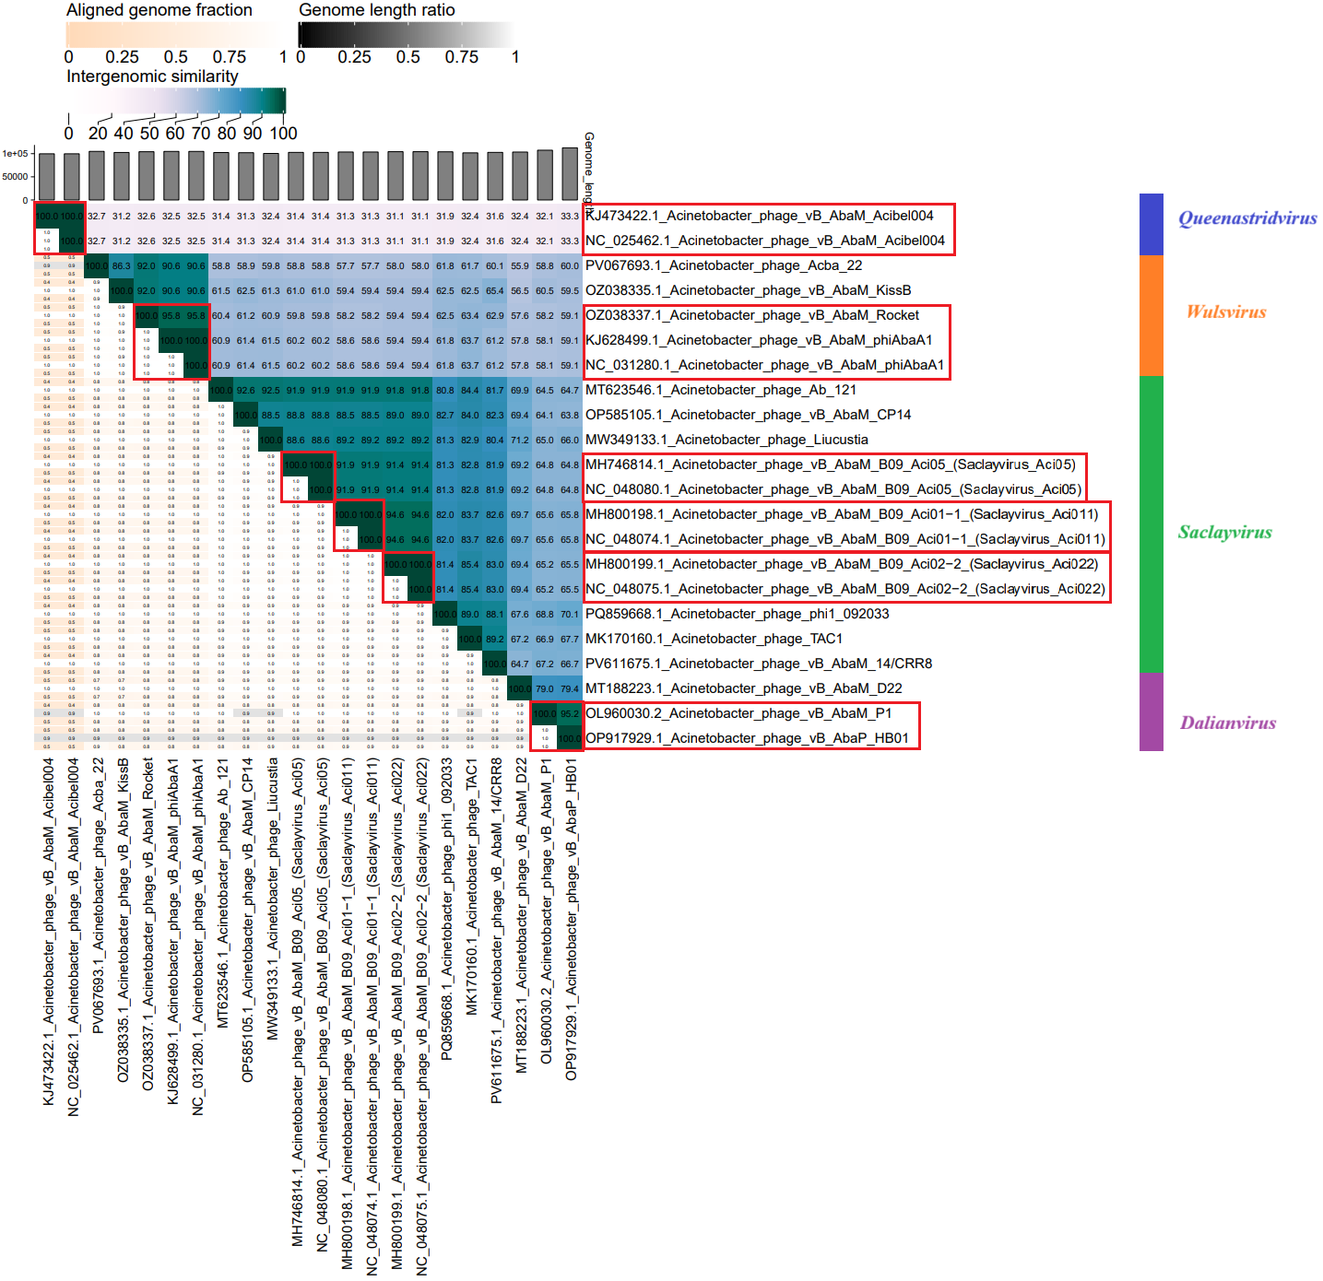

Figure 1. VIRIDIC heat map: VIRIDIC (Virus Intergenomic Distance Calculator [2]; http://rhea.icbm.uni-oldenburg.de/VIRIDIC/) computes pairwise intergenomic distances/similarities amongst phage genomes. Phages belonging to the same species (nucleotide similarity above 95%) are marked with a red frame.

All phages pre-classified in the NCBI database were divided into four groups, based on which we propose the creation of separate genera. Proposed genera names: blue – new genus: Queenastridvirus, orange – new genus: Wulsvirus, green – genus: Saclayvirus, and purple – new genus: Dalianvirus.

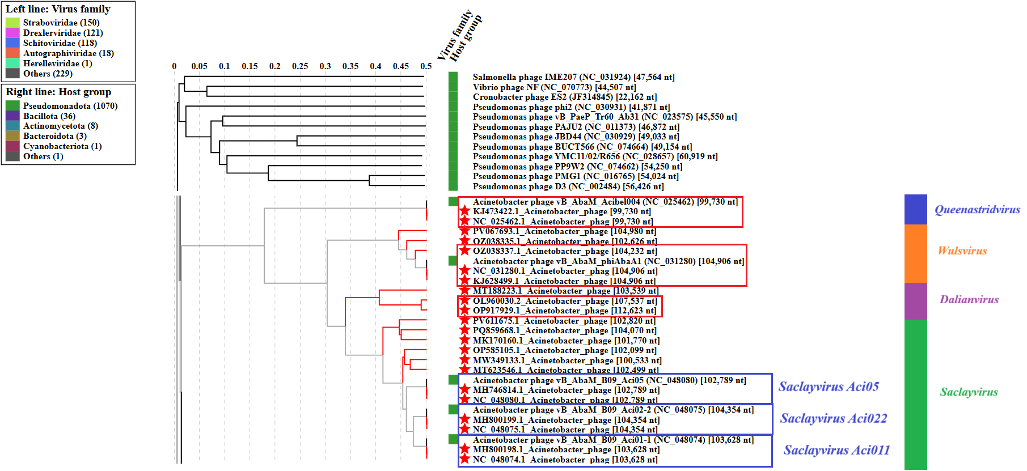

Figure 2. ViPTree analysis*: ViPTree analysis (https://www.genome.jp/viptree/; [4]) is based upon Rohwer and Edwards (2002) Phage Proteomic Tree [5]. The phages of interest are indicated with a red stars.
Phages belonging to the same species (nucleotide similarity above 95%) are marked with a red frame.

* The Autographiviridae family shown in Figure 2 (automatically labeled by the software) is outdated. In 2025, the Autographiviridae family was elevated to the rank of order and renamed Autographivirales.

All phages pre-classified in the NCBI database were divided into four groups, based on which we propose the creation of separate genera. Proposed genera names: blue – new genus: Queenastridvirus, orange – new genus: Wulsvirus, green – genus: Saclayvirus, and purple – new genus: Dalianvirus.

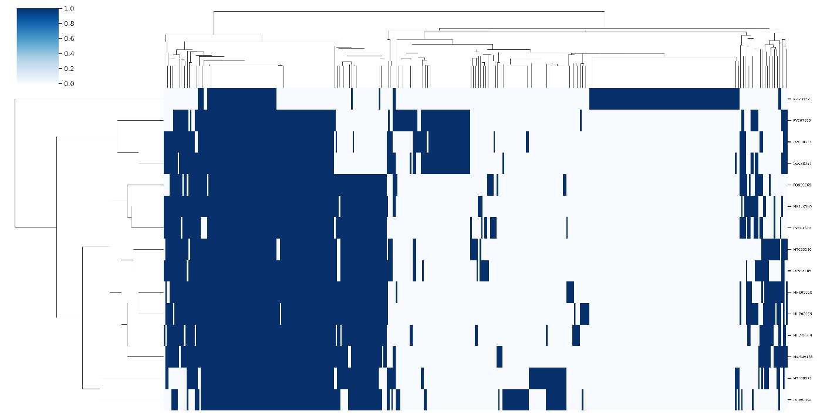
Figure 3. Presence-absence matrix of protein clusters by genome. Rows and columns were heirarchically clustered using the complete method. Rows represent individual genomes with columns representing protein clusters. Vertical blue bars denote the presence of protein clusters in each genome.

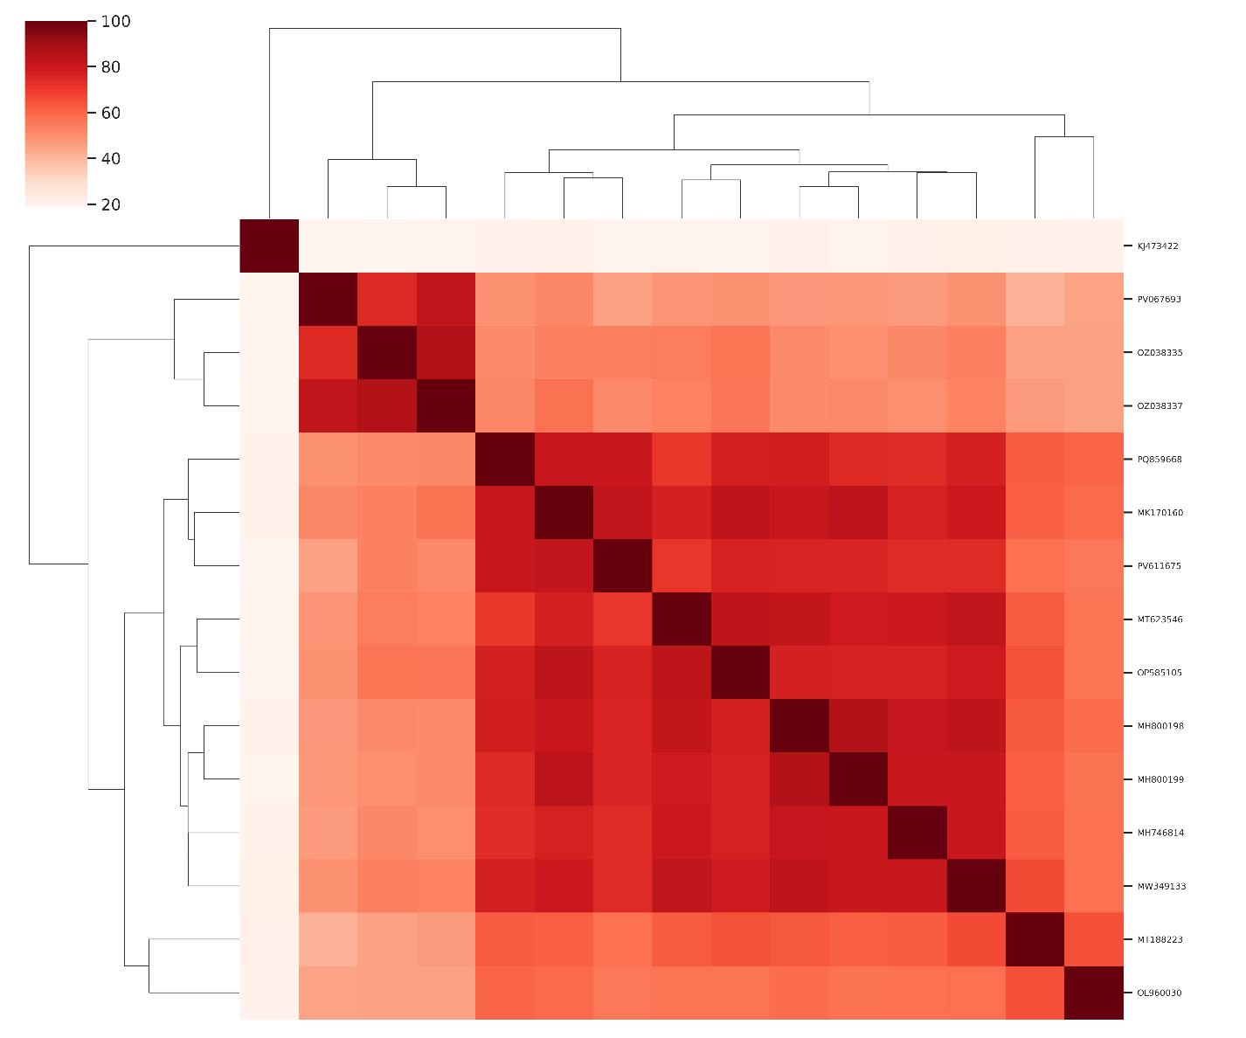
Figure 4. Heatmap of Jaccard similarity calculated from the percentage of shared protein clusters between genomes.

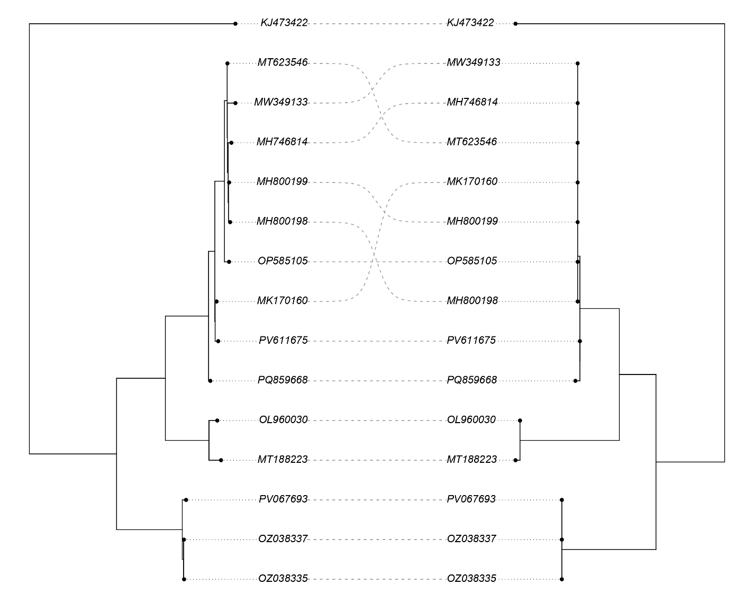
Figure 5. Co-phylogeny of partitioned maximum likelihood phylogeny of 42 proteins (left) and portal vertex protein (right). The protein clusters corresponding to a DNA polymerase and HNH homing endonuclease were omitted from the partition tree.

A. To create a new family, Luriaviridae, with four genera.

After examination of bacteriophages based on nucleotide sequence similarity, tblastx distances and core gene phylogeny, we propose the creation of a new family, Luriaviridae, with four genera (Queenastridvirus, Wulsvirus, Saclayvirus, and Dalianvirus).

B. To create a new single species genus, Queenastridvirus.

Genome summary:

Phage name | RefSeq No. | INSDC | Size (bp) | GC% | Protein | Overall % DNA sequence identity (*) | Overall % homologous proteins (**)
Acinetobacter phage vB_AbaM_Acibel004 | KJ473422 = NC_025462 | KJ473422 | 99,730 | 37.3 | 156 | 100.0 | 100.0
(*) determined using VIRIDIC [2]
(**) determined using CoreGenes 3.5 [6]

C. To create a new genus, Wulsvirus, with three species.

Genome summary:

Phage name | RefSeq No. | INSDC | Size (bp) | GC% | Protein | Overall % DNA sequence identity (*) | Overall % homologous proteins (**)
Acinetobacter phage Acba_22 (selected as the reference genome) | PV067693.1 | PV067693 | 104,980 | 37.9 | 162 | 100.0 | 100.00
Acinetobacter phage vB_AbaM_KissB |  | OZ038335 | 102,626 | 37.7 | 190 | 86.3 | 91.36
Acinetobacter phage vB_AbaM_Rocket |  | OZ038337 | 104,232 | 37.8 | 189 | 92.0 | 95.06
(*) determined using VIRIDIC [2]
(**) determined using CoreGenes 3.5 [6]

D. To move the genus, Saclayvirus, to a new family, Luriaviridae.

After examining bacteriophages based on nucleotide sequence similarity, tblastx distance, and core gene phylogeny, we proposed to include the genus Saclayvirus in a newly proposed family, Luriaviridae.

E. To create six new species in genus Saclayvirus.

Genome summary:

Phage name | RefSeq No. | INSDC | Size (bp) | GC% | Protein | Overall % DNA sequence identity (*) | Overall % homologous proteins (**)
Acinetobacter phage vB_AbaM_B09_Aci01-1 (Saclayvirus Aci011; reference genome) | MH800198 = NC_048074 | MH800198 | 103,628 | 37.2 | 163 | 100.0 | 100.00
Acinetobacter phage vB_AbaM_B09_Aci02-2 (Saclayvirus Aci022) | MH800199 = NC_048075 | MH800199 | 104,354 | 37.2 | 171 | 94.6 | 96.93
Acinetobacter phage vB_AbaM_B09_Aci05 (Saclayvirus Aci05) | MH746814 = NC_048080 | MH746814 | 102,789 | 37.2 | 160 | 91.9 | 92.02
Acinetobacter phage Ab_121 |  | MT623546 | 102,499 | 37.2 | 159 | 91.9 | 88.34
Acinetobacter phage vB_AbaM_CP14 |  | OP585105 | 102,099 | 37.4 | 169 | 88.5 | 90.80
Acinetobacter phage Liucustia |  | MW349133 | 100,533 | 37.1 | 157 | 89.2 | 90.18
Acinetobacter phage phi1_092033 |  | PQ859668 | 104,070 | 37.6 | 188 | 82.0 | 90.18
Acinetobacter phage TAC1 |  | MK170160 | 101,770 | 37.5 | 163 | 83.7 | 92.64
Acinetobacter phage vB_AbaM_14/CRR8 |  | PV611675 | 102,820 | 37.6 | 164 | 82.6 | 86.50
(*) determined using VIRIDIC [2]
(**) determined using CoreGenes 3.5 [6]

F. To create a new genus, Dalianvirus, with two species.

Genome summary:

Phage name | RefSeq No. | INSDC | Size (bp) | GC% | Protein | Overall % DNA sequence identity (*) | Overall % homologous proteins (**)
Acinetobacter phage vB_AbaM_D22 (selected as the reference genome) | MT188223.1 | MT188223 | 103,539 | 37.4 | 159 | 100.0 | 100.00
Acinetobacter phage vB_AbaM_P1 |  | OL960030 | 107,537 | 37.7 | 183 | 79.4 | 91.19
(*) determined using VIRIDIC [2]
(**) determined using CoreGenes 3.5 [6]

