

The International Committee on Taxonomy of Viruses
Taxonomy Proposal Form, 2025

Part 1a: Details of taxonomy proposals

Title: | Create two new single-species genera – Odravirus and Solivirus (class Caudoviricetes)
Code assigned: | 2025.088B.Caudoviricetes_2ng_2ns

Author(s), affiliation and email address(es):
Given name (+middle initial(s)) | Surname | Affiliation | Email address | Corresponding author(s)
Michał J. | Wójcicki | Bacteriophage Laboratory, Department of Phage Therapy, Hirszfeld Institute of Immunology and Experimental Therapy, Polish Academy of Sciences, Wroclaw, Poland | michal.wojcicki@hirszfeld.pl | X
Martyna A. | Cieślik | Bacteriophage Laboratory, Department of Phage Therapy, Hirszfeld Institute of Immunology and Experimental Therapy, Polish Academy of Sciences, Wroclaw, Poland | martyna.cieslik@hirszfeld.pl
Edyta | Pawlak | Laboratory of Immunopathology, Department of Experimental Therapy, Hirszfeld Institute of Immunology and Experimental Therapy, Polish Academy of Sciences, Wroclaw, Poland | edyta.pawlak@hirszfeld.pl
Andrzej | Górski | Bacteriophage Laboratory, Department of Phage Therapy, Hirszfeld Institute of Immunology and Experimental Therapy, Polish Academy of Sciences, Wroclaw, Poland | andrzej.gorski@hirszfeld.pl
Ewa M. | Jończyk-Matysiak | Bacteriophage Laboratory, Department of Phage Therapy, Hirszfeld Institute of Immunology and Experimental Therapy, Polish Academy of Sciences, Wroclaw, Poland | ewa.jonczyk-matysiak@hirszfeld.pl

Part 1b: Taxonomy Proposal Submission
ICTV Subcommittee:
Animal DNA Viruses and Retroviruses |  | Bacterial viruses | X
Animal minus-strand and dsRNA viruses |  | Fungal and protist viruses
Animal positive-strand RNA viruses |  | Plant viruses
Archaeal viruses |  | General

List the ICTV Study Group(s) that have seen or have been involved in creating this proposal:
Caudoviricetes Study Group
Optional – complete only if formally voted on by an ICTV Study Group:
Study Group | Number of members
Study Group | Votes in support | Votes against | No vote

Submission date: | 20/06/2025

Part 1c: Feedback from ICTV Executive Committee (EC) meeting
Executive Committee Meeting Decision code: | X
A – Accept
Ac – Accept subject to revision by relevant subcommittee chair. No further vote required
U – Accept without revision but with re-evaluation and email vote by the EC
Uc – Accept subject to revision and re-evaluation and email vote by the EC | x
Ud – Deferred to the next EC meeting, with an invitation to revise based on EC comments
J - Reject
W - Withdrawn

Comments from the Executive Committee:
proposal doesn’t respect the demarcation criteria (95% for species; 70% for genus). Please also check italics.

Part 1d: Revised Taxonomy Proposal Submission
Response of proposer:
All issues have been corrected in accordance with the comments from the Executive Committee.
The division of the Obolenskvirus genus has been moved in its entirety to proposal 2025.054B.

Revision date: | 23/10/2025

Part 3: TAXONOMIC PROPOSAL

Taxonomic changes proposed:
Establish new taxon | X | Split taxon
Abolish taxon |  | Merge taxon
Move taxon |  | Promote taxon
Rename taxon |  | Demote taxon
Move and rename

Etymology (origin) of proposed taxonomic names:
Taxon name | Etymology of the term
Odravirus | Genus name derived from Odra (Latin: Viadrus, Oddera) – river in Central Europe, within the Baltic Sea basin, located in the territories of the Czech Republic, Poland, and Germany.
Odravirus Acjo20 | Species name derived from the phage name in the GenBank database – Acinetobacter phage Acjo_20.
Solivirus | Genus name derived from the name of the bacterial host for this phage, which is the only representative of the newly created species – Acinetobacter soli (according to the GenBank database).
Solivirus phiAC1 | Species name derived from the phage name in the GenBank database – Acinetobacter phage phiAC-1.

Permission for use of names derived from a living person
Taxon name | Full name of person from whom the name is derived | Attached

Abstract of Taxonomy Proposal:
Taxonomic rank(s) affected:
Genus, species

Description of current taxonomy:
The Acinetobacter phage Acjo_20 and Acinetobacter phage phiAC-1 have not yet been classified by the ICTV. Analysis of the NCBI database indicates their closest similarity to phages from the Obolenskvirus genus, but the degree of relatedness is too low to link them to the Obolenskvirus genus.

Proposed taxonomic change(s):
To create two new single-species genera – Odravirus and Solivirus (class Caudoviricetes).

We performed a genomic analysis of several Acinetobacter-specific phages deposited in the NCBI database, all of which have been classified within the genus Obolenskvirus. Based on our analysis, we propose the creation of a two distinct genera, not classified to the family level.

- To create a new single species genus, Odravirus.
- To create a new single species genus, Solivirus.

Justification:
Analysis performed using VIRIDIC and ViPTree indicates that the Acinetobacter phage Acjo_20 and Acinetobacter phage phiAC-1 each form a single species in two new genera. The proposed taxa conform to the demarcation criteria employed by the ICTV Bacterial Viruses Subcommittee.

Text of Taxonomy proposal:
Taxonomic rank(s) affected:
Genus, species

Description of current taxonomy:
The Acinetobacter phage Acjo_20 and Acinetobacter phage phiAC-1 have not yet been classified by the ICTV. Analysis of the NCBI database indicates their closest similarity to phages from the Obolenskvirus genus, but the degree of relatedness is too low to link them to the Obolenskvirus genus.

Proposed taxonomic change(s):
To create two new single-species genera – Odravirus and Solivirus (class Caudoviricetes).

We performed a genomic analysis of several Acinetobacter-specific phages deposited in the NCBI database, all of which have been classified within the genus Obolenskvirus. Based on our analysis, we propose the creation of a two distinct genera, not classified to the family level.

- To create a new single species genus, Odravirus.
- To create a new single species genus, Solivirus.

Demarcation criteria:
Species demarcation criteria: Two phages are assigned to the same species if their genomes are more than 95% identical over their genome length for isolates.
These values can be calculated by several tools, such as BLASTn [1] – usually calculated using the intergenomic distance calculator VIRIDIC [2].

Genus demarcation criteria: In search for criteria that create cohesive and distinct genera that are reproducible and monophyletic, the Bacterial Viruses Subcommittee has established 70% nucleotide identity of the genome length as the cut-off for genera. Genus-level groupings should always be monophyletic in the signature genes, as tested with a phylogenetic tree [3].

Justification:
Analysis performed using VIRIDIC and ViPTree indicates that the Acinetobacter phage Acjo_20 and Acinetobacter phage phiAC-1 form a single species in two new genera. The proposed taxa conform to the demarcation criteria employed by the ICTV Bacterial Viruses Subcommittee.

References:
- Sayers EW, Beck J, Bolton EE, Bourexis D, Brister JR, Canese K, Comeau DC, Funk K, Kim S, Klimke W, Marchler-Bauer A, Landrum M, Lathrop S, Lu Z, Madden TL, O'Leary N, Phan L, Rangwala SH, Schneider VA, Skripchenko Y, Wang J, Ye J, Trawick BW, Pruitt KD, Sherry ST. Database resources of the National Center for Biotechnology Information. Nucleic Acids Res. 2021, 49(D1):D10-D17.
- Moraru C, Varsani A, Kropinski AM. VIRIDIC - a novel tool to calculate the intergenomic similarities of prokaryote-infecting viruses. Viruses 2020, 12(11):1268.
- Turner D, Kropinski AM, Adriaenssens EM. A roadmap for genome-based phage taxonomy. Viruses 2021, 13(3):506.
- Nishimura Y, Yoshida T, Kuronishi M, Uehara H, Ogata H, Goto S. ViPTree: the viral proteomic tree server. Bioinformatics 2017, 33(15):2379-2380.
- Rohwer F, Edwards R. The Phage Proteomic Tree: a genome-based taxonomy for phage. J. Bacteriol. 2002, 184(16):4529-35.
- Turner D, Reynolds D, Seto D, Mahadevan P. CoreGenes3.5: a webserver for the determination of core genes from sets of viral and small bacterial genomes. BMC Res. Notes. 2013, 6:140.

Accompanying files:
Filename | Description of contents
2025.088B.N.v2.Caudoviricetes_2ng_2ns.xlsx | To present the proposed taxonomic changes as a comparison of new taxonomic structures.
Tables, Figures:

Proposals data:

- To create a new single species genus, Odravirus.
- To create a new single species genus, Solivirus.

Figure 1. VIRIDIC heat map: VIRIDIC (Virus Intergenomic Distance Calculator [2]; http://rhea.icbm.uni-oldenburg.de/VIRIDIC/) computes pairwise intergenomic distances/similarities amongst phage genomes.

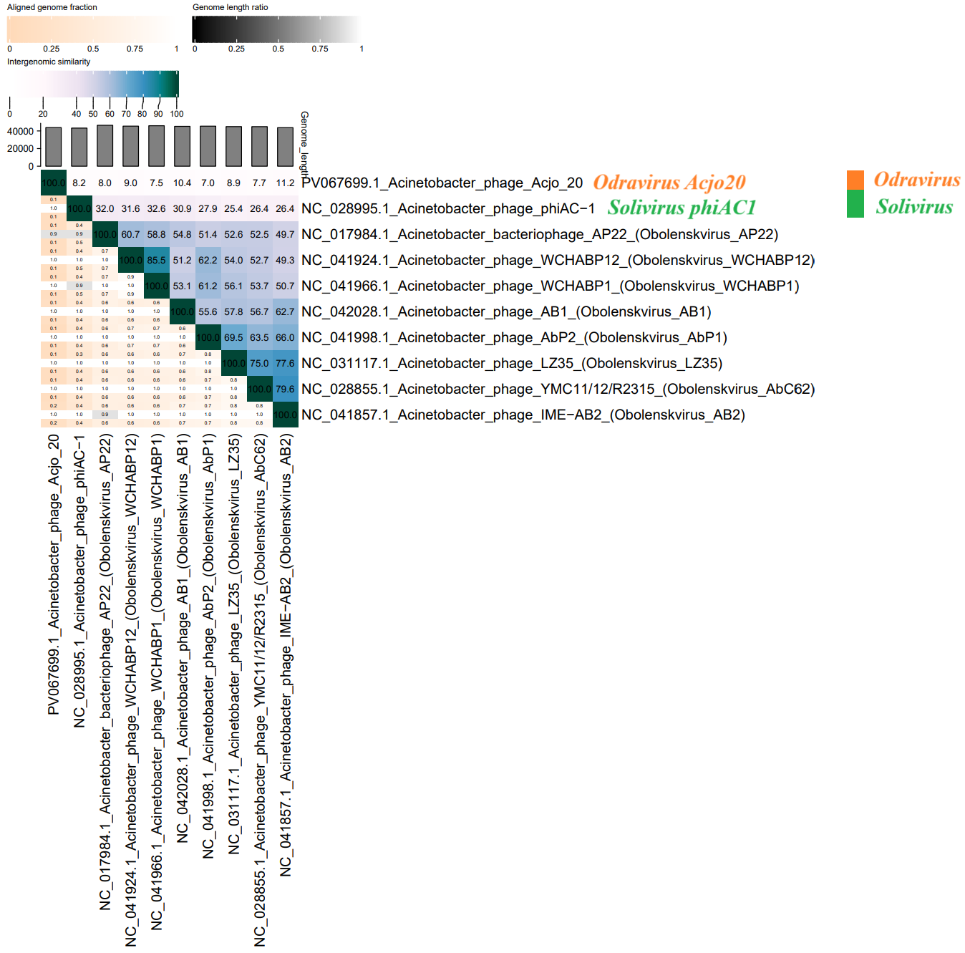

Figure 2. ViPTree analysis*: ViPTree analysis (https://www.genome.jp/viptree/; [4]) is based upon Rohwer and Edwards (2002) Phage Proteomic Tree [5]. The phage of interest is indicated with a red star and an orange, and green bars. Current species in the Obolenskvirus genus are marked in blue font.

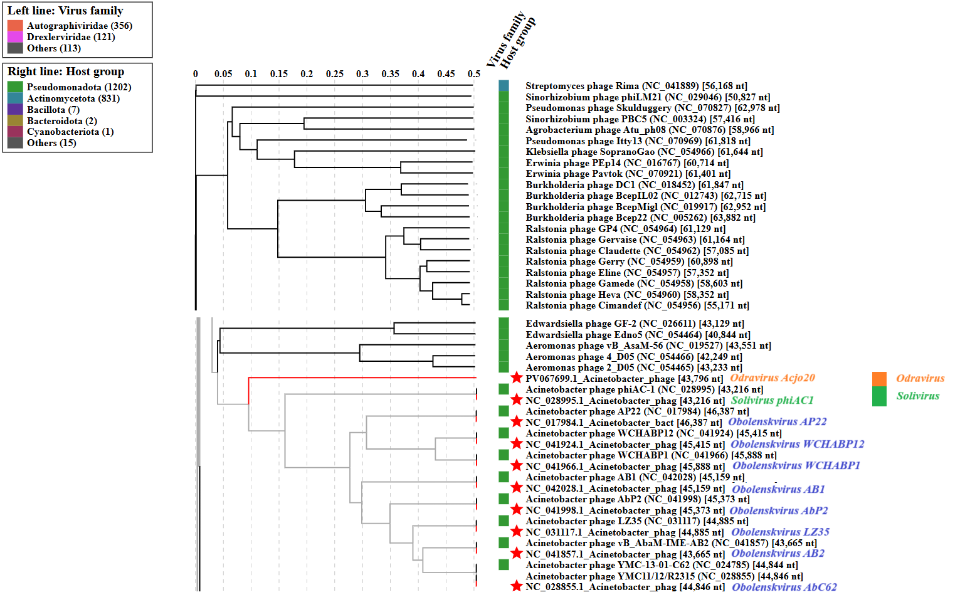

* The Autographiviridae family shown in Figure 2 (automatically labeled by the software) is outdated. In 2025, the Autographiviridae family was elevated to the rank of order and renamed Autographivirales.

- To create a new single species genus, Odravirus.

Genome summary:

Phage name | RefSeq No. | INSDC | Size (bp) | GC% | Protein | Overall % DNA sequence identity (*) | Overall % homologous proteins (**)
Acinetobacter phage Acjo_20 |  | PV067699 | 43,796 | 40.6 | 71 | 100.0 | 100.0
(*) determined using VIRIDIC [2]
(**) determined using CoreGenes 3.5 [6]

- To create a new single species genus, Solivirus.

Genome summary:

Phage name | RefSeq No. | INSDC | Size (bp) | GC% | Protein | Overall % DNA sequence identity (*) | Overall % homologous proteins (**)
Acinetobacter phage phiAC-1 | NC_028995.1 | NC_028995 | 43,216 | 38.5 | 82 | 100.0 | 100.0
(*) determined using VIRIDIC [2]
(**) determined using CoreGenes 3.5 [6]

