

The International Committee on Taxonomy of Viruses
Taxonomy Proposal Form, 2025

Part 1a: Details of taxonomy proposals

Title: | Create one new species in the genus Benyvirus (Hepelivirales: Benyviridae)
Code assigned: | 2025.005P.Benyviridae_Benyvirus_1nsp

Author(s), affiliation and email address(es):
Given name (+middle initial(s)) | Surname | Affiliation | Email address | Corr. author(s)
Juliana B. | Valente | Dep. De Agronomia, Universidade do Estado de Santa Catarina, Brazil | julianabvalente@hotmail.com
Fernando P. | Sartori | Dep. De Agronomia, Universidade do Estado de Santa Catarina, Brazil | fernandopereira2254@hotmail.com
Lucas A. | Stempkowski | Dep. De Agronomia, Universidade do Estado de Santa Catarina, Brazil | lucas_stempkowski@hotmail.com
Monica | Farias | Dep. De Agronomia, Universidade do Estado de Santa Catarina, Brazil | fariasmonicaagro@gmail.com
Paulo R. | Kuhnem | Biotrigo Genética, Brazil | paulo@biotrigo.com.br
Douglas | Lau | Empresa Brasileira de Pesquisa Agropecuária, Embrapa Florestas, Brazil | douglas.lau@embrapa.br
Thor V.M. | Fajardo | Empresa Brasileira de Pesquisa Agropecuária, Embrapa Uva e Vinho, Brazil | thor.fajardo@embrapa.br
Antonio | Nhani Junior | Empresa Brasileira de Pesquisa Agropecuária, Embrapa Informática, Brazil | antonio.nhani@embrapa.br
Ricardo T. | Casa | Dep. De Agronomia, Universidade do Estado de Santa Catarina, Brazil | ricardo.casa@udesc.br
Amauri | Bogo | Dep. De Agronomia, Universidade do Estado de Santa Catarina, Brazil | amauri.bogo@udesc.br
Fábio N. | Silva | Dep. De Agronomia, Universidade do Estado de Santa Catarina, Brazil | fabio.silva@udesc.br | X

Part 1b: Taxonomy Proposal Submission
ICTV Subcommittee:
Animal DNA Viruses and Retroviruses |  | Bacterial viruses
Animal minus-strand and dsRNA viruses |  | Fungal and protist viruses
Animal positive-strand RNA viruses |  | Plant viruses | X
Archaeal viruses |  | General

List the ICTV Study Group(s) that have seen or have been involved in creating this proposal:
Virgaviridae and Benyviridae
Optional – complete only if formally voted on by an ICTV Study Group:
Study Group | Number of members
Study Group | Votes in support | Votes against | No vote
Virgaviridae and Benyviridae | 5 |  | 3

Submission date: | 03/06/2025

Part 1c: Feedback from ICTV Executive Committee (EC) meeting
Executive Committee Meeting Decision code: | X
A – Accept
Ac – Accept subject to revision by relevant subcommittee chair. No further vote required
U – Accept without revision but with re-evaluation and email vote by the EC
Uc – Accept subject to revision and re-evaluation and email vote by the EC | X
Ud – Deferred to the next EC meeting, with an invitation to revise based on EC comments
J - Reject
W - Withdrawn

Comments from the Executive Committee:
The EC voted Uc for this proposal (see the table above for explanation). Before the proposal can be accepted, the following points should be addressed:
- Please clarify if figures have been reproduced with permission; if not, new figures should be produced.
- A new tree including SINV (Togaviridae) instead of RUBV should be prepared.
- The paragraph concerning the KTER motif should be modified considering that the KTER motif was not found in RSNV; linking this to Polymyxa graminis transmission is not verified.
- Mangifera indica latent virus does not belong to a recognized species in the family Benyviridae.
- Please check if there is an inversion between the replicase and first triple gene block (b and c, or c and b) in Figure 3.

Additional comments are reported in the text. Moreover, minor revisions mainly concerning style issues have been included.

Part 1d: Revised Taxonomy Proposal Submission
Response of proposer:
All corrections and suggestions have been implemented as recommended. New figures have been prepared and included.
Revision date: | 15/10/2025

Part 3: TAXONOMIC PROPOSAL

Taxonomic changes proposed:
Establish new taxon | X | Split taxon
Abolish taxon |  | Merge taxon
Move taxon |  | Promote taxon
Rename taxon |  | Demote taxon
Move and rename

Etymology (origin) of proposed taxonomic names:
Taxon name | Etymology of the term
“Benyvirus tritici” | Epithet derived from the host genus name Triticum

Permission for use of names derived from a living person:
Taxon name | Full name of person from whom the name is derived | Attached

Abstract of Taxonomy Proposal:
Taxonomic rank(s) affected:
Genus Benyvirus in the family Benyviridae

Description of current taxonomy:
Riboviria › Orthornavirae › Kitrinoviricota › Alsuviricetes › Hepelivirales › Benyviridae › Benyvirus
The genus Benyvirus consists of four species.

Proposed taxonomic change(s):
Create one species in the genus Benyvirus: “Benyvirus tritici”

Justification:
Based on the genomic organization of P. graminis-associated WhSMV-infected plant samples, as well as the nucleotide and amino acid sequences of the viral isolates characterized in this study, we propose that wheat stripe mosaic virus (WHSMV) is classified into a novel putative species within the family Benyviridae, for which the name “Benyvirus tritici” is suggested.

Text of Taxonomy proposal
Taxonomic rank(s) affected:
Genus Benyvirus in the family Benyviridae

Description of current taxonomy:
Riboviria › Orthornavirae › Kitrinoviricota › Alsuviricetes › Hepelivirales › Benyviridae › Benyvirus

Four species are currently assigned to the genus Benyvirus in the family Benyviridae: Benyvirus arctii, Benyvirus necrobetae, Benyvirus oryzae, Benyvirus solibetae

Proposed taxonomic change(s):
We propose to create one new species in the genus Benyvirus, “Benyvirus tritici”

Demarcation criteria:
The current taxonomic criterion used for species demarcation in the genus Benyvirus is amino acid sequence identity of the coat protein (CP) <90% [1].
According to the current taxonomic criterion for species demarcation within the genus Benyvirus, a virus is considered as a member of a distinct species if the amino acid sequence identity of its coat protein (CP) is <90%

Justification:
After next-generation sequencing (NGS) analysis, the complete genome sequence of a virus isolated from wheat (Triticum aestivum) collected from Brazil in a field infested with the plasmodiophorid Polymyxa graminis was determined [2]. The virus was identified as a putative new member of the family Benyviridae, for which the name wheat stripe mosaic virus (WhSMV) was proposed [2]. WhSMV was also detected in wheat samples showing mosaic symptoms in South Africa and Paraguay [3, 4]. WhSMV has a bipartite genome comprising RNA 1 and RNA 2 with an organization consistent with members of the Benyviridae family, which typically contain two to five segments of positive-sense single-stranded RNA (ssRNA).
The 5′ untranslated region (UTR) of WhSMV RNA 1 (115 nt), is comparable in length to that of viruses within the genus Benyvirus ranging from 124 to 153 nucleotides (nt). In contrast, the 3′-UTR of WhSMV RNA1, (336–353 nt) is notably longer than that observed for Benyvirus members, which typically ranges from 181 to 233 nucleotides. WhSMV RNA 1 encodes a polyprotein of approximately 231.7kDa, putatively functioning as a viral replicase, with a molecular size similar to those reported for Benyvirus species. Proteolytic cleavage of the replicase has been described for members of the family Benyviridae and distinguishes this group from all other viruses with rod-shaped particles. Furthermore, a conserved GDD motif (Gly-Asp-Asp) is present in all WhSMV isolates and is also present in the same position as in other members of the Benyviridae family.

The length of WhSMV RNA-2 (4879–4901 nt) was similar to that of members of the genus Benyvirus (4314–4635 nt). The 5′-UTR of WhSMV RNA-2 (145 nt) was also similar in length to that of members of the genus Benyvirus (144–179 nt). However, the 3′-UTR of WhSMV (96–116 nt) was shorter. Six putative ORFs were identified in WhSMV RNA-2, similar to what is observed for the RNA-2 of beet necrotic yellow vein virus (BNYVV), beet soil-borne mosaic virus (BSBMV) and rice stripe necrosis virus (RSNV). ORF 2 encodes the viral coat protein (CP). A conserved KTER (Lys-Thr-Glu-Arg) motif found in the RT protein of BNYVV and BSBMV members of the genus Benyvirus) is required for virus-mediated transmission by P. betae. A similar motif (VTER) was found in the amino acid sequences of the WhSMV. ORFs 3, 4 and 5 encode the putative triple gene block (TGB) proteins which are associated with viral movement within host plants. ORF3 encodes the putative TGB 1 protein which contains a helicase domain, also found in BdMV, BNYVV and MILV. ORF4 encodes the putative TGB 2 protein which includes a conserved domain implicated with viral movement, as described for BdMV. ORF 5 encodes the putative TGB 3 protein, functionally analogous to those in other members of the family Benyviridae. These TGB proteins are important for both cell-to-cell and long-distance movement of the virus, as demonstrated in BNYVV-infected plants. Given the similarities and the conserved domains, it is suggested that the TGB discovered in isolates of the new virus is involved in cell-to-cell movement. The size of ORF 6 was the most divergent among the characterized isolates and species of the Benyviridae.

The current taxonomic criterion for species demarcation within the genus Benyvirus is amino acid sequence identity of the CP <90% [1]. Based on the genomic organization, P. graminis associated WhSMV-infected plants, and the nucleotide and amino acid sequences obtained from the viral isolates described in this study, it is proposed that wheat stripe mosaic virus represents a member of a novel species within the genus Benyvirus in the family Benyviridae, for which the name “Benyvirus tritici” is proposed.

Phylogenetic analyses further support this classification, as WhSMV isolates formed a distinct clade in trees constructed using the complete RNA segments and all coding regions. This clustering indicates a close relationship among the Brazilian isolates and corroborates the sequence identity data reinforcing the conclusion that the viral isolates described herein belong to the same species and are genetically distinct from the other recognized species within the genus Benyvirus.
References:
[1] GILMER D, RATTI C, ICTV REPORT CONSORTIUM (2017). ICTV Virus Taxonomy Profile: Benyviridae. Journal of General Virology, 98: 1571–1572. (https://ictv.global/report/chapter/benyviridae/benyviridae).
[2] VALENTE JB, PEREIRA FS, STEMPKOWSKI LA, FARIAS M, KUHNEM P, LAU D, FAJARDO TVM, NHANI JUNIOR A, CASA RT, BOGO A, SILVA FN (2019). A novel putative member of the family Benyviridae is associated with soilborne wheat mosaic disease in Brazil. Plant Pathology 68:588–600. (https://doi.org/10.1111/ppa.12970).
[3] ESQUIVEL-FARIÑA A, CAMELO-GARCÍA VM, KITAJIMA EW, REZENDE JAM, GONZÁLEZ-SEGNANA LR (2019). First report of wheat stripe mosaic virus in Paraguay. Australasian Plant Disease Notes 14:24. (https://doi.org/10.1007/s13314-019-0355-4).
[4] TEREFE TG, VISSER B, BOTHA W, KOZANA A, ROBERTS R, THOMPSON GD, PRINSLOO G, READ DA (2020). Detection and molecular characterization of wheat stripe mosaic virus on wheat in South Africa. Crop Protection 143:105464. (https://doi.org/10.1016/j.cropro.2020.105464).

Accompanying files:
Filename | Description of contents
2025.005P.Uc.v1.Benyviridae_Benyvirus_1nsp | spreadsheet
2025.005P_Plant Pathology 2018 | article

Tables, Figures:
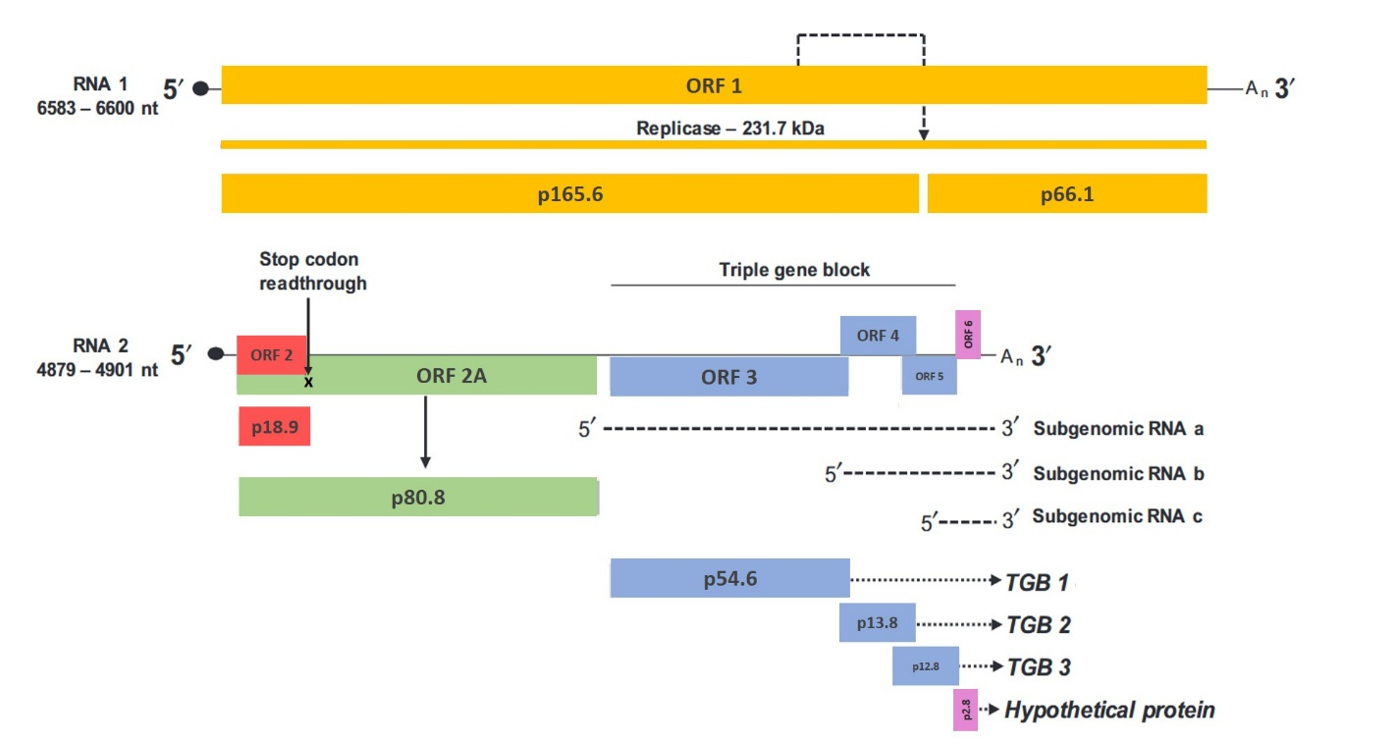Figure 1. Genome organization and putative translation strategies of wheat stripe mosaic virus (WhSMV). Putative self-cleavage of the replicase protein (black arrow RNA-1), a read-through stop codon UAG (black x RNA-2), putative m7Gppp (black circle) and the 3′ poly (A)-tails (A_{n}). WhSMV has seven predicted open reading frames (ORFs): ORF 1 encodes the putative viral replicase, ORF 2 encodes the putative coat protein, ORF 2A encodes a putative read-through CP, ORF 3 encodes the putative triple gene block 1 (TGB 1), probably coded from subgenomic RNA a, ORF 4 encodes the putative TGB 2, probably from subgenomic RNA b, ORF 5 encodes the putative TGB 3, probably from subgenomic RNA b, and ORF 6 encodes a hypothetical protein, probably from subgenomic RNA c. Predicted molecular weights of proteins are indicated in kilodaltons (kDa). Dotted lines are used for all putative aspects.

Figure 2. Percent sequence identity matrices among isolates of wheat stripe mosaic virus (WhSMV) and species of the family Benyviridae for RNA 1, RNA 2, and all open reading frames (ORFs), except ORF 6. Percent nucleotide and amino acid sequence identities are shown below and above the diagonal, respectively. ORF 1 encodes the viral replicase, ORF 2 encodes the coat protein, ORF 2A encodes a read-through CP, ORF 3 encodes the triple gene block 1 (TGB 1), ORF 4 encodes TGB 2, and ORF 5 encodes TGB 3. Members of the family Benyviridae are beet necrotic yellow vein virus (BNYVV), beet soil-borne mosaic virus (BSBMV), burdock mottle virus (BdMV), rice stripe necrosis virus (RSNV). Mangifera indica latent virus (MILV) is a related unclassified virus.

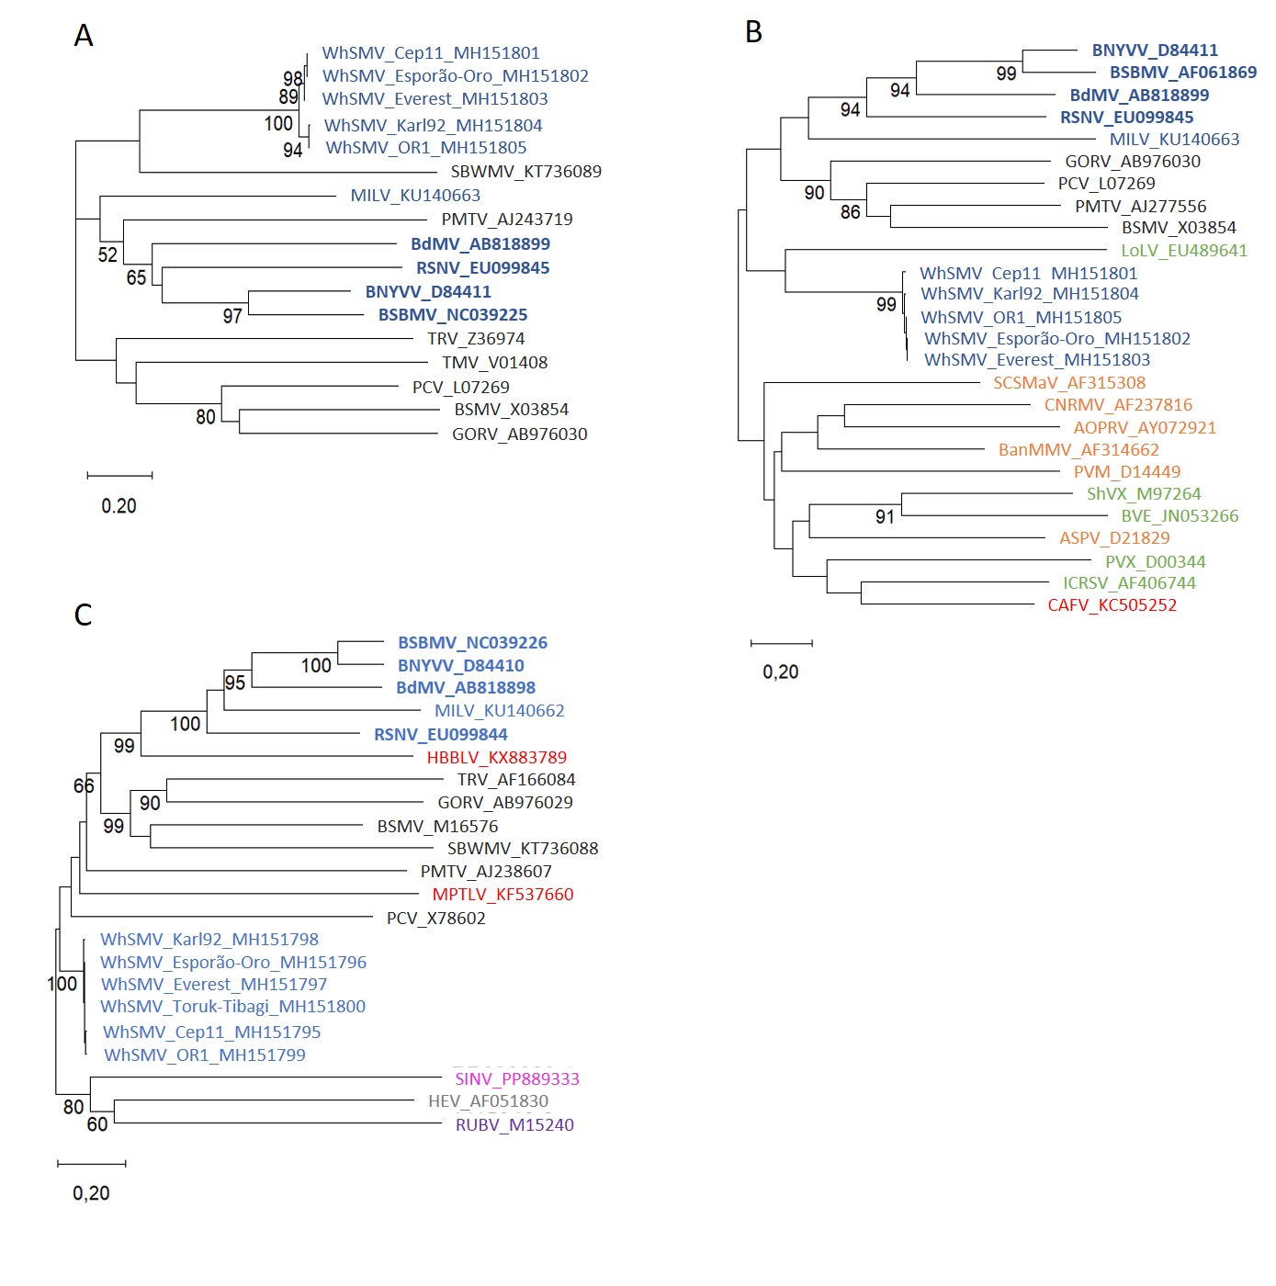
Figure 3. Phylogenetic relationships, based on the codon-aligned nucleotide sequences of coat protein (a), first triple gene block (b), and replicase (c) of viruses of the family Benyviridae and other related viruses. Numbers on branches indicate bootstrap values. Alignments were performed with muscle. Scale bars indicate substitutions per site. Members of the family Benyviridae are wheat stripe mosaic virus (WhSMV), beet necrotic yellow vein virus (BNYVV), beet soil-borne mosaic virus (BSBMV), burdock mottle virus (BdMV), rice stripe necrosis virus (RSNV), and the related Mangifera indica latent virus (MILV) (represented by blue color). Other viruses are: AOPRV, African oil palm ringspot virus; ASPV, apple stem pitting virus; BanMMV, banana mild mosaic virus; BSMV, barley stripe mosaic virus; BVE, blackberry virus E; CAFV, cassava alphaflexivirus; CNRMV, cherry necrotic rusty mottle virus; GORV, gentian ovary ringspot virus; HBBLV, Hubei beny-like virus 1; HEV, human hepatitis E virus; ICRSV, Indian citrus ringspot virus; LoLV, Lolium latent virus; MPTLV, Macrophomina phaseolina tobamo-like virus; PCV, peanut clump virus; PMTV, potato mop top virus; PVM, potato virus M; PVX, potato virus X; RUBV, rubella virus; SBWMV, soil-borne wheat mosaic virus; SCSMaV, sugarcane striate mosaic-associated virus; ShVX, shallot virus X; TMV, tobacco mosaic virus; and TRV, tobacco rattle virus. The colours black, green, orange, pink, grey, and purple represent members of the families Virgaviridae, Alphaflexiviridae, Betaflexiviridae, Togaviridae, Hepeviridae, and Matonaviridae, respectively. Red represents unclassified viruses. Phylogenetic trees were constructed using the maximum likelihood method implemented in the MEGA v. 12 program (Kumar et al., 2024) with Tamura’s three-parameter model, gamma distribution (G), and invariant sites (I). The robustness of each internal branch was estimated from 2000 bootstrap replicates for the coat protein (CP) and for the triple gene block movement 1 (TGB 1) genes, and from 6000 bootstrap replicates for the replicase gene.

